HighPointRR
Mac Installation Guide

V1.00 – Nov, 2020

Contents

1. Overview 3
2. Prerequisites 3
3. Apple T2 security Chip-Disable Secure boot 4
Disabling Secure Boot 4
4. Installing the Device Driver 6
macOS High Sierra 10.13 Driver Installation Procedure 6
macOS Mojave10.14 and macOS Catalina 10.15 and macOS Big Sur 11.0 Driver Installation Procedure 9
5. Uninstalling the Device Driver 13
Uninstalling the Device driver for macOS 10.13 and 10.14 13
Uninstalling the Device driver for macOS 10.15 and macOS 11.0 13
6. Installing the RAID Management Software (WebGUI) 14
7. Updating the WebGUI 16
8. Uninstalling the WebGUI 16
9. Trouble shooting 17
Unable to connect to the WebGUI 17
This error can be triggered by one of the following issues: 17
1. The hardware is not recognized by macOS 17
2. The device driver is not installed or is not loading properly. 17
3. WEBGUI service is not running. 17
4. The system’s SIP status is incorrect. 17
5. If you are using a T2 system; Secure Boot may not be disabled. 17
1. Verifying the hardware 17
3. Check the SIP status 19
4. For T2 Systems: Make sure Secure Boot is disabled 19
The WebGUI can't connect to a remote system 19
Appendix 20
Collecting the macOS version 20
Check the security & privacy 20
Checking the SIP Status 22
Systems with T2 chipsets – Secure Boot status 22
Checking the Driver status and Version 22
WebGUI Screenshots 23
WebGUI service restart 23
How to Collect System Logs 23

Overview

This guide includes important hardware/software requirements, installation & upgrade procedures, for using RAID controllers, with a macOS operating system.
Support products：
RR3740 / 3742 / 3720 / 2840 / 840
RR640L / 644L / 644LS / 642L
RR2720 / 2721 / 2722 / 2711
RS6628T / 6674T

Prerequisites
This section describes the base hardware and software requirements for RAID controllers & enclosures.

Driver Installation
This section covers driver installation, driver upgrade and driver uninstallation procedures for RAID controllers & enclosures in a macOS environment.

RAID Management Software (WebGUI) Installation
This section covers WebGUI installation, WebGUI upgrade and WebGUI uninstallation procedures for RAID controllers & enclosures in a macOS environment.

Troubleshooting
Please consult this section if you encounter any difficulties installing or using RAID controllers & enclosures .It includes descriptions and solutions for commonly reported technical issues.

Prerequisites
- Operating System Support: macOS 10.13 or later
- Before installing the driver and RAID Management software, you should log into the system as a System Administrator.
- Identify the system as either T2 or Non-T2 based – if the system has a T2 chip, make sure to follow section 3 before attempting to install any software for the device.

Apple T2 security Chip-Disable Secure boot
Secure Boot must be disabled on the following products:
Learn more About the Apple T2 Security Chip：https://support.apple.com/en-us/HT208862
- iMac Pro
- Mac Pro introduced in 2019
- Mac mini introduced in 2018
- MacBook Air introduced in 2018 or later
- MacBook Pro introduced in 2018 or later
You can also use System Information to learn whether your Mac has this chip:
- Press and hold the Option key while choosing Apple menu > System Information.
- In the sidebar, select either Controller or iBridge, depending on the version of macOS in use.
- If you see "Apple T2 chip" on the right, your Mac has the Apple T2 Security Chip.
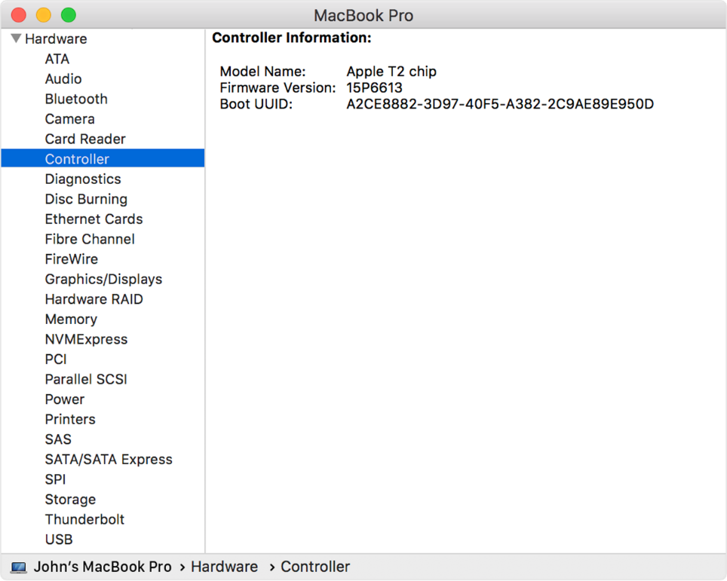

Disabling Secure Boot
- Restart the computer and then press the Command + R keys simultaneously. Keep holding the keys down until the Apple Logo appears.
- When the menu bar says: “Utilities”, you have booted into Recovery mode. Launch the Startup Security Utility application by selecting it from the Utilities menu.
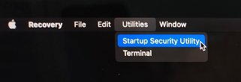
- A dialog box will appear, telling you that you will need to authenticate as an Administrator to make changes, click the Enter macOS Password… button.
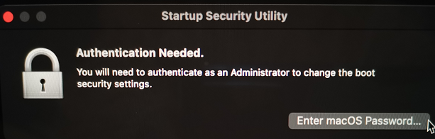
- When the Startup Security Utility window appears, select No Security under the Secure Boot options.
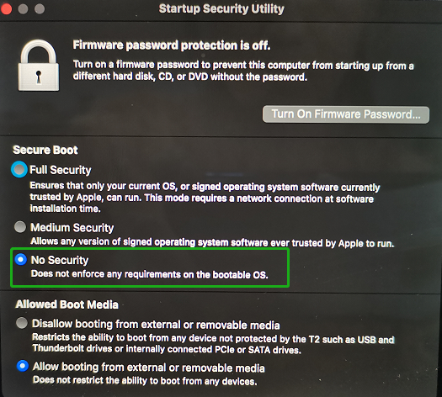
- Select Restart from the Apple menu to restart your Mac, and wait for your normal Desktop to appear.
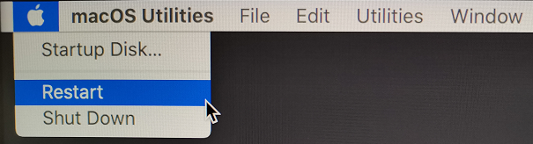

Installing the Device Driver
Current drivers can be downloaded from each product’s Software Downloads webpage.
Product | Download Page
RR3740/3742/3720 | https://highpoint-tech.com/USA_new/series-rr3700-download.htm
RR2840 | https://highpoint-tech.com/USA_new/series-rr2840a-download.htm
RR840 | https://highpoint-tech.com/USA_new/series-rr800-download.htm
RR2720/2721/2722/2711 | https://highpoint-tech.com/USA_new/series_rr272x_configuration.htm
RR640L/642L/644L/644LS | https://highpoint-tech.com/USA_new/series_rr600-download.htm
RS6628T | https://highpoint-tech.com/USA_new/series-rs6628t-download.htm
RS6674T | https://highpoint-tech.com/USA_new/series-rs6674t-download.htm

macOS High Sierra 10.13 Driver Installation Procedure
- Restart the computer and then press the Command + R keys simultaneously. Keep holding the keys down until the Apple logo appears. Click on Utilities in the upper left corner and select Terminal.
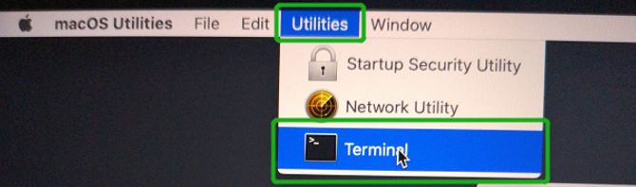
- Open a Terminal window and enter the following command:
csrutil disable
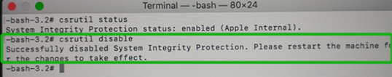
- Select Restart from the Apple menu to restart your Mac, and wait for your normal Desktop to appear.
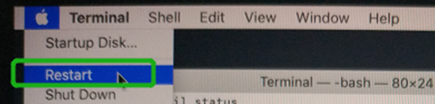
- After rebooting, confirm that SIP is in the disabled state. Open terminal and type the following command:
csrutil status
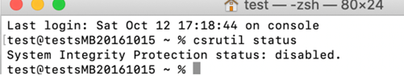

- Next, start the driver installation procedure. Locate the download and double click the package to start the installer. Click the Continue button:
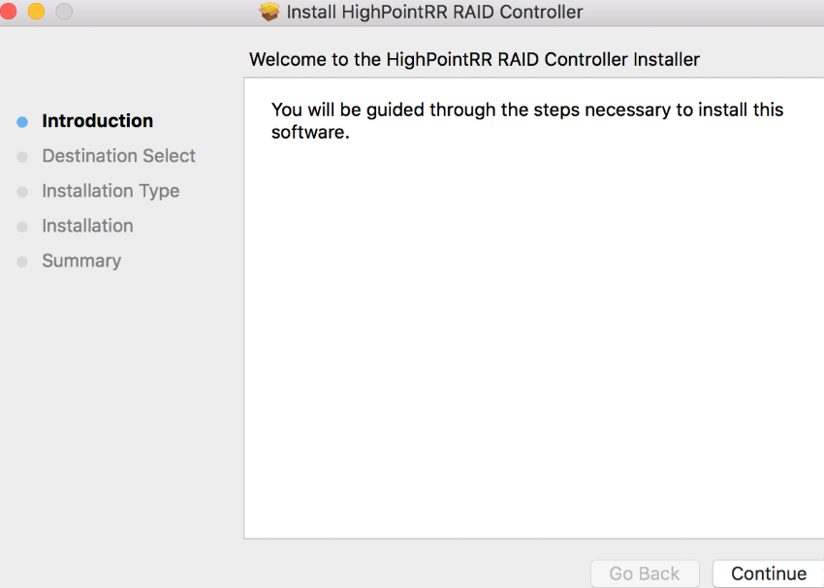
- macOS will prompt you to install the driver. Click Install to proceed.
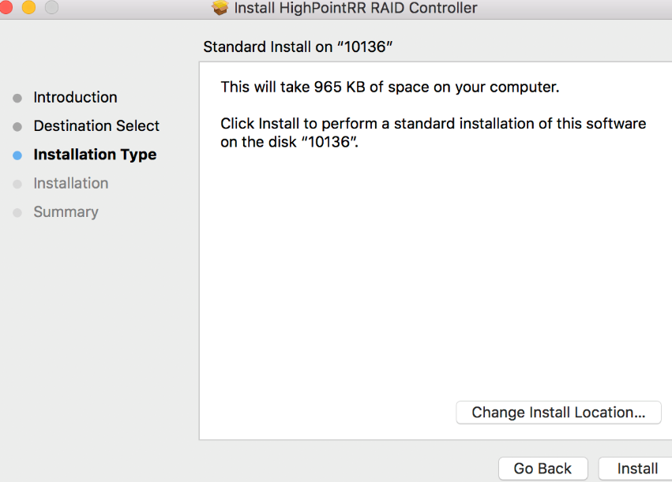
- You will be prompted that a reboot is needed to install the software. Click Continue Installation.
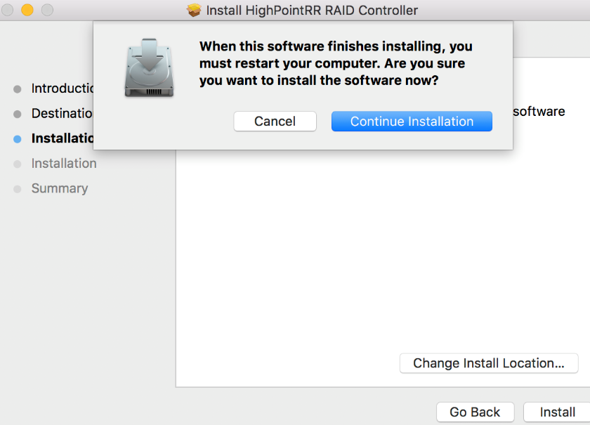
- If no pop-ups appear, please proceed to the next step of installation. Click Restart.

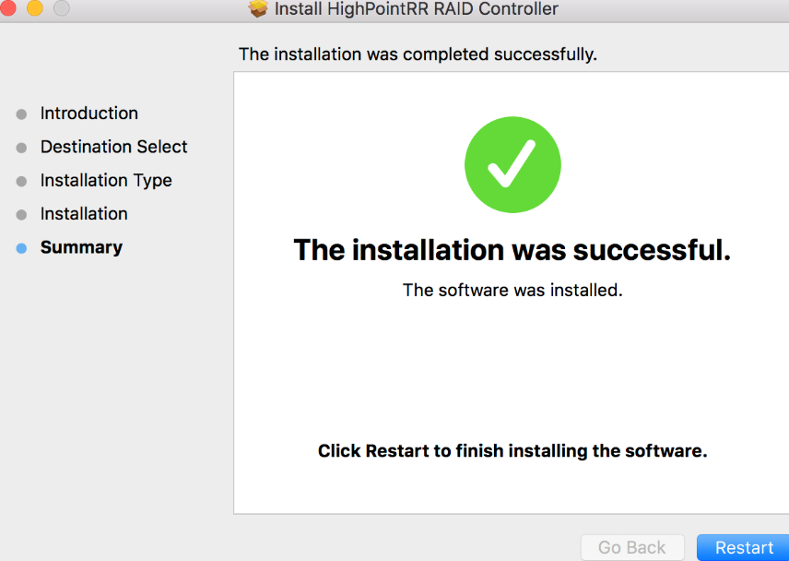
- If you receive a popup window prompting you for permission, click Open Security Preferences.
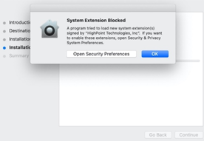

- Make sure App Store and identified developers is checked, and then click Allow.
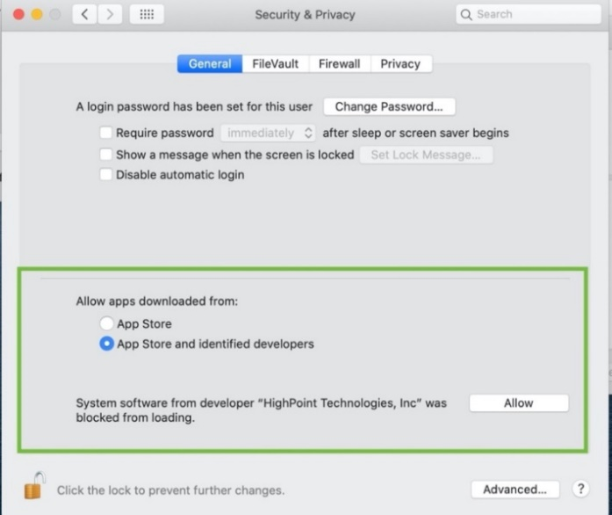

- You will receive a popup window, prompting you to restart. Click OK.
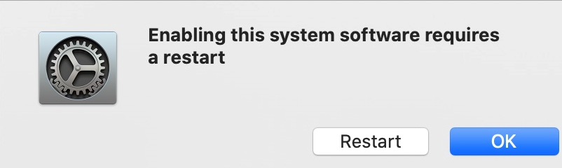

- Return to the driver installation window. Click Restart to restart the system. 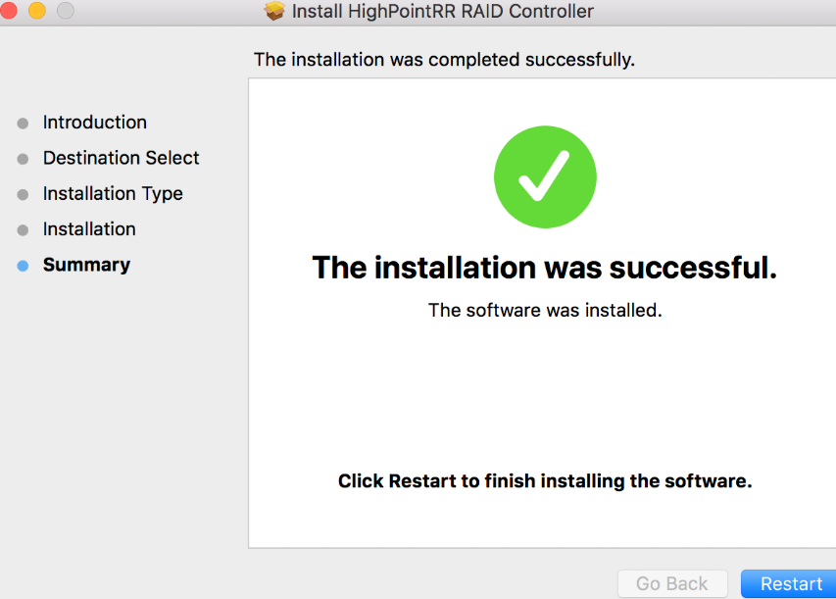

- After the system restarts, the driver’s status can be viewed under System Information→Extensions; The following screenshot shows the driver has been loaded:
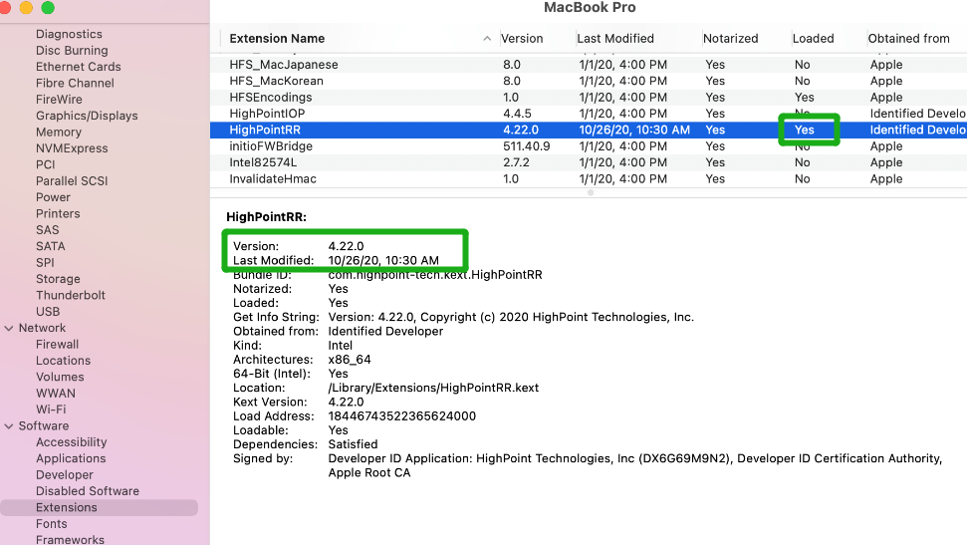

macOS Mojave10.14 and macOS Catalina 10.15 and macOS Big Sur 11.0 Driver Installation Procedure
- Locate the download and double click the package to start the installer. Click the Continue button:
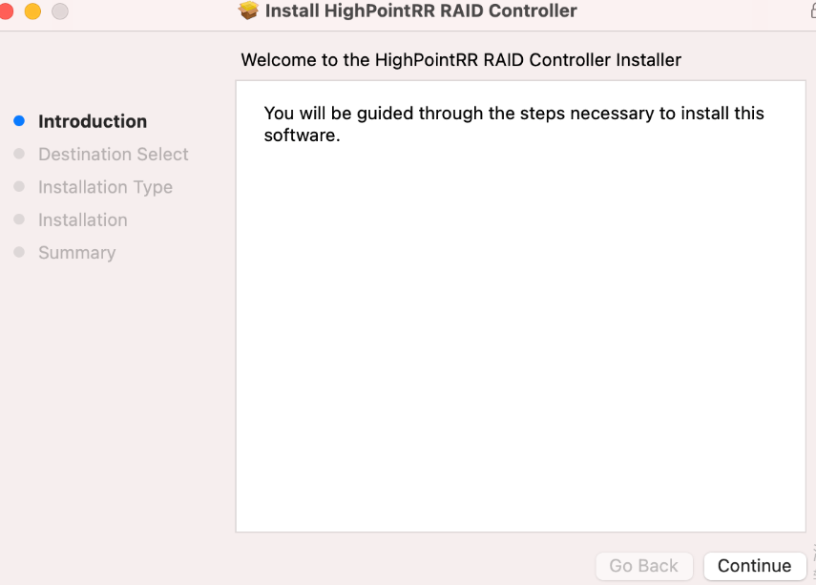
- macOS will prompt you to install the driver. Click Install to proceed.
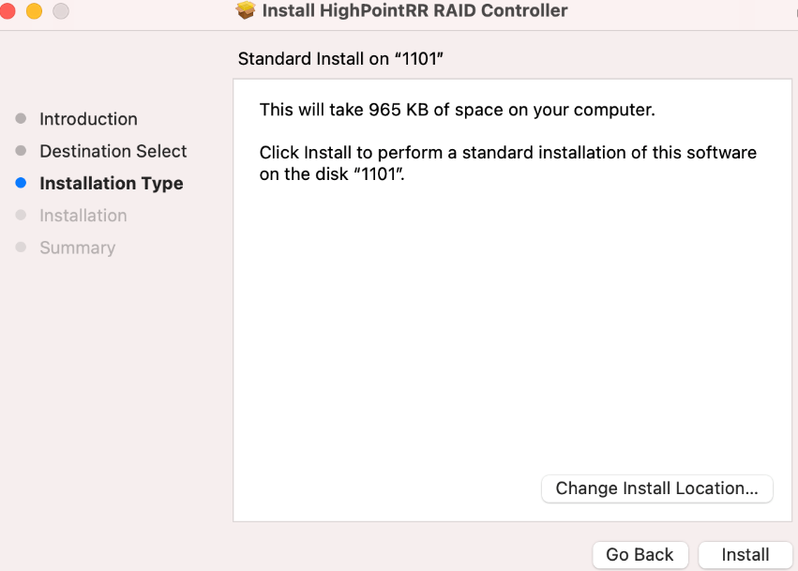
- You will be prompted that installer is trying to install new software, enter the Administrator Username and Password. Once these have been entered, Click Install Software.
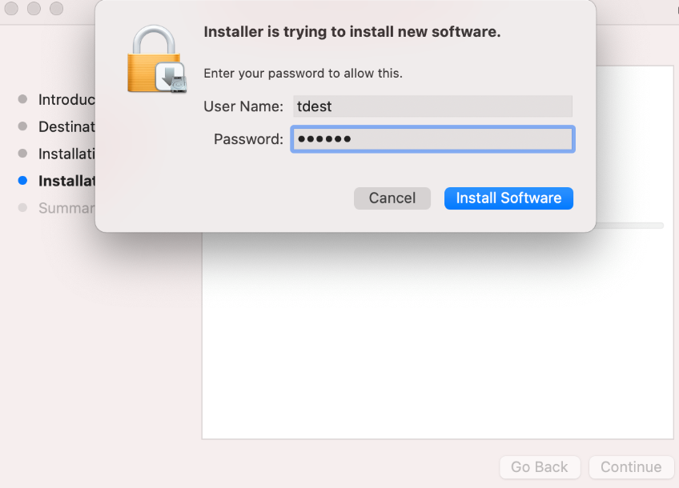
- If no pop-ups appear, please proceed to the next step of installation. Click Restart.
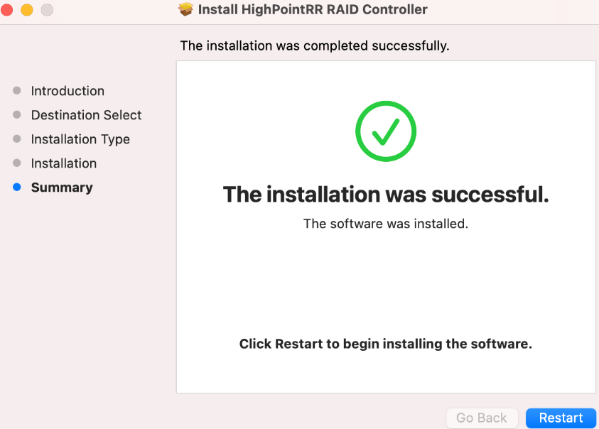
- If you receive a popup window prompting you for permission, click Open Security Preferences.
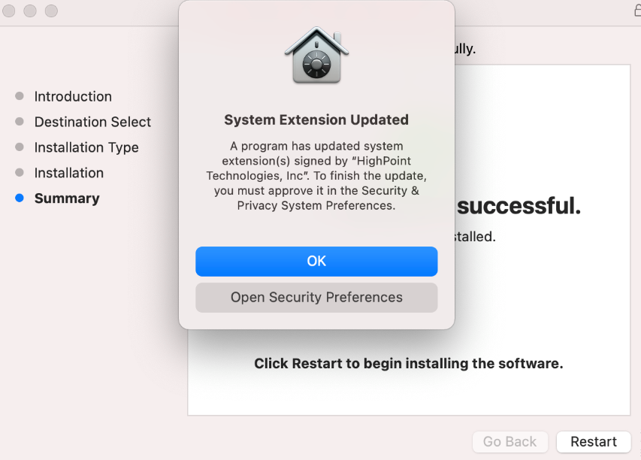

- Make sure App Store and identified developers is checked, and then click Allow.
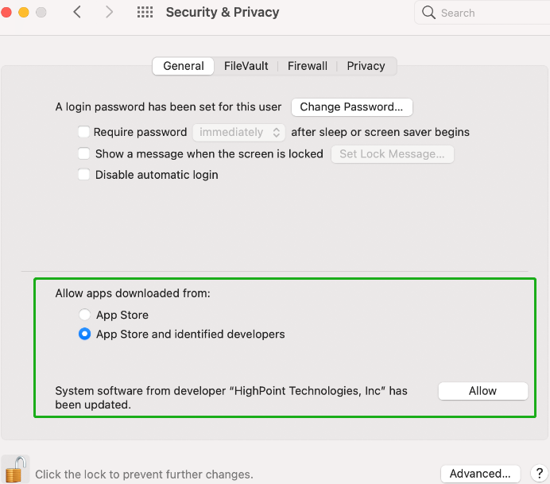
- You will receive a popup window, prompting you to restart. Click Not Now.
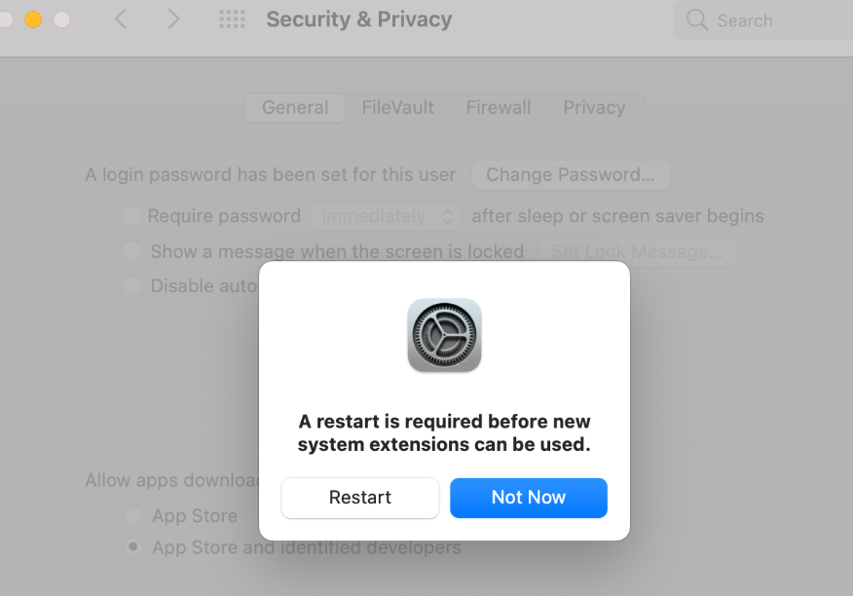

- Return to the driver installation window. Click Restart to restart the system.
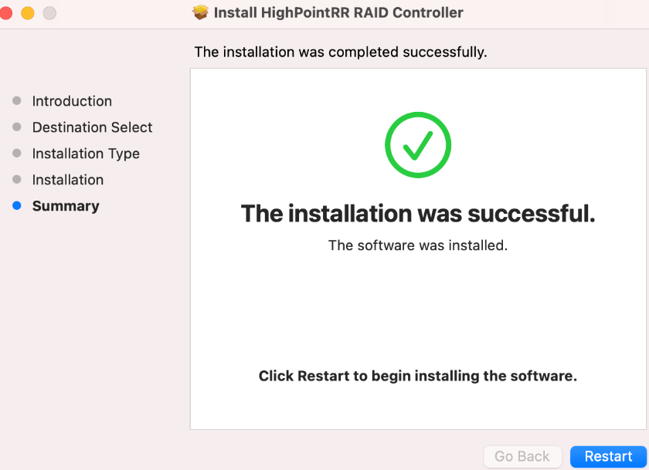

- After the system restarts, the driver’s status can be viewed under System Information; The following screenshot shows the driver has been loaded:

Uninstalling the Device Driver

Uninstalling the Device driver for macOS 10.13 and 10.14
To uninstall the HighPointRR driver, you will need to open a Terminal window and enter the following command:
sudo rm -rf /Library/Extensions/HighPointRR.kext
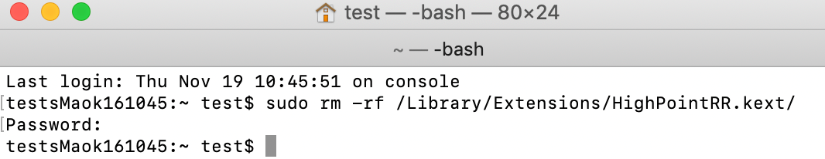

Uninstalling the Device driver for macOS 10.15 and macOS 11.0
To uninstall the HighPointRR driver, you will need to open a Terminal window and enter the following command:
sudo rm -rf /Library/Extensions/HighPointRR.kext
sudo kextcache –i /
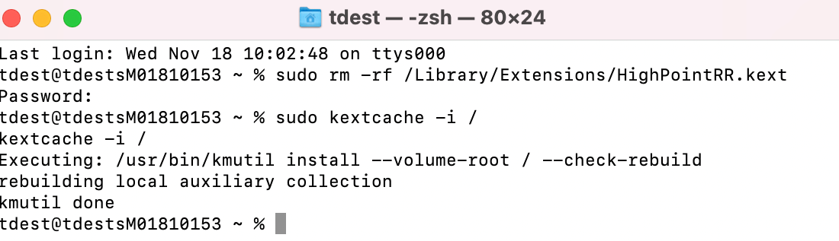

Installing the RAID Management Software (WebGUI)

- Double click the package named HighPointWebGUI.pkg to start the installer. When the window appears, click the Continue button.
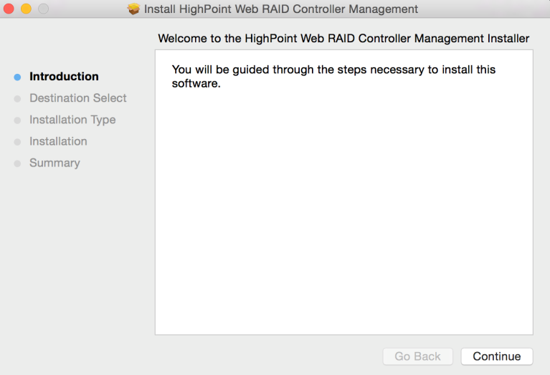
- You will be promoted to click the Install button. Click Install to continue.

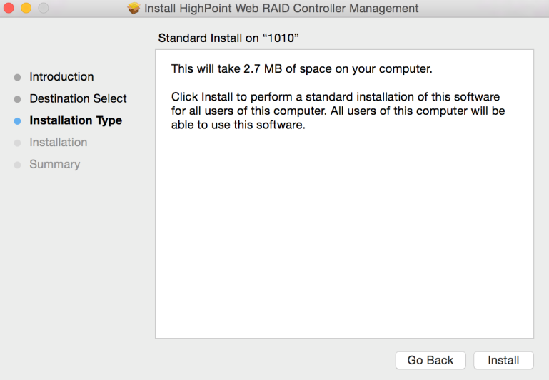

- You will then be promoted to enter the Administrator Username and Password. Once these have been entered, click Install Software to continue.
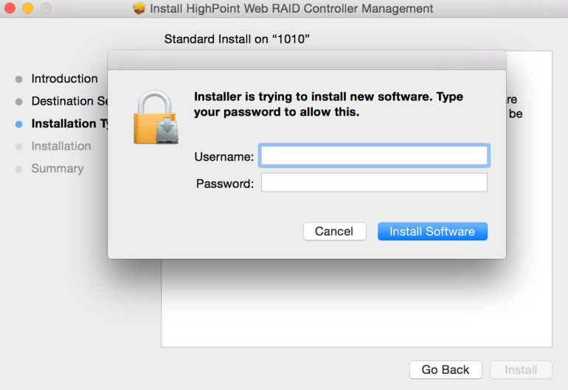

- The WebGUI Management software has been installed. Click Close to complete the procedure.
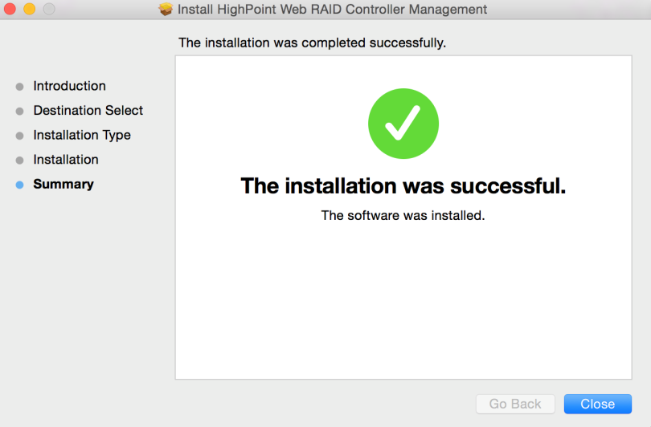

Updating the WebGUI
- First, uninstall the current WebGUI. Please refer to item 8 below (Uninstalling the WebGUI ).
- Download the latest version of the WebGUI from the appropriate Software Downloads webpage.
- Locate the download and double click the package named HighPointWebGUI.pkg to start the installer. Please refer to Installing the WebGUI for more information.

Uninstalling the WebGUI
To uninstall the WebGUI, access Applications, click on HPTWEBGUI, select uninstall, and double-click the uninstall-WEBGUI. command. The uninstall command will automatically open a terminal
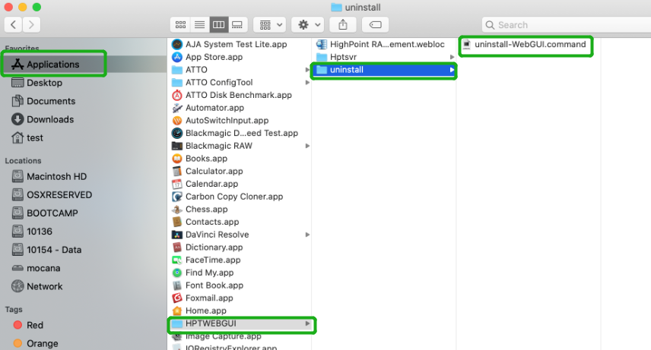

Enter the macOS password, uninstall the software:
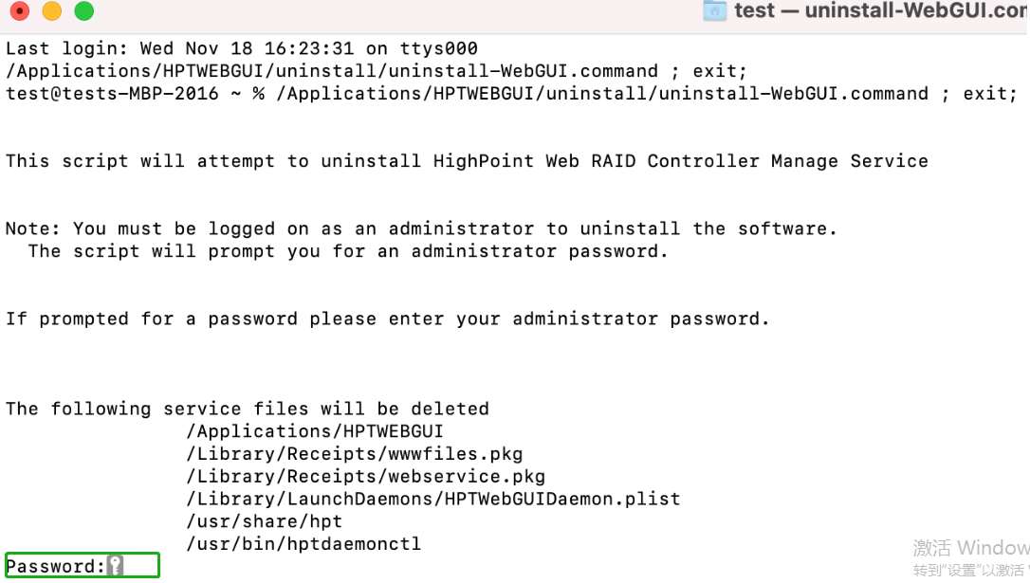

Trouble shooting

Unable to connect to the WebGUI
After the driver and management software are installed, the management software displays a "Connection Failure" warning when attempting to start the interface:
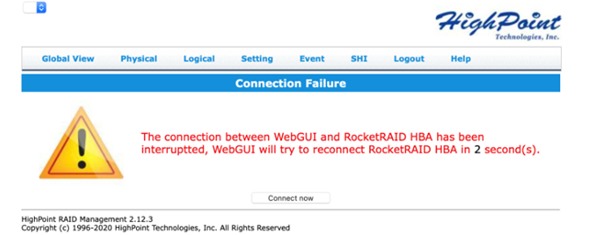

This error can be triggered by one of the following issues:
- The hardware is not recognized by macOS
- The device driver is not installed or is not loading properly.
- WEBGUI service is not running.
- The system’s SIP status is incorrect.
- If you are using a T2 system; Secure Boot may not be disabled.

Verifying the hardware

- The device is connected to the host through the Thunderbolt
- If you are using the controller via our RocketStor 6661A adapter and a Thunderbolt™ 3 connection, please make sure the RocketStor 6661A device is properly recognized by macOS.
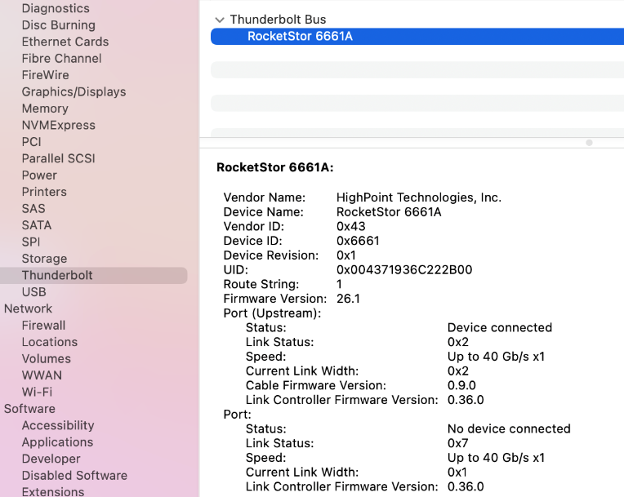
If the RocketStor 6661A entry is not displayed, this may be related to a connection problem – move the RS6661A to another Thunderbolt™ 3 port or replace the cable and recheck the entry.
- If RocketStor 6661A is correctly connected, make sure the System Information→PCI controller is recognized by macOS (see example below):
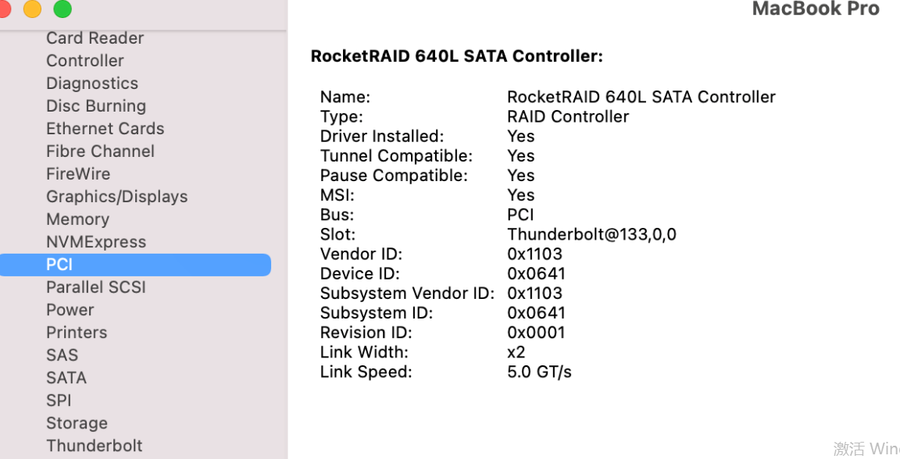
- The device is directly connected to the host through the PCIE SLOT
- make sure the System Information→PCI controller is recognized by macOS (see example below):
- The device is RAID enclosures
- make sure the System Information→Thunderbolt controller is recognized by macOS (see example below):
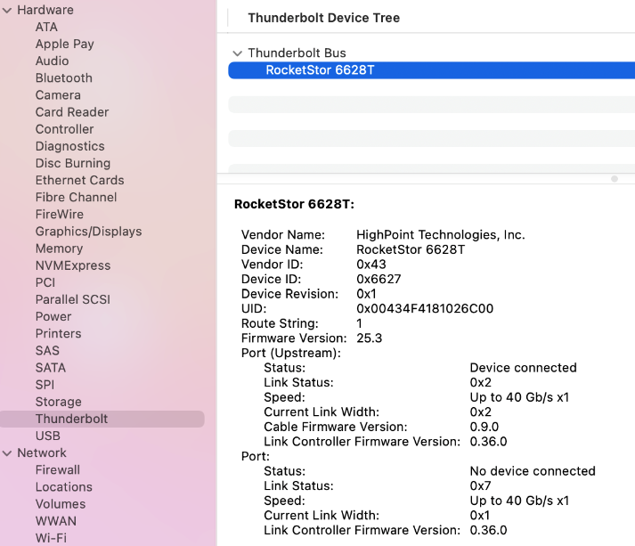

- Make sure the HighPointRR Driver is loaded
Please refer to the Appendix - Checking the Driver status and Version to make sure the HighPointRR driver is installed properly.
- If the HighPointRR driver is not loading, proceed to – Check the security & privacy status. If HighPoint software is blocked in the permission, you need to click Allow.
- If the driver is loading properly, but the WebGUI is still unable to start, please try to restart the WebGUI service. Please refer to Appendix - WebGUI service restart make settings.
If WebGUI is still not connected, please contact our Support Department to open a support ticket. Please make sure to include any screenshots and system information you are able to collect (see the Appendix for more information).

Check the SIP status
- Please refer to the Appendix - Checking the SIP Status.
- If the settings are not correct for your system, please refer to the driver installation manual for each system to reset the SIP status.

For T2 Systems: Make sure Secure Boot is disabled
- Please refer to the Appendix - Systems with T2 chipsets – Secure Boot status . If the setting is incorrect, you will need to reboot the system to change the setting.
If you encounter any problems while checking items 1-4, please refer to the Appendix to collect information about your system and configuration, and submit a support ticket to our Customer Support department using our Online Support Portal: https://www.highpoint-tech.com/websupport/main.php

The WebGUI can't connect to a remote system
If you can't connect to a remote system, make sure raidman-httpsd is running on the target system, and confirm that you can access the remote system via a TCP/IP connection. If you have a firewall configured, make sure TCP port 7402 is not blocked.

Appendix
When submitting s support ticket via our Online Support Portal, the following information will help our Support Department diagnose and resolve your issue as quickly and efficiently as possible.

Collecting the macOS version
- Click on the Apple logo located near the upper left-hand portion of the Desktop, and click “Version”. Then the version number of the system will all be displayed.
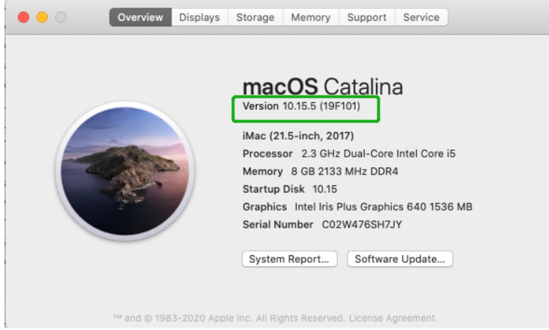

Check the security & privacy
- Check if there is HighPoint software blocked in the permission, if it is blocked, you need to click “Allow”.
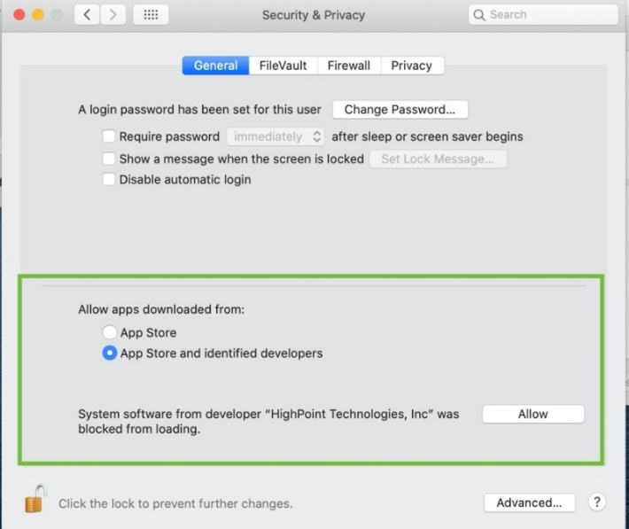
- If ‘System software from developer ’HighPoint Technologies, Inc’ was blocked from loading’ is not displayed, please do the following:
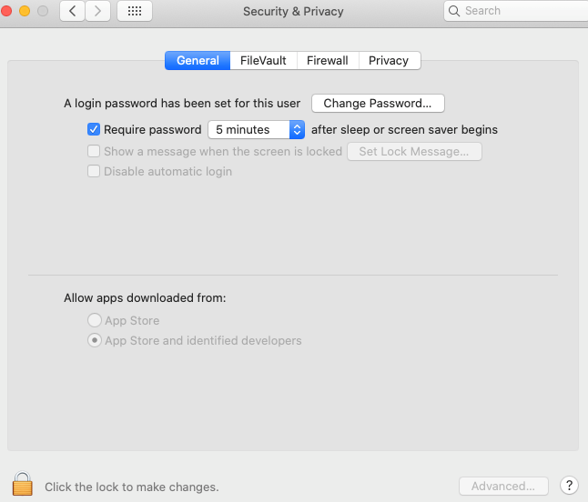

- First, uninstall the driver, please refer to the Uninstalling the Device Driver
- Install the driver again, please refer to the Installing the Device Driver, The System Extensions Updated window that pops up when installing the driver, please click Open Security Preferences, Allow the permission.

Checking the SIP Status
Open a Terminal window and enter the following command: csrutil status
Please take a screenshot of the output, and attach it to a support case (see example below):
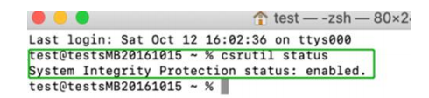
The status will vary depending on which version of macOS you are using:
MacOS Version | SIP Status | Driver Status
10.13.x | Disable | Loaded
10.14.x | Enable | Loaded
10.15.x | Enable | Loaded
11.0.x | Enable | Loaded

Systems with T2 chipsets – Secure Boot status
You will need reboot the system and enter Recovery Mode to check the Secure Boot status. This setting should remain disabled.

Checking the Driver status and Version
- Click on System Information Extensions, and then click on HighPointRR entry – please take a screenshot and attach it this support case (see the example below):
Make sure System Information ExtensionsHighPointRR ‘Loaded’ is Yes

WebGUI Screenshots
Please take screenshots of WEBGUI each Tab (such as Physical, Logical, Event, etc.) and upload these to your support case. In addition, check the Event log tab and save a copy of the current log – please upload this to the support case.

WebGUI service restart
If you can't connect to the WebGUI, please check if a process named raidman-httpsd is running on the system. If it is not running, you can start it manually by opening a terminal window and running the command: “sudo hptdaemonctl restart”.

How to Collect System Logs
- Please attach a copy of the /var/log folder to your support ticket.
To locate the /var/log Folder: 1. Go to Applications → Utilities → Console:
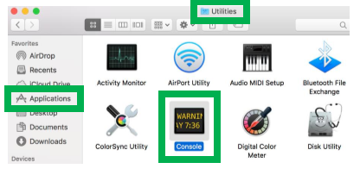
- On the left side of the Console application, right-click on the /var/log folder and select Reveal in Finder:
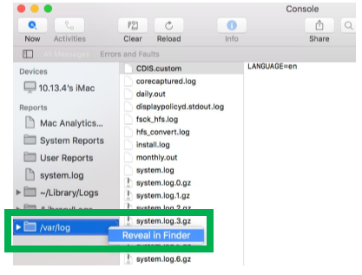

- You should then be automatically directed to the log folder in the var directory. Please remember when sending the folder to zip file, you should first direct it to a separate location (such as the desktop).
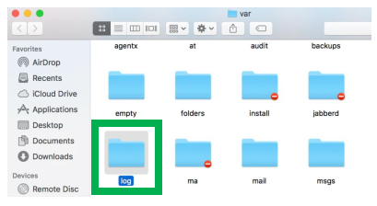
- In addition to /var/log Folder detailed above, please attach a copy of the errlog.txt file:
- Open terminal and type the following, then press Enter:
log show |grep kernel > hptsyslog.txt
Please attach the hptsyslog.txt to your support ticket.

