SSD7101A/7204/7104/7120/6540/6540M/7180/7184/7140 Data RAID Linux Installation Guide
Revision History
Date | Version | Author | Approve | Description
2020/05/25 | V1.00 | HMY | QYT | 添加G4 Linux 安装手册
2020/05/28 | V1.01 | CB |  | Updated to new format
2020/07/29 | V1.02 | QYT |  | 增加SSD7180/7184
2020/09/24 | V1.03 | ZY |  | 增加SSD7140

Contents
Overview 3
Prerequisites for a Data-RAID Configuration 4
Driver Installation 5
Installing the Driver 5
Updating the Driver 9
Uninstalling the Driver 13
HighPoint RAID Management (WebGUI) Installation / Driver Installation Verification 15
Troubleshooting 17
WebGUI 17
1. The WebGUI fails to install 17
2. The WebGUI cannot connect to the controller 17
3. Fail to compile gcc, make and other driver files. 18
4. If you experience any other WebGUI or CLI related problems 19
Controller and Drive Detection Issues 19
Appendix 20

Overview

This guide includes important hardware/software requirements, installation & upgrade procedures, and troubleshooting tips for using SSD7101A-1, SSD7120, SSD7204,
SSD7104, SSD7180, SSD7184 and SSD7140 NVMe RAID controllers and SSD6540/6540M RAID enclosures with a Linux operating system.

Prerequisites
This section describes the base hardware and software requirements for SSD7000 series NVMe RAID controllers & enclosures.

Driver Installation
This section covers driver installation, driver upgrade and driver uninstallation procedures for SSD7000 series NVMe RAID controllers & enclosures in a Linux environment.

Management Software Installation
This section explains how to download and install the HighPoint RAID Management Software Suite for Linux distributions. The download includes both the Web RAID Management Interface (WebGUI), and the CLI (Command Line Interface).

Troubleshooting
Please consult this section if you encounter any difficulties installing or using SSD7000 series NVMe RAID controllers or enclosures. It includes descriptions and solutions for commonly reported technical issues.

Appendix
This section describes how to collect trouble shooting information for support cases you have submitted via our Online Support Portal.

Prerequisites for a Data-RAID Configuration
The HighPoint SSD7101A-1, SSD7120, SSD7104, SSD7204, SSD6540M, SSD6540,
SSD7180, SSD7184, & SSD7140 were designed to support data-only NVMe storage configurations. In order to configure a non-bootable NVMe RAID array, you will need the following:
- An NVMe SSD must be installed. You must have at least one NVMe SSD installed into the SSD7000 series RAID controller or enclosure.
- A PCIe 3.0 slot with x8 or x16 lanes. SSD7200 series RAID controllers (such as the SSD7204) can be used with PCIe 3.0 slots that have either x8 or x16 lanes. All other SSD7000 series NVMe solutions require x16 lanes for maximum performance.
- Make sure any non-HighPoint drivers are uninstalled for any SSD’s hosted by the SSD7000 series RAID controllers. 3rd party software and manufacturer provided drivers may prevent the SSD7000 controller or enclosure from functioning properly.

Warnings:
- Failing to remove the controller and SSD’s when uninstalling the driver may result in data loss.
- Always make sure the SSD7000 driver is installed before moving a SSD7000 series NVMe RAID controller & RAID array to another Linux system.

Linux distributions will always load the default NVMe support after the SSD7000 driver has been uninstalled, or if it detects the present of a card when no driver has been loaded – this driver will only recognize the NVMe SSD’s as separate disks.

If the SSD’s are recognized separately, any data they contain may be lost – this includes RAID configuration data.

Driver Installation

Installing the Driver
- Power on the system and boot the Linux distribution.
- Open a system terminal with root privileges, and verify that the SSD7000 series controller or enclosure is detected by using the following command:
lspci
Example screenshot (SSD7101A/7104/7120/6540/6540M):
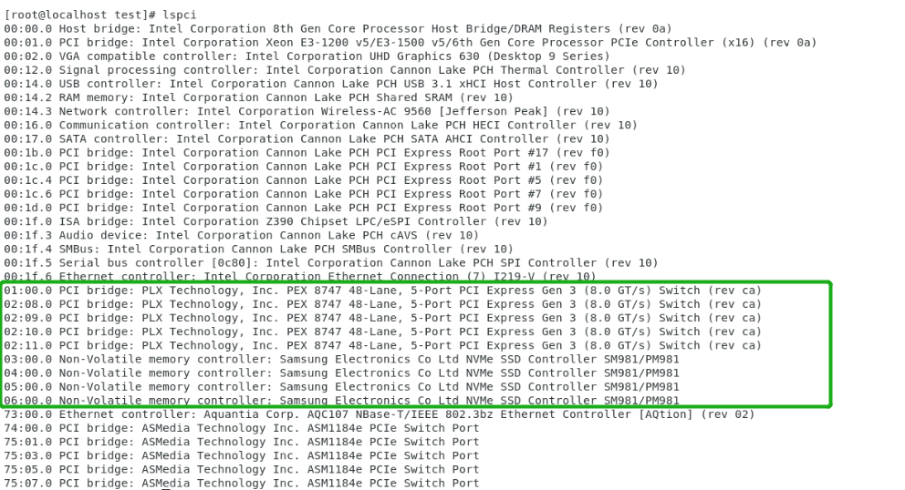
SSD7204：
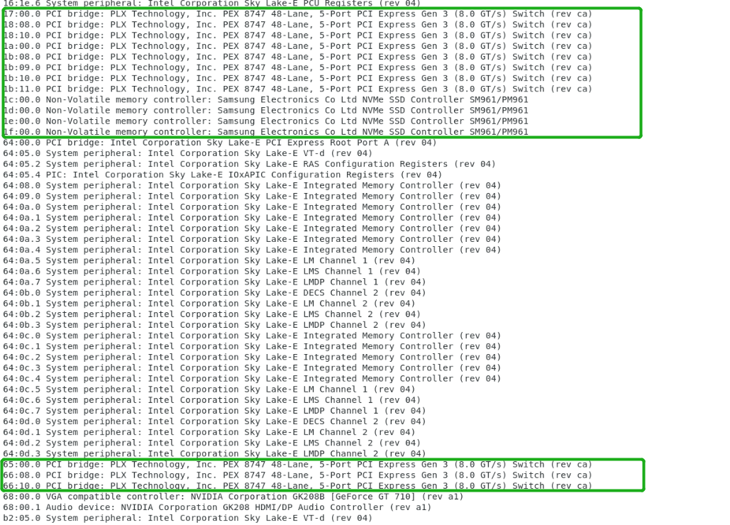

SSD7184/7180:
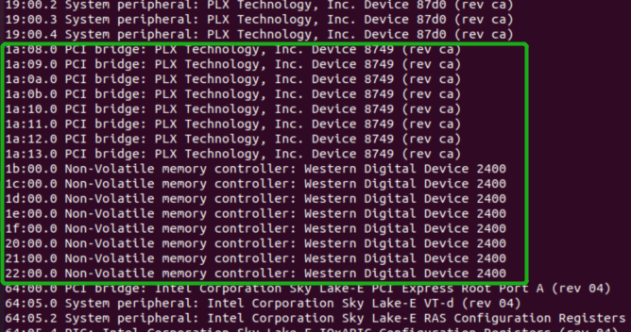
SSD7140:
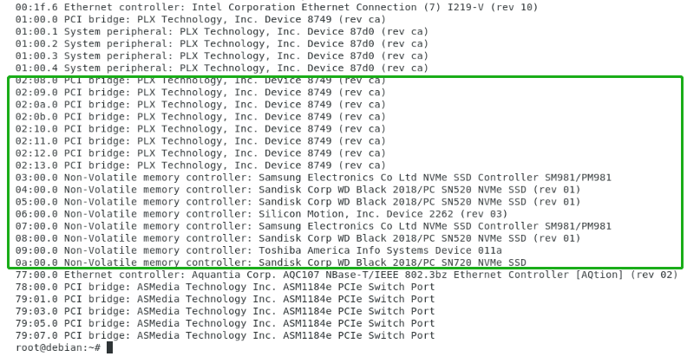
Additionally, you can verify that the NVMe SSD’s are detected by using the following command:
fdisk -l
Example screenshot (SSD7101A-1):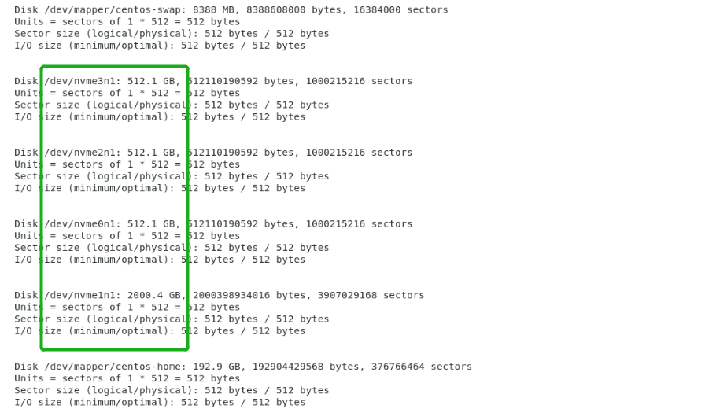
- Download the appropriate driver from Software Downloads web page：
SSD7101A-1:

https://highpoint-tech.com/USA_new/series-ssd7101a-1-download.htm
SSD7104:
https://highpoint-tech.com/USA_new/series-ssd7104-download.htm
SSD7204:
https://highpoint-tech.com/USA_new/series-ssd7204-download.htm
SSD7120:
https://highpoint-tech.com/USA_new/series-ssd7120-download.htm
SSD6540:
https://highpoint-tech.com/USA_new/series-ssd6540-download.htm
SSD6540M:
https://highpoint-tech.com/USA_new/series-ssd6540m-download.htm
SSD7180:
https://highpoint-tech.com/USA_new/series-hpc-download.htm
SSD7184:
https://highpoint-tech.com/USA_new/series-hpc-download.htm
SSD7140:
https://highpoint-tech.com/USA_new/series-ssd7140-download.htm

- Using the system terminal with root privileges, browse to the directory where the driver download, and enter the following commands to extract the Linux Open Source Driver software package:
SSD7101A/7104/7204/7120/6540/6540M/7140：
tar zxvf RocketNVMe_Linux_Src_vx.x.xx_xx_xx_xx.tar.gz
SSD7180/7184：
tar zxvf HighPoint_NVMe_G5_Linux_Src_vx.x.xx_xxxx_xx_xx.tar.gz
- Install the Open Source Driver using the following command:
SSD7101A/7104/7204/7120/6540/6540M/7140：
sh rsnvme_linux_src_vx.x.xx_xx_xx_xx.bin
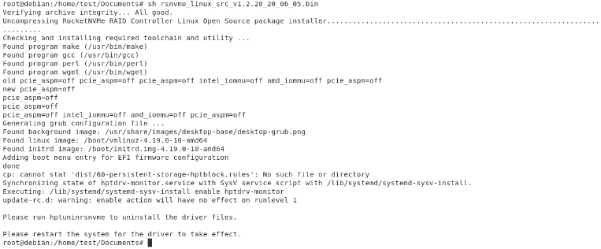

SSD7180/7184:
sh hptnvme_g5_linux_src_vx.x.xx_xxxx_xx_xx.bin
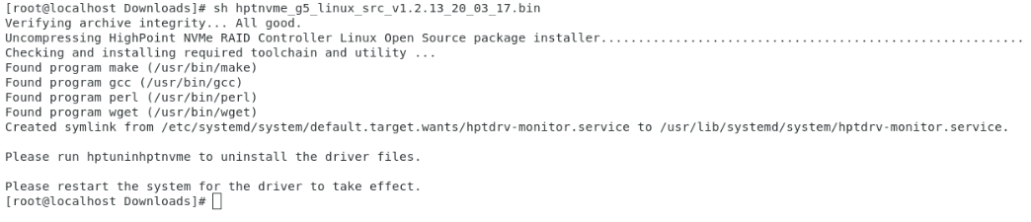
- After the driver installation is complete, the system will prompt you to restart to make the driver take effect. Manually restart the system.
- After the distribution as rebooted, open the system terminal with root privileges and check the driver status using the following command:
SSD7101A/7104/7204/7120/6540/6540M/7140：
dmesg | grep rsnvme
The following screenshot shows driver version v1.2.20.
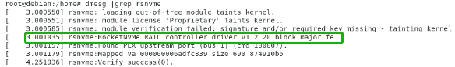
SSD7180/SSD7184:
dmesg | grep hptnvme
The following screenshot shows driver version v1.2.13.
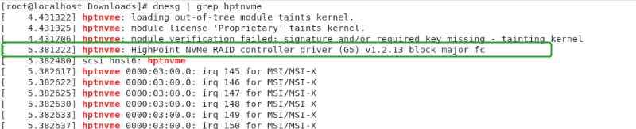
Additionally, you can check the NVMe driver using the following command:
fdisk -l
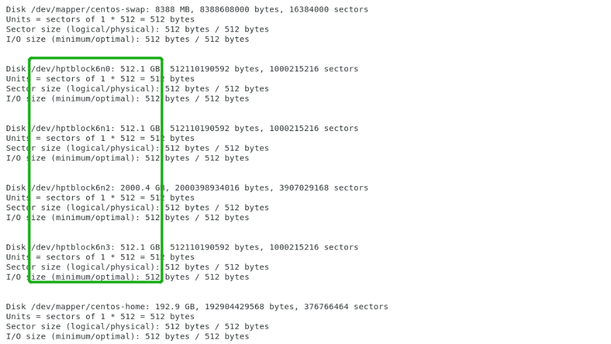

Updating the Driver
- Prerequisites
- Ensure that the SSD7000 series controller or enclosure is attached to the motherboard.
- Open the system terminal with root privileges to check the current driver version by using the following command:
SSD7101A/7104/7204/7120/6540/6540M/7140：
dmesg | grep rsnvme
The following screenshot shows driver version v1.2.18.
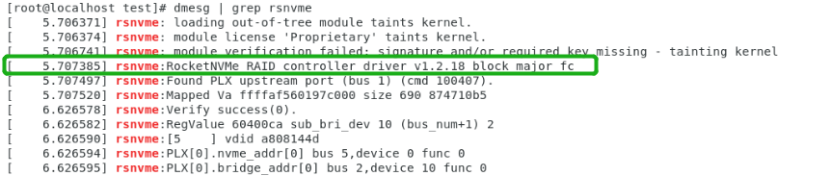
SSD7180/SSD7184:
dmesg | grep hptnvme
The following screenshot shows driver version v1.2.13.

- Download the latest driver from the Software Downloads webpage:
SSD7101A-1:

https://highpoint-tech.com/USA_new/series-ssd7101a-1-download.htm
SSD7104:
https://highpoint-tech.com/USA_new/series-ssd7104-download.htm
SSD7204:
https://highpoint-tech.com/USA_new/series-ssd7204-download.htm
SSD7120:
https://highpoint-tech.com/USA_new/series-ssd7120-download.htm
SSD6540:
https://highpoint-tech.com/USA_new/series-ssd6540-download.htm
SSD6540M:
https://highpoint-tech.com/USA_new/series-ssd6540m-download.htm
SSD7180:
https://highpoint-tech.com/USA_new/series-hpc-download.htm
SSD7184:
https://highpoint-tech.com/USA_new/series-hpc-download.htm
SSD7140:
https://highpoint-tech.com/USA_new/series-ssd7140-download.htm

- Open the directory where the latest driver version is located and open the system terminal with root privileges. Extract the Linux Open Source Driver software package.
SSD7101A/7104/7204/7120/6540/6540M/7140：
tar zxvf RocketNVMe_ Linux_Src_vx.x.xx_xx_xx_xx.tar.gz
SSD7180/7184:
tar zxvf HighPoint_NVMe_G5_Linux_Src_vx.x.xx_xxxx_xx_xx.tar.gz

- Make sure the system has an active internet connection. To install the latest Open Source Driver, open the system terminal with root privileges and enter the following command:
SSD7101A/7104/7204/7120/6540/6540M/7140：
sh rsnvme_linux_src_vx.x.xx_xx_xx_xx.bin

SSD7180/7184:
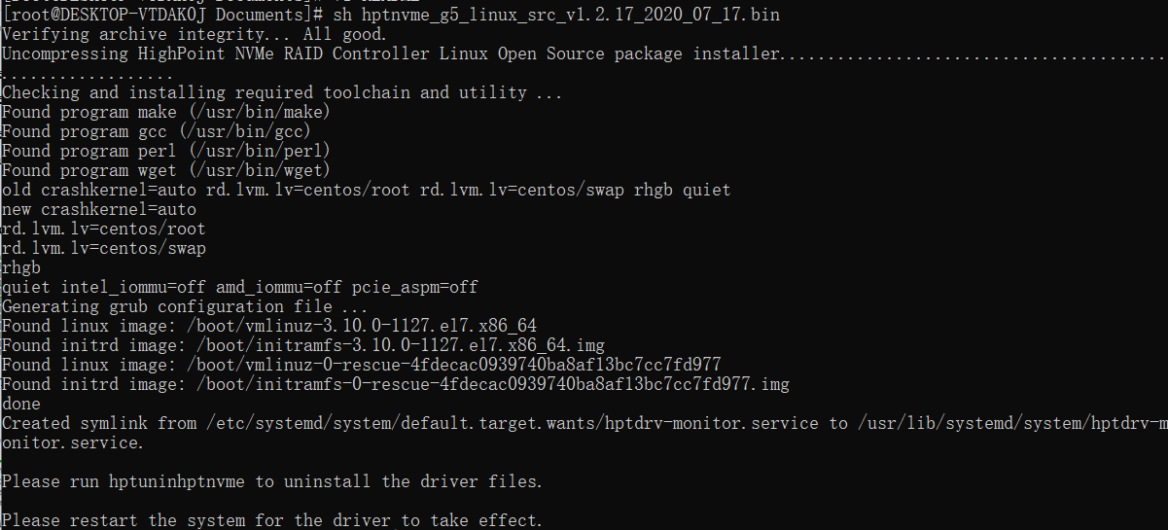

- After the driver installation is complete, the system will prompt you to restart to allow the new driver to take effect. Manually restart the system
- Once the distribution has rebooted, open the system terminal with root privileges and check the current driver version using the following command
SSD7101A/7104/7204/7120/6540/6540M/7140：
dmesg | grep rsnvme.
The screenshot below shows driver v1.2.20 is installed:
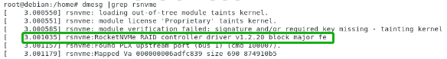

SSD7180/7184:
The screenshot below shows driver v1.2.17 is installed:
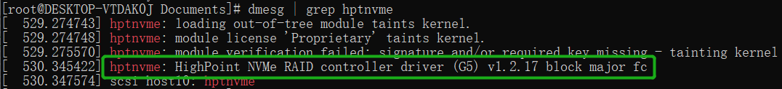

- Open the WebGUI to make sure it can connect to the controller and recognize the NVMe SSD’s/RAID array.
- As shown below, the new driver has been successfully installed and loaded at bootup – the WebGUI can connect to the controller and recognize the SSD’s and RAID array:
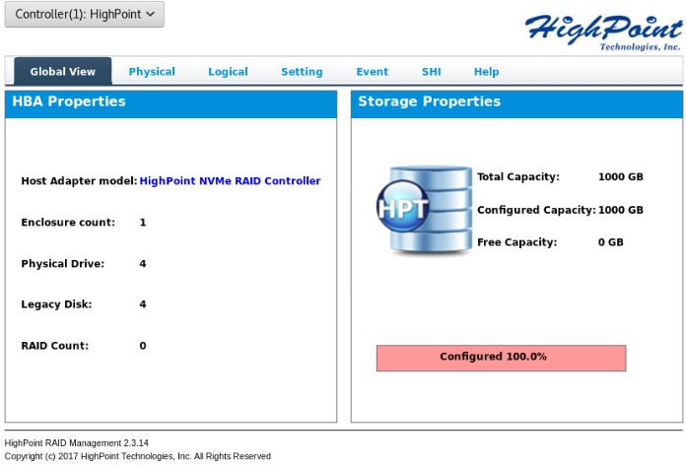

Uninstalling the Driver
- Prerequisites
- Power off the system and remove the SSD7000 device from the motherboard.
Note: failing to remove the controller and SSD’s when uninstalling the driver may result in data loss. The Linux distribution will load the default NVMe support after the SSD7000 driver has been uninstalled – this driver will only recognize the NVMe SSD’s as separate disks.
- To uninstall the driver:
- Open the system terminal with root privileges. Enter the following commands to uninstall the driver:
SSD7101A-1/7104/7204/7120/6540/6540M/7140：
hptuninrsnvme

SSD7180/7184:
hptuninhptnvme

- Press ’Y’ to confirm.
SSD7101A-1/7104/7204/7120/6540/6540M/7140：
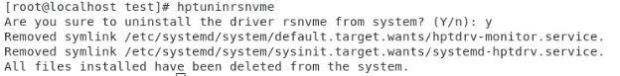
SSD7180/7184:
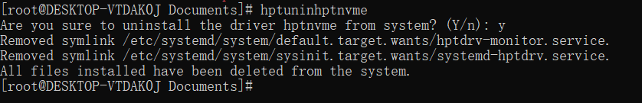
- After uninstalling the driver, manually reboot the system.
- After the distribution has rebooted, open the system terminal with root privileges. And enter the following command to check the driver status:
SSD7101A-1/7104/7204/7120/6540/6540M/7140：
lsmod | grep rsnvme
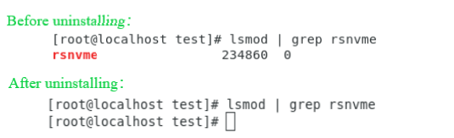

SSD7180/7184:
lsmod | grep hptnvme
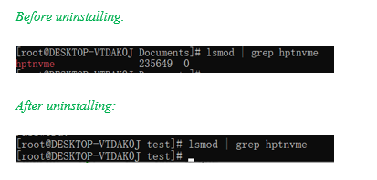
- If the system does not display information about “rsnvme or hptnvme”, the driver has been successfully uninstalled.

HighPoint RAID Management (WebGUI) Installation / Driver Installation Verification
The HighPoint RAID Management software is used to configure and monitor SSD’s and arrays hosted by the SSD7000 series RAID controller or enclosure.
Download the RAID Management software package from the HighPoint website:
SSD7101A-1:

https://highpoint-tech.com/USA_new/series-ssd7101a-1-download.htm
SSD7104:
https://highpoint-tech.com/USA_new/series-ssd7104-download.htm
SSD7204:
https://highpoint-tech.com/USA_new/series-ssd7204-download.htm
SSD7120:
https://highpoint-tech.com/USA_new/series-ssd7120-download.htm
SSD6540:
https://highpoint-tech.com/USA_new/series-ssd6540-download.htm
SSD6540M:
https://highpoint-tech.com/USA_new/series-ssd6540m-download.htm
SSD7180:
https://highpoint-tech.com/USA_new/series-hpc-download.htm
SSD7184:
https://highpoint-tech.com/USA_new/series-hpc-download.htm
SSD7140:
https://highpoint-tech.com/USA_new/series-ssd7140-download.htm

- Using the system terminal with root privileges, browse to the directory where the driver download, and enter the following commands to extract the management software package:
tar zxvf RAID_Manage_Linux_vx.x.xx_xx_xx_xx.tgz
- Install the HighPoint RAID management software (WebGUI & CLI) using the following command:
./RAID_Manage_Linux_v2.x.x_x_x_x.bin
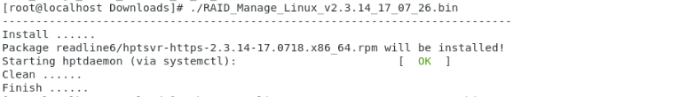
- After the software is installed, open the WebGUI to make sure it can connect to the SSD7000 series RAID controller or enclosure.

- You can also check the controller using the CLI (command line interface).Using the system terminal, enter the following command:
hptraidconf
For more information about the CLI, please download the guide: Link.
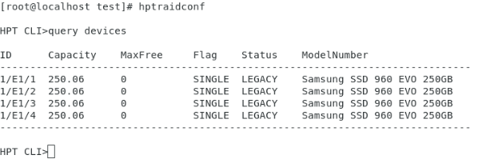
- If the WebGUI/CLI can connect to the controller and recognized the NVMe SSD’s, the driver has been installed and is functioning normally:

Troubleshooting

WebGUI

The WebGUI fails to install
If you use a Ubuntu system, the system may prompt you about the lack of a readline5 package when installing the WebGUI – this will interrupt the installation process.
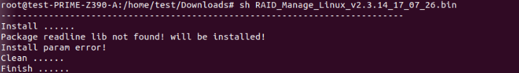
Solution:
- With root permissions enabled, you can use the following command to load readline5 at using a terminal, and will be allowed to install the WebGUI:
apt-get install libreadline5
- Once complete, restart the WebGUI installation procedure.

The WebGUI cannot connect to the controller
If you are unable to access the SSD7000 series RAID controller or enclosure using the WebGUI:
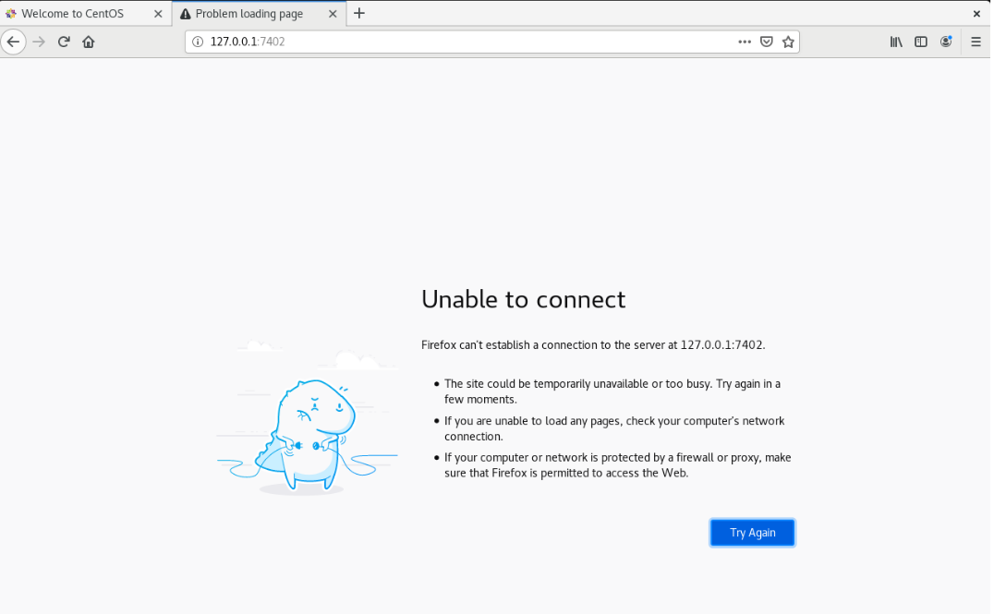
- WebGUI service did not start successfully.
Solution：
Start the WebGUI by opening the system terminal with root privileges and entering the following command:
hptsvr
- The driver cannot be compiled.
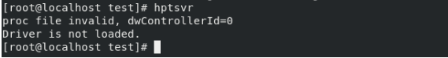
Solution：
- Make sure at least one NVMe SSD’s has been installed into the SSD7000 series RAID controller or enclosure.
- Make sure motherboard can recognize the SSD7000 device and display NVMe information during the BIOS post.
- If you use a CentOS system, open the system terminal with root privileges and entering the following command to install “elfutils-libelf-deve”l:
yum install elfutils-libelf-devel
Once complete, install the SSD7000 driver once more.
- If you use an Ubuntu/Debian system, open the system terminal with root privileges and entering the following command to install “libelf-dev”:
#yum install libelf-dev
Once complete, install the SSD7000 driver once more.

Fail to compile gcc, make and other driver files.
When installing the driver, due to various factors, driver files such as gcc and make cannot be compiled, thus interrupting the driver installation process:
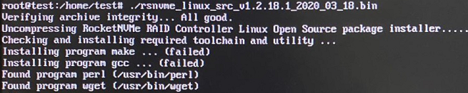
This problem can be caused by：
- The system is not connected to a network (internet connection)
Solution：
- Double check the system’s internet connection
- Once confirmed, reinstall the driver.
- System process is occupied/busy
Solution：
Open the system terminal with root privileges and enter the following command:
apt-get update
This will prompt the system to release the process and update the download source. Install the driver again after the system process has been released.
- If you experience any other WebGUI or CLI related problems, please submit a support ticket using our Online Support Portal, include a description of the problem in as much detail as possible, and upload the following:
Collect the following Log files: pci.log, drivermod.log, hptdrv.log, kernel.log
Please click the following link for more information about locating and collecting these logs. More information is also available in the Appendix section, starting on page 20.

Controller and Drive Detection Issues
If the system is unable to detect the controller or SSD’s, make sure to remove any NVMe device from the system that is not related to the SSD7000 series RAID controller or enclosure during the troubleshooting process. The presence of other NVMe devices may interfere with the detection of the SSD7000 device.

If you experience any other controller related problems, please submit a support ticket using our Online Support Portal, include a description of the problem in as much detail as possible.
Please check the Appendix, starting on page 20 – providing system logs, screenshots and other information about your system will enable our Support Department resolve your support issue as quickly and efficiently as possible.

Appendix
When submitting s support ticket via our Online Support Portal, the following information will help out Support Department diagnose and resolve your issue as quickly and efficiently as possible.

- How to collect WebGUI information
Please take screenshots of each Tab (such as Physical, Logical, Event, etc.) and upload these to your support case. In addition, check the Event log tab and save a copy of the current log – please upload this to the support case.

- How to collect Log Files:
- Provide a screenshot of the installed driver:
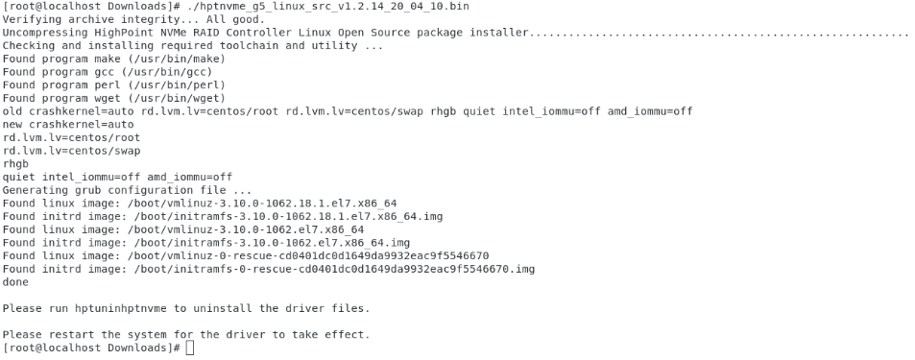
- Open system terminal and enter the following command:
lspci >pci.log
The screenshot below shows that hardware has been identified:

- Using the system terminal, enter the following command to access the drivermod.log:
lsmod >drivermod.log
The screenshot below shows that the driver has been installed.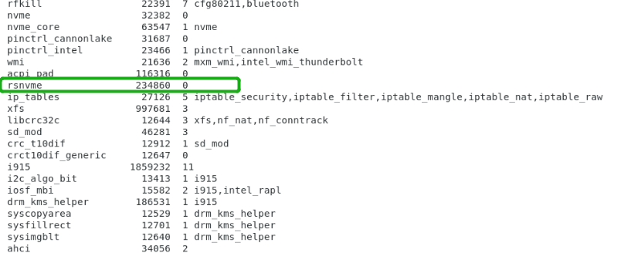
- Using the system terminal, enter the following command to view the driver log:
vi /var/log/hptdrv.log
- To view the kernel log, open the system terminal and enter the following command:
dmesg >kernel.log.

