Revision Log
Date | Version | Owner | Approve | Remake
6/2/2020 | v1.00 | WB | / | Init version
7/28/2020 | V1.01 | QYT |  | 增加SSD7180/7180/7104
9/23/2020 | V1.02 | ZY |  | 增加SSD7140

Contents
SSD7101A-1_SSD7204_SSD7104_SSD7120_SSD6540 3
Prerequisites for a Data-RAID Configuration 4
Driver Installation 5
Installing the Device Driver 5
1. Verify that Windows recognizes the controller 5
2. Download the Device Driver 7
3. Install the Device Driver 7
Updating the Device Driver 10
1. Check the Driver version 10
2. Download the Device Driver 10
3. Shutdown and Remove the Device 11
4. Uninstall the old Device Driver 11
5. Install the new Device Driver 12
Uninstalling the Device Driver 15
Installing the HighPoint RAID Management Software (WebGUI & CLI) 17
Troubleshooting 19
The WebGUI will not start after double-clicking the desktop icon. 19
BSOD (Blue Screen of Death) 20
How to Turn off Quick Shutdown for Windows 21
Controller and Drive Detection Issues 22
Appendix 23
How to Collect Debug View Logs 23
How to Collect INF Logs: 24
How to Collect System Logs: 25
Collecting Windows Dump Files 26

SSD7101A-1_SSD7204_SSD7104_SSD7120_SSD6540
_SSD6540M_SSD7180_SSD7184_SSD7140 Driver & Management Software Installation Guide

This guide includes important hardware/software requirements, installation & upgrade procedures, and troubleshooting tips for using SSD7101A-1/SSD7204/SSD7104/SSD7120/SSD6540/SSD6540M/SSD7180/SSD7184/SSD7140 NVMe RAID controllers with a Windows operating system.
Prerequisites
This section describes the base hardware and software requirements for the SSD7101A-1
/SSD7204/SSD7104/SSD7120/SSD6540/SSD6540M/SSD7180/SSD7184/SSD7140 PCIe 3.0 NVMe RAID controllers.

Driver Installation
This section covers driver installation, driver upgrade and driver uninstallation procedures for SSD7101A-1/SSD7204/SSD7104/SSD7120/SSD6540/SSD6540M/SSD7180/SSD7184/SSD7140 NVMe RAID controllers.

Management Software Installation
This section explains how to download and install the SSD7101A-1/SSD7204/SSD7104/SSD7120/
SSD6540/SSD6540M/SSD7180/SSD7184/SSD7140 RAID Management Software Suite for Windows operating systems. The download includes both the Web RAID Management Interface (WebGUI), and the CLI (Command Line Interface).

Troubleshooting
Please consult this section if you encounter any difficulties installing or using the SSD7101A-1
/SSD7204/SSD7104/SSD7120/SSD6540/SSD6540M/SSD7180/SSD7184/SSD7140 NVMe RAID controller. It includes descriptions and solutions for commonly reported technical issues.

Appendix
A selection of useful information and web links for the SSD7101A-1/SSD7204/SSD7104/SSD7120
/SSD6540/SSD6540M/SSD7180/SSD7184/SSD7140 NVMe RAID controllers.

Prerequisites for a Data-RAID Configuration
The SSD7101A-1/SSD7204/SSD7104/SSD7120/SSD6540/SSD6540M/SSD7180/SSD7184 /SSD7140 controllers can support Data-RAID arrays. In order to configure a Data-RAID array, you will need the following:
- An NVMe SSD must be installed. You must have at least one NVMe SSD installed into the SSD7101A-1/SSD7204/SSD7104/SSD7120/SSD6540/SSD6540M/SSD7180/SSD7184/SSD7140 controller.
- A PCIe 3.0 slot with x8 or x16 lanes. The SSD7101A-1/SSD7104/SSD7120/SSD6540/
SSD6540M/SSD7180/SSD7184/SSD7140 must be installed into a PCIe 3.0 slot with x16 dedicated lanes, The SSD7204 can be installed into a PCIe 3.0 x8 or x16 slot.
- Make sure any non-HighPoint drivers are uninstalled for any SSD’s hosted by the SSD7000 series RAID controllers. 3rd party software and manufacturer provided drivers may prevent the SSD7000 from functioning properly.
Warnings:
- Failing to remove the controller and SSD’s when uninstalling the driver may result in data loss.
- Always make sure the SSD7000 driver is installed before moving a SSD7000 series NVMe RAID controller & RAID array to another Windows system.

Windows operating systems will always load the default NVMe support after the SSD7000 driver has been uninstalled, or if it detects the present of a card when no driver has been loaded – this driver will only recognize the NVMe SSD’s as separate disks.

If the SSD’s are recognized separately, any data they contain may be lost – this includes RAID configuration data.

Driver Installation

Installing the Device Driver
The following section discusses driver installation for a non-bootable NVMe configuration.

Verify that Windows recognizes the controller
After installing the SSD7000 controller into the motherboard, power on the computer, boot the Windows operating system, and open Device Manager.
- Expand the Disk drives tab. Each NVMe SSD’s installed into the SSD7101A-1
/SSD7120/SSD7204/SSD7104/SSD6540/SSD6540M/SSD7180/SSD7184/SSD7140 controller should be displayed here.
- Expand the Storage Controllers tab. You should see a “Standard NVM Express Controller” entry for each NVMe SSD that is installed into the SSD7101A1/SSD7204/SSD7104/SSD7120/
SSD6540/SSD6540M/SSD7180/SSD7184/SSD7140 controller.
Example screenshot (SSD7101A-1/7104/7204/7120/6540/6540M):
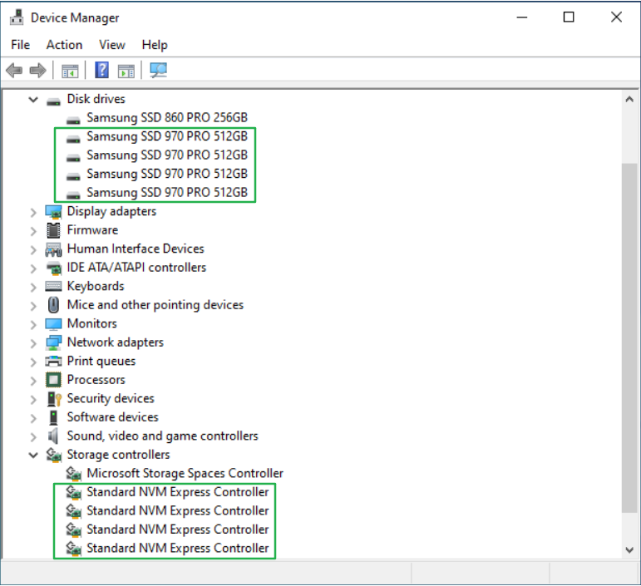
B
A

Example screenshot(SSD7180/7184):
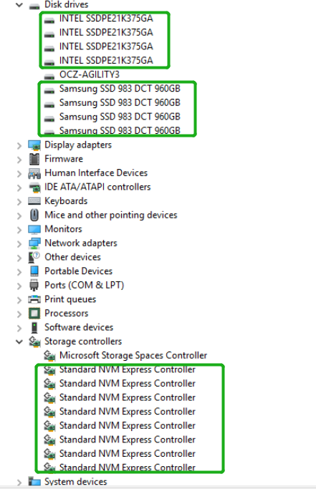
Example screenshot(SSD7140):
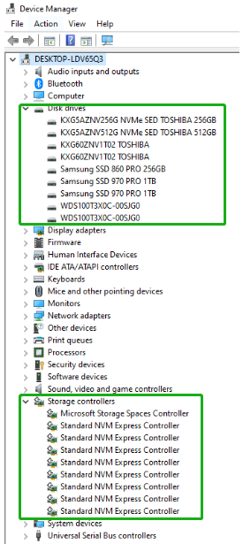

Download the Device Driver
Download the appropriate SSSD7000 driver from the controller’s Software Downloads webpage.
SSD7101A-1:
https://highpoint-tech.com/USA_new/series-ssd7101a-1-download.htm
SSD7104：
https://highpoint-tech.com/USA_new/series-ssd7104-download.htm
SSD7204:
https://highpoint-tech.com/USA_new/series-ssd7204-download.htm
SSD7120:
https://highpoint-tech.com/USA_new/series-ssd7120-download.htm
SSD6540:
https://highpoint-tech.com/USA_new/series-ssd6540-download.htm
SSD6540M:
https://highpoint-tech.com/USA_new/series-ssd6540m-download.htm
SSD7180:
https://highpoint-tech.com/USA_new/series-hpc-download.htm
SSD7184:
https://highpoint-tech.com/USA_new/series-hpc-download.htm
SSD7140:
https://highpoint-tech.com/USA_new/series-ssd7140-download.htm

Install the Device Driver
- Locate the driver download and open the file.
- Double-click setup.
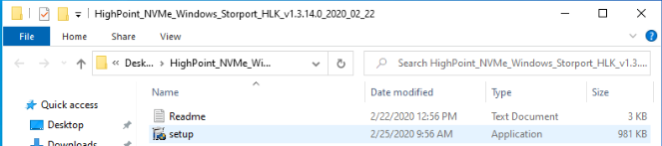
Note: If installation does not start, you may have to manually start setup using Administrator Privileges. Right-click setup, select Run as Administrator from the menu, and confirm the pop-up window to proceed.
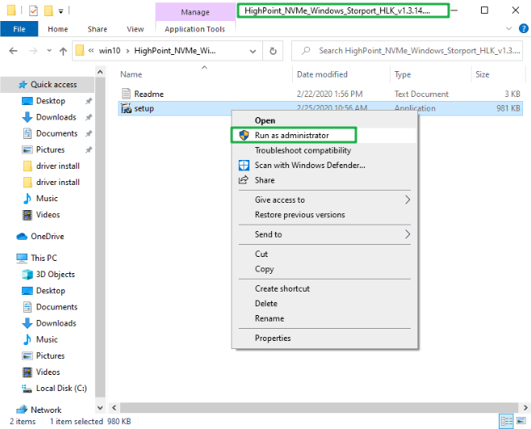
After driver installation is complete, click OK to reboot.
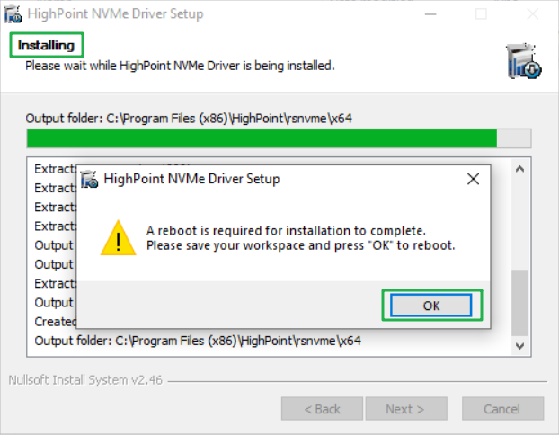
- Once Windows has rebooted, open Device Manager to check the status of the driver.
Expand Storage controllers and click on the HighPoint NVMe RAID Controller entry. View the properties and click the Driver tab:

Example screenshot (SSD7101A-1/7120/7104/7204/6540/6540M)

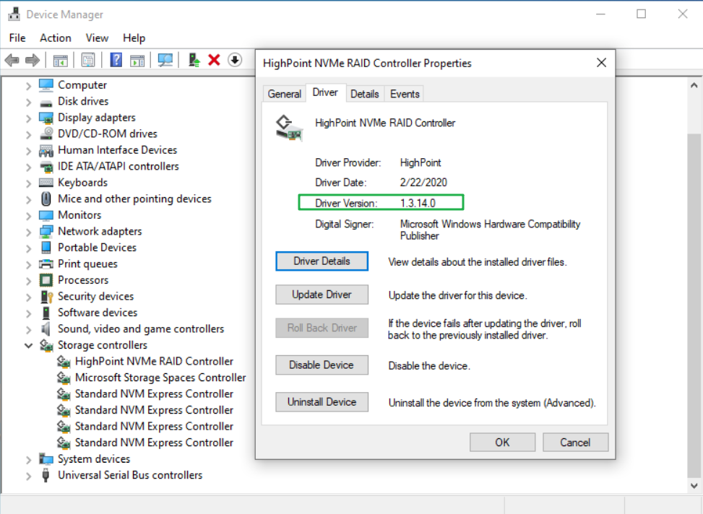

- First, make sure the WebGUI has been installed (see page 17). Open the WebGUI and make sure the SSD.’s / arrays are properly recognized.
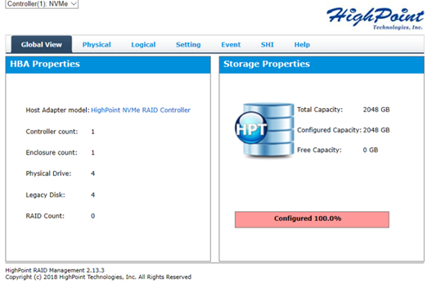
Note: Please refer to Appendix A to verify that your Device Manager entries correspond with the driver version you have installed.

Updating the Device Driver
Note: Before attempting to update the driver entry, ensure that the SSD7101A-1/SSD7204/
SSD7104/SSD7120/SSD6540/SSD6540M/SSD7180/SSD7184/SSD7140 is removed from the motherboard.

Check the Driver version
Open Device Manager to check the current driver version. Expand Storage controllers and click on the HighPoint NVMe RAID Controller entry. View the properties and click the Driver tab:
Example screenshot (SSD7101A-1/7120/7104/7204/6540/6540M)
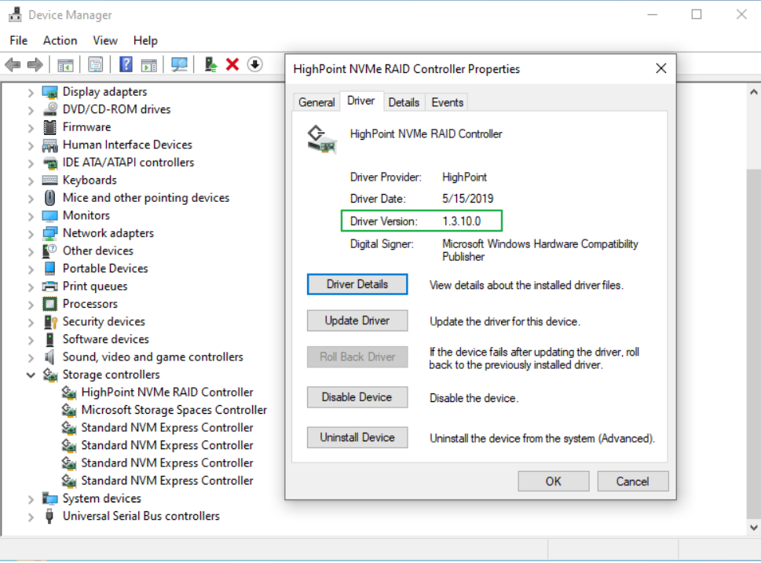

Download the Device Driver
Download the latest driver from the controller’s Software Downloads webpage.
SSD7101A-1:
https://highpoint-tech.com/USA_new/series-ssd7101a-1-download.htm
SSD7104：
https://highpoint-tech.com/USA_new/series-ssd7104-download.htm
SSD7204:
https://highpoint-tech.com/USA_new/series-ssd7204-download.htm
SSD7120:
https://highpoint-tech.com/USA_new/series-ssd7120-download.htm

SSD6540:
https://highpoint-tech.com/USA_new/series-ssd6540-download.htm
SSD6540M:
https://highpoint-tech.com/USA_new/series-ssd6540m-download.htm
SSD7180:
https://highpoint-tech.com/USA_new/series-hpc-download.htm
SSD7184:
https://highpoint-tech.com/USA_new/series-hpc-download.htm
SSD7140:
https://highpoint-tech.com/USA_new/series-ssd7140-download.htm

Shutdown and Remove the Device
- Power down the system and remove the SSD7101A-1/SSD7204/SSD7104/SSD7120/SSD6540/SSD6540M/SSD7180/SSD7184/SSD7140 RAID controller from the motherboard.
Note: Failing to remove the SSD7000 controller from the motherboard during the uninstall process may result in data loss. Whenever the driver is uninstalled, Windows will attempt to install the default NVMe support, which may corrupt the RAID configurations and any data stored on SSD’s hosted by the SSD7000 controller.
- Power on the system and boot Windows.

Uninstall the old Device Driver
- Access Control Panel and select Programs Programs and Features, and click on the HighPoint NVMe Driver entry.
- Click Uninstall/Change
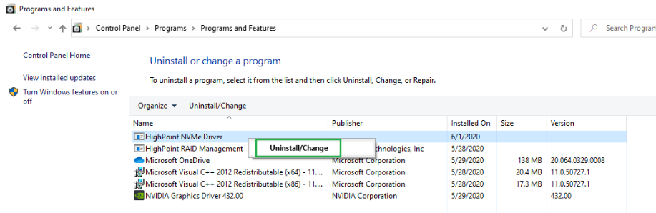

- After uninstalling the driver, click OK to reboot.
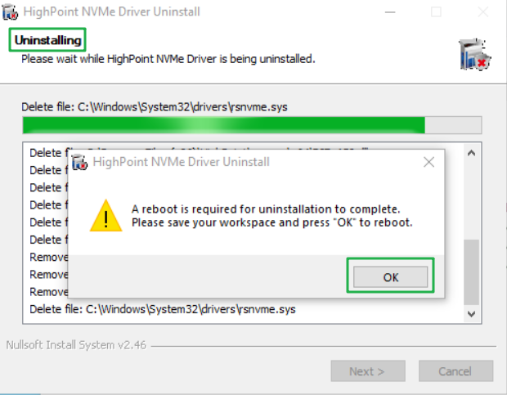
- After Windows has rebooted, access Control Panel to make sure the driver has been uninstalled. If there are no HighPoint NVMe RAID/Driver entries present, the driver has been successfully uninstalled:

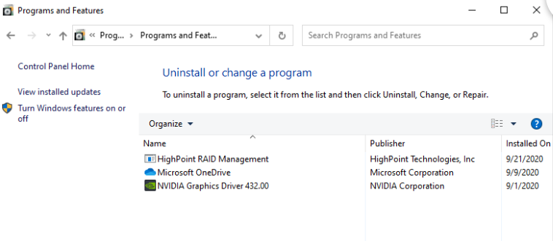

Install the new Device Driver
- Locate the driver download and open the file.
- Double-click setup.
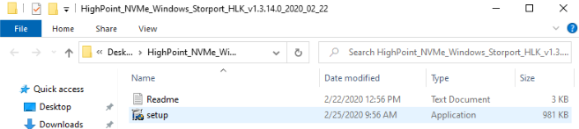

Note: If the update does not start, you may have to manually start setup using Administrator Privileges. Right-click setup, select Run as Administrator from the menu, and confirm the pop-up window to proceed.
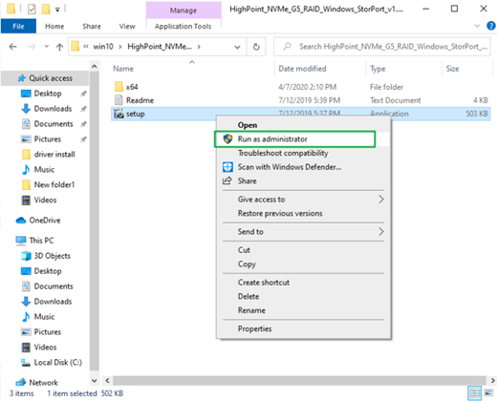

- Windows will notify you that the driver is already installed. Click OK to reboot.
- After entering the system, shut down the system. In the shutdown state, connect the SSD7000 controller to the motherboard.
- Boot into the system.
- Once Windows has rebooted, open Device Manager to check the status of the driver. Expand Storage controllers and click on the HighPoint NVMe RAID Controller entry. View the properties and click the Driver tab:

Example screenshot (SSD7101A-1)

- First, make sure the WebGUI has been installed (see page 17). Open the WebGUI and make sure the SSD.’s / arrays are properly recognized.

Uninstalling the Device Driver

- Power down the system and remove the SSD7101A-1/SSD7204/SSD7104/SSD7120/SSD6540/
SSD6540M/SSD7180/SSD7184/SSD7140 RAID controller from the motherboard.
Note: Failing to remove the SSD7000 controller from the motherboard during the uninstall process may result in data loss. Whenever the driver is uninstalled, Windows will attempt to install the default NVMe support, which may corrupt the RAID configurations and any data stored on SSD’s hosted by the SSD7000 controller.
- Power on the system and boot Windows.
- Access Control Panel and select Programs Programs and Features, and click on the HighPoint NVMe Driver entry.
- Click Uninstall/Change
- After uninstalling the driver, click OK to reboot.

- After Windows has rebooted, access Control Panel to make sure the driver has been uninstalled. If there are no HighPoint NVMe RAID/Driver entries present, the driver has been successfully uninstalled

Installing the HighPoint RAID Management Software (WebGUI & CLI)

The HighPoint RAID Management Software (WebGUI and CLI utilities) are used to configure and monitor NVMe SSD’s hosted by the SSD7101A-1/SSD7204/SSD7104/SSD7120/SSD6540/SSD6540M
SSD7180/SSD7184/SSD7140 RAID controller. Download the latest software package from the HighPoint website:
SSD7101A-1:
https://highpoint-tech.com/USA_new/series-ssd7101a-1-download.htm
SSD7104：
https://highpoint-tech.com/USA_new/series-ssd7104-download.htm
SSD7204:
https://highpoint-tech.com/USA_new/series-ssd7204-download.htm
SSD7120:
https://highpoint-tech.com/USA_new/series-ssd7120-download.htm
SSD6540:
https://highpoint-tech.com/USA_new/series-ssd6540-download.htm
SSD6540M:
https://highpoint-tech.com/USA_new/series-ssd6540m-download.htm
SSD7180:
https://highpoint-tech.com/USA_new/series-hpc-download.htm
SSD7184:
https://highpoint-tech.com/USA_new/series-hpc-download.htm
SSD7140：
https://highpoint-tech.com/USA_new/series-ssd7140-download.htm

- Extract the package and double-click the HighPoint RAID Management program to install the software.
- Once installed, locate the Management icon on the desktop and double-click to start the WebGUI interface.

Example screenshot (SSD7101A-1)

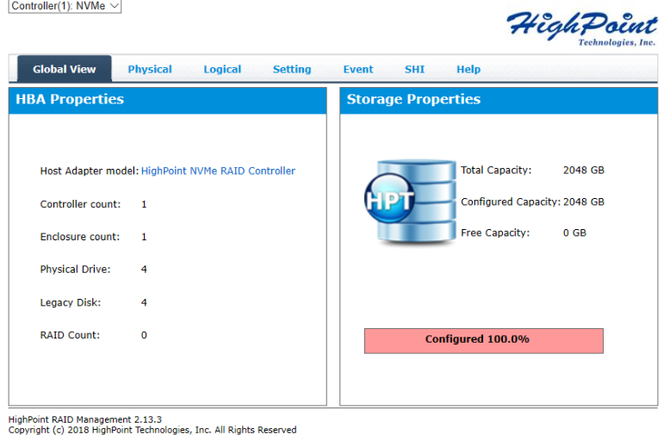

Troubleshooting
Note: When troubleshooting your SSD7101A-1/SSD7204/SSD7104/SSD7120/SSD6540/
SSD6540M/SSD7180/SSD7184/SSD7140 NVMe RAID controller, make sure all of the Prerequisites have been met before proceeding.

The WebGUI will not start after double-clicking the desktop icon.
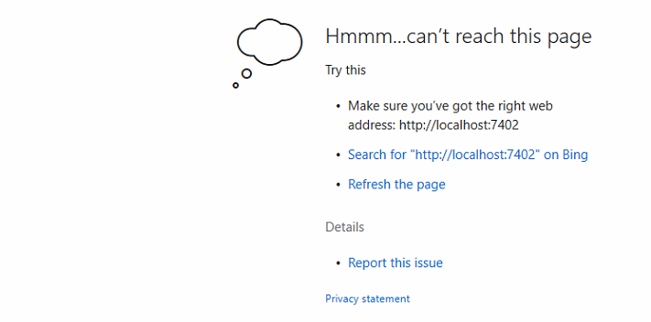
- This is often the result of a missing driver or improperly installed driver. Open Device Manager and check under Storage Controllers.
If the Driver is properly installed, you should see a HighPoint NVMe Controller entry for SSD7101A-1/SSD7204/SSD7104/SSD7120/SSD6540/SSD6540M/SSD7180/SSD7184/
SSD7140 controller, followed by HighPoint NVMe RAID Controller entry:

Example screenshot (SSD7101A-1)

- You should also check to make sure hptsvr is running under Task Management → Services. If the status of hptsvr process is Stopped, right-click on this entry and select Start from the menu:
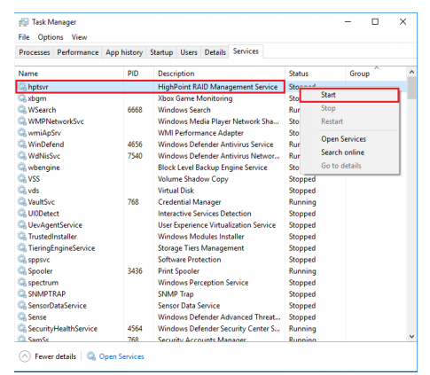

BSOD (Blue Screen of Death)
There are three scenarios in which a BSOD may occur with
SSD7101A-1/SSD7204/SSD7104/SSD7120/SSD6540/SSD6540M/SSD7180/SSD7184/SSD7140:
- Windows displays a BSOD when the SSD7101A-1/SSD7204/SSD7104/SSD7120/SSD6540
/SSD6540M/SSD7180/SSD7184/SSD7140 is installed.
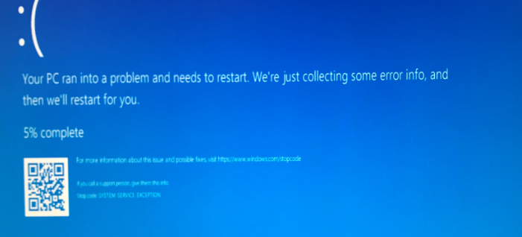
If you are running Windows 10, please make sure that any Quick Shutdown options are disabled – these features can cause a BSOD when the SSD7101A-1 /SSD7204 /SSD7104 / SSD7120 /SSD6540 /SSD6540M /SSD7180 /SSD7184 /SSD7140 is installed into or removed from your motherboard. BSODs can be avoided by completely powering off your system.

How to Turn off Quick Shutdown for Windows
- Use administrator privileges to access the Command Prompt utility:
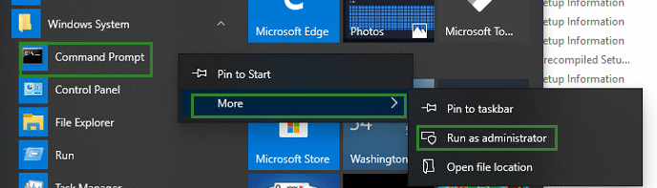
- Enter the following command and press Enter:
powercfg / h off
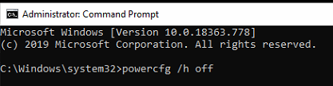
- To make sure the setting has been disabled, enter the following command and press Enter:
powercfg / a
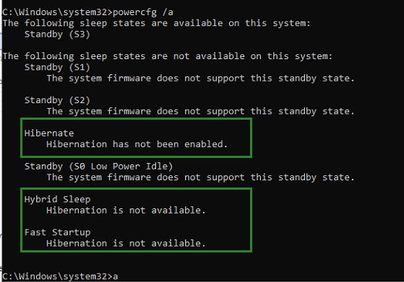
- Shut down the computer and remove the SSD7101A-1 /SSD7204 /SSD7104 /SSD7120 /SSD6540 /SSD6540M/SSD7180/SSD7184/SSD7140 from the motherboard;
- Restart the system and open the SSD7101A-1/SSD7204 /SSD7104 /SSD7120 /SSD6540 /SSD6540M/SSD7180/SSD7184/SSD7140 driver download.
- Double-click Setup to reinstall the driver; if you are prompted to uninstall the driver, you will need to follow the prompts and restart. After rebooting, double-click Setup once more to install the driver.
- After the driver installation is complete, shut down the computer. Connect the NVMe SSD’s to the SSD7101A-1/SSD7204/SSD7120/SSD6540/SSD6540M/SSD7180/
SSD7184 /SSD7140 and insert it into the motherboard PCIe slot.
- Power on the system, boot Windows and access the WebGUI; if the WebGUI can't connect, you need to restart again.
- If it fails to start the second time, please access our Online Support portal and submit a support ticket.
Note: If you are running a Server version of windows, and encounter a BSOD at bootup, please collect the following information: Windows version & build numbers, Memory Dump and System event Log

- A BSOD is encountered when installing the driver:
If you experience a BSOD during driver installation, please collect the following information: Memory Dump, INF log, Debug Log, System Event log, and submit a new support ticket via our Online Support Portal.

- If Windows reports that driver installation has failed:
- Please collect these debugging information: INF log, Debug Log, Device Manager/Storage Controller screen shot, System Event log
Note: If you experience a BSOD or error when installing the driver, please ensure that any Quick Shutdown options are not enabled – Quick shutdown can cause a BSOD when removing the SSD7101A-1/SSD7204/SSD7120/SSD6540/SSD6540M/SSD7180/SSD7184/SSD7140 from your motherboard, and plugging it back in. BSODs can be avoided by completely powering off your system:

Controller and Drive Detection Issues
- If your motherboard or Windows is unable to detect the
SSD7101A-1/SSD7204/SSD7104/SSD7120/SSD6540/SSD6540M/SSD7180/SSD7184 /SSD7140 RAID controller or NVMe SSD’s, please shutdown the system and try moving the
SSD7101A-1/SSD7204/SSD7104/SSD7120/SSD6540/SSD6540M/SSD7180/SSD7184/SSD7140 to another PCIe slot.
- Make sure any unrelated NVMe devices are removed from the motherboard while troubleshooting the SSD7101A-1/SSD7204/SSD7104/SSD7120/SSD6540/SSD6540M
/SSD7180/SSD7184/SSD7140 controller.

Appendix

How to Collect Debug View Logs
If other troubleshooting steps fail to solve the problem, we suspect that the driver and management software cannot establish a connection with the
SSD7101A-1/SSD7204/SSD7104/SSD7120/SSD6540/SSD6540M/SSD7180/SSD7184/SSD7140 controller. We will provide you with a Debug version of the driver to collect information about the problem you are experiencing.
To install the Debug driver, follow the standard driver installation procedure (please refer to the SSD7101A-1/SSD7204/SSD7104/SSD7120/SSD6540/SSD6540M/SSD7180/SSD7184/SSD7140 RAID controller User Guide). After installing the driver, follow the steps below:
- Download the DebugView utility from https://download.sysinternals.com/files/DebugView.zip.
- Unzip, right-click on the icon, and run DebugView with administrator privileges. Select Capture Win32, Capture Kernel, Enable Verbose Kernel Output, and Pass in the Capture toolbar.
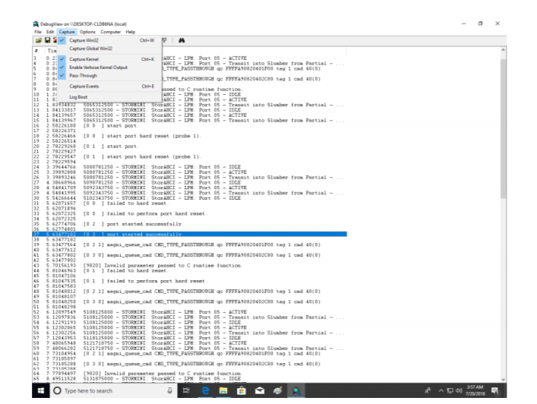
- If the utility displays an “access denied” message, rename the following file: C:\Windows\System32\drivers\Dbgv.sys For example, rename it to “Dbgv.sys1”, i.e change the file type.
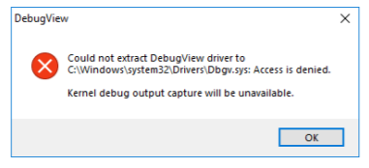

- Save the information printed by DebugView and send this to our support department.
- If required, we will provide management software information collection tools for the NVMe RAID Manager interface.

How to Collect INF Logs:
- Go to drive C→ Windows→ INF, and locate the setuppapi.dev and setupapi.setup logs:
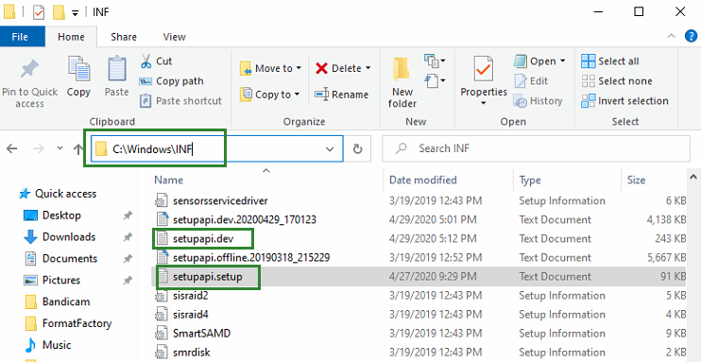
INF logs can be used to check what kind of software has been installed into the Windows systems.

- Please access Device Manager, Storage Controllers, and check the properties for the HighPoint entry. Click on Driver Details and take a screenshot – include this with the log files you submit for your support case.
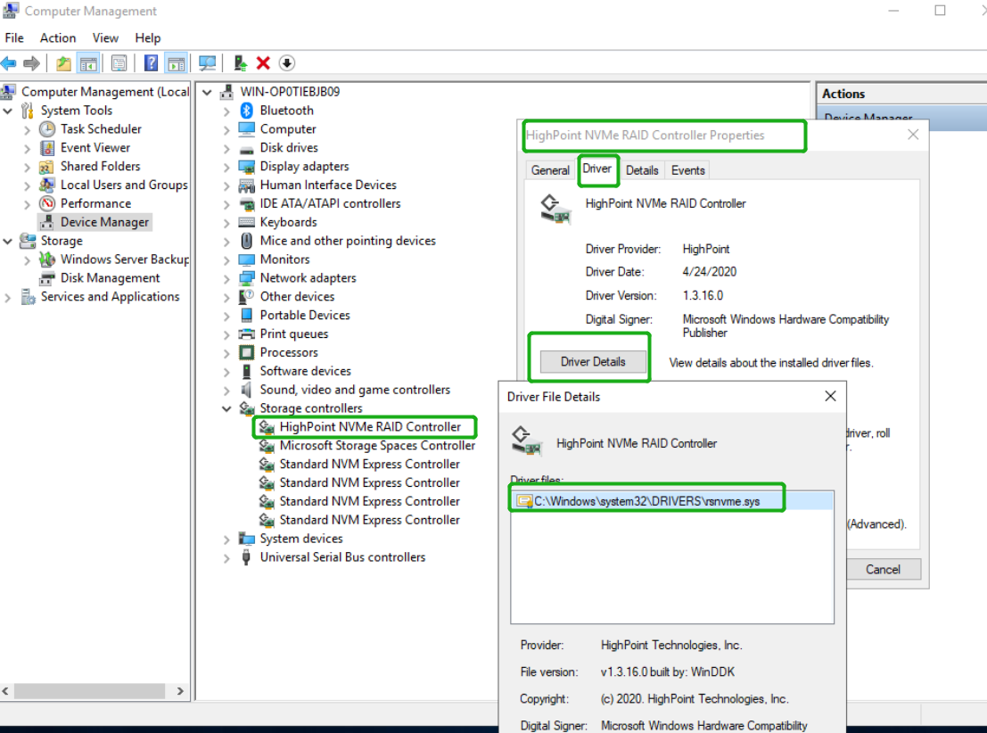
How to Collect System Logs:
In addition to DebugView logs, System Logs can aid our Support department diagnose and resolve the support issues you have submitted. The System Log typically records errors, device failures, and software or driver related incidents. This information can help our engineers narrow down or even identify the source of the problem you are experiencing.
System Log
- Click the Windows button towards the bottom left-hand corner of your desktop, and click on the Search field.
- Type Event Viewer and click the icon as shown below:
- Expand the Windows Log folder and select System:

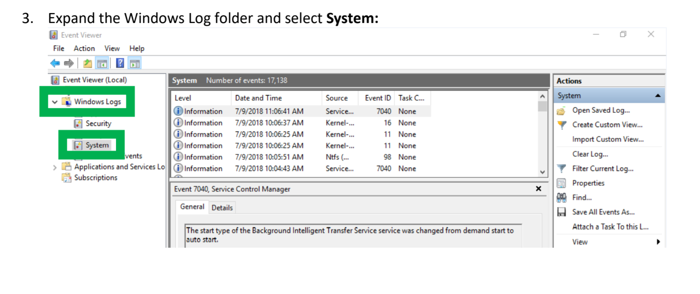
- Select Save All Events as… and save the .evtx file in an easy to find location.
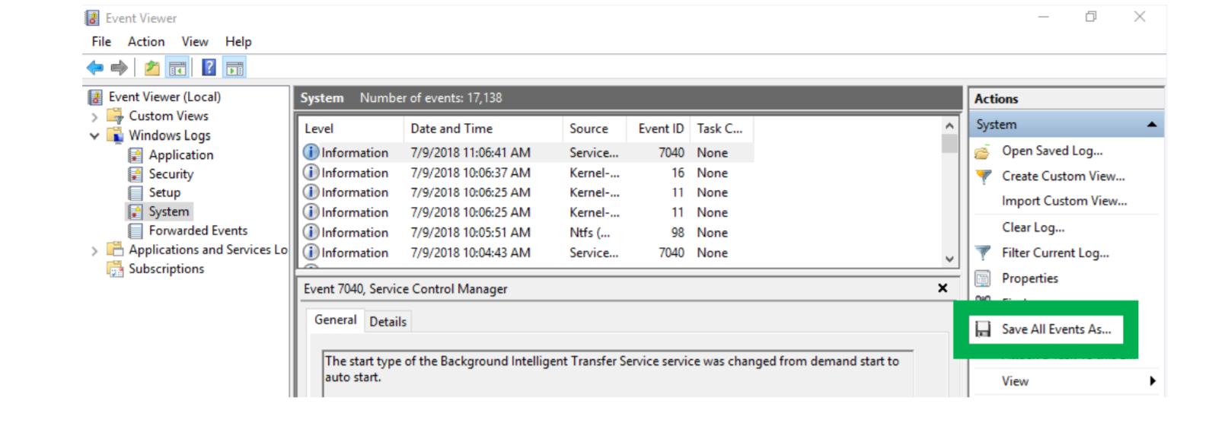
Collecting Windows Dump Files
Windows Dump files are snap shots that show which processes were running at the time of the event or failure. If possible, locate and upload the following files to your support case:
- Memory.dmp
- Minidump.dmp
To locate the dump files, check the C:\Windows directory and search for Memory.dmp and Minidump.dmp:
