SSD7000 Series NVMe RAID Solutions
macOS11.0 Installation Guide

V1.00– Nov, 2020

Contents

Overview 4
Prerequisites 5
1. Apple T2 security Chip-Disable Secure boot 6
Disabling Secure Boot 6
2. Installing the Device Driver 8
macOS Big Sur 11.0 Driver Installation Procedure 8
3. Updating the Device Driver 12
Updating the Device Driver (for macOS11.0) 12
4. Uninstalling the Device Driver 17
Uninstalling the Device Driver for macOS11.0 17
5. Installing the RAID Management Software (WebGUI) 17
Installing the WebGUI for macOS11.0 17
6. Updating the WebGUI for macOS11.0 19
7. Uninstalling the WebGUI for macOS11.0 19
8. Trouble shooting 20
Unable to connect to the WebGUI 20
This error can be triggered by one of the following issues: 20
1. The HighPoint NVMe hardware is not recognized by macOS 20
2. The HighPoint NVMe device driver is not installed or is not loading properly. 20
3. WEBGUI service is not running. 20
4. The system’s SIP status is incorrect. 20
5. If you are using a T2 system; Secure Boot may not be disabled 20
1. Verifying the HighPoint NVMe hardware 20
2. Make sure the HighPoint NVMe Driver is loaded 20
3. Check the SIP status 21
4. For T2 Systems: Make sure Secure Boot is disabled 21
The WebGUI can’t connect to a remote system 21
Appendix 22
Collecting the macOS version 22
Check the security & privacy 22
Verifying Product Installation 23
WEBGUI Screenshots 25
WEBGUI service restart 25
Checking the SIP Status 25
Systems with T2 chipsets – Secure Boot status 26
Checking the Driver status and Version 26
How to Collect System Logs 26

Overview

This guide includes important hardware/software requirements, installation & upgrade procedures, and troubleshooting tips for using SSD7000 NVMe RAID controllers, the RocketStor 6661A-NVMe Thunderbolt™ 3 NVMe RAID solution, and SSD6540/6540M RAID enclosures with a macOS operating system.

Prerequisites
This section describes the base hardware and software requirements for SSD7000 series NVMe RAID controllers & enclosures.

Driver Installation
This section covers driver installation, driver upgrade and driver uninstallation procedures for SSD7000 series NVMe RAID controllers & enclosures in a macOS environment.

Troubleshooting
Please consult this section if you encounter any difficulties installing or using SSD7000 series NVMe RAID controllers or enclosures. It includes descriptions and solutions for commonly reported technical issues.

Appendix
This section describes how to collect trouble shooting information for support cases you have submitted via our Online Support Portal.

Prerequisites
- Make sure at least one NVMe SSD’s has been installed into the HighPoint NVMe controller or enclosure. The driver will not install properly unless NVMe SSD’s are detected by the hardware environment.
- The SSD7101A-1/7120/6540/6540M/7103/7104/7140/7505/7540 NVMe device must installed into a PCIe 3.0 slot with x16 dedicated lanes. The SSD7204 can be installed into a PCIe 3.0 x8 or x16 slot.
If you are using the RocketStor 6661A-NVMe or a SSD7000 NVMe RAID controller via the RocketStor 6661A adapter, the RocketStor unit must be plugged into a Thunderbolt™ 3 port.
- Operating System Support: macOS 11.0
- Before installing the driver and RAID Management software, you should log into the system as a System Administrator.
- Identify the system as either T2 or Non-T2 based – if the system has a T2 chip, make sure to follow section 3 before attempting to install any software for the HighPoint NVMe device.

Apple T2 security Chip-Disable Secure boot
Secure Boot must be disabled on the following products:
Learn more About the Apple T2 Security Chip：https://support.apple.com/en-us/HT208862
- iMac Pro
- Mac Pro introduced in 2019
- Mac mini introduced in 2018
- MacBook Air introduced in 2018 or later
- MacBook Pro introduced in 2018 or later
You can also use System Information to learn whether your Mac has this chip:
- Press and hold the Option key while choosing Apple menu > System Information.
- In the sidebar, select either Controller or iBridge, depending on the version of macOS in use.
- If you see "Apple T2 chip" on the right, your Mac has the Apple T2 Security Chip.
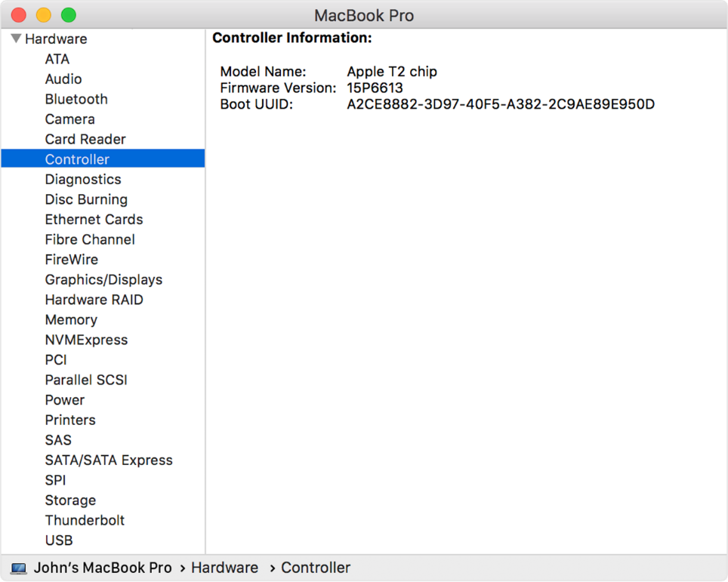

Disabling Secure Boot
- Restart the computer and then press the Command + R keys simultaneously. Keep holding the keys down until the Apple Logo appears.
- When the menu bar says: “macOS Utilities”, you have booted into Recovery mode. Launch the Startup Security Utility application by selecting it from the Utilities menu.
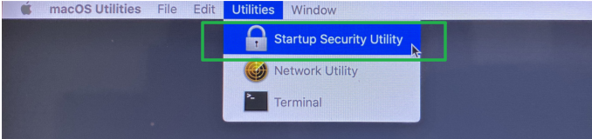

- A dialog box will appear, telling you that you will need to authenticate as an Administrator to make changes, click the Enter macOS Password… button.
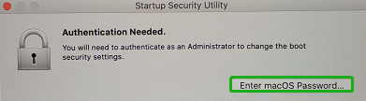
- When the Startup Security Utility window appears, select No Security under the Secure Boot options.
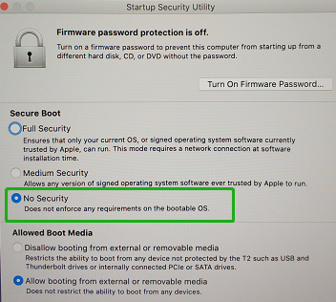
- Select Restart from the Apple menu to restart your Mac, and wait for your normal Desktop to appear.

Installing the Device Driver
Current drivers can be downloaded from each product’s Software Downloads webpage.
Product | Download Page
SSD7101A-1 | https://www.highpoint-tech.com/USA_new/series-ssd7101a-1-download.htm
SSD7120 | https://highpoint-tech.com/USA_new/series-ssd7120-download.htm
SSD7204 | https://highpoint-tech.com/USA_new/series-ssd7204-download.htm
SSD7104 | https://highpoint-tech.com/USA_new/series-ssd7104-download.htm
SSD6540M | https://highpoint-tech.com/USA_new/series-ssd6540m-download.htm
SSD6540 | https://highpoint-tech.com/USA_new/series-ssd6540-download.htm
SSD7103 | https://highpoint-tech.com/USA_new/series-ssd7103-download.htm
SSD7140 | https://highpoint-tech.com/USA_new/series-ssd7140-download.htm
RS6661A-NVMe | https://highpoint-tech.com/USA_new/series-rs6661a-nvme-download.htm
SSD7505 | https://highpoint-tech.com/USA_new/series-ssd7500-download.htm
SSD7540 | https://highpoint-tech.com/USA_new/series-ssd7500-download.htm

macOS Big Sur 11.0 Driver Installation Procedure
- Locate the download and double click the HighPointNVMe.pkg package to start the installer. Click the Continue button:
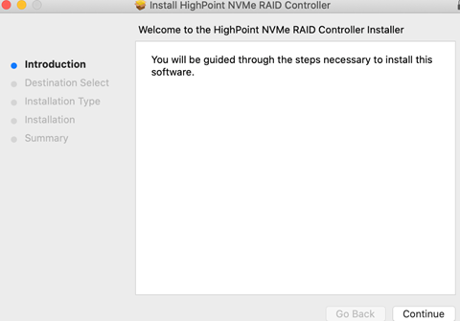
- macOS will prompt you to install the driver. Click Install to proceed.
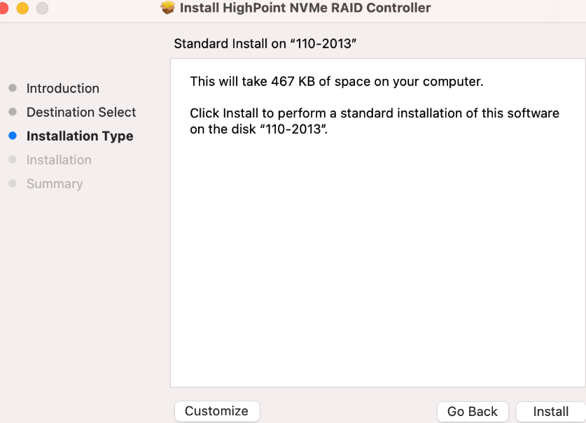
- You will be prompted that installer is trying to install new software, enter the Administrator Username and Password. Once these have been entered, Click Install Software.
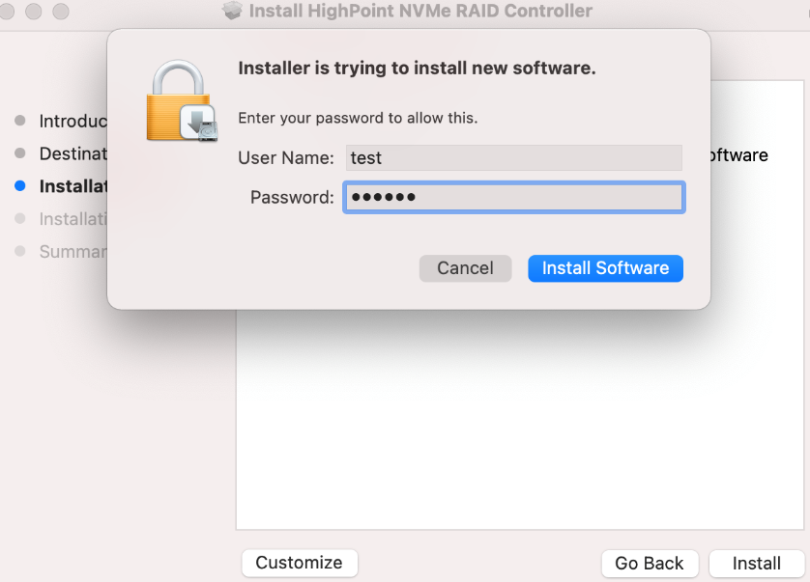
- If no pop-ups appear, please proceed to the next step of installation. Click Restart.
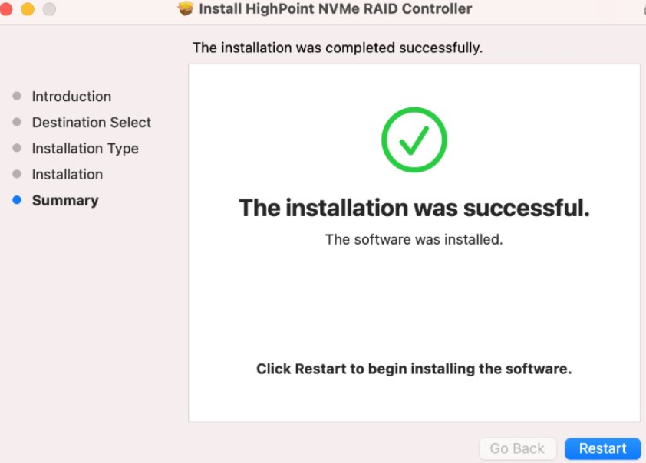
- If you receive a popup window prompting you for permission, click Open Security Preferences.
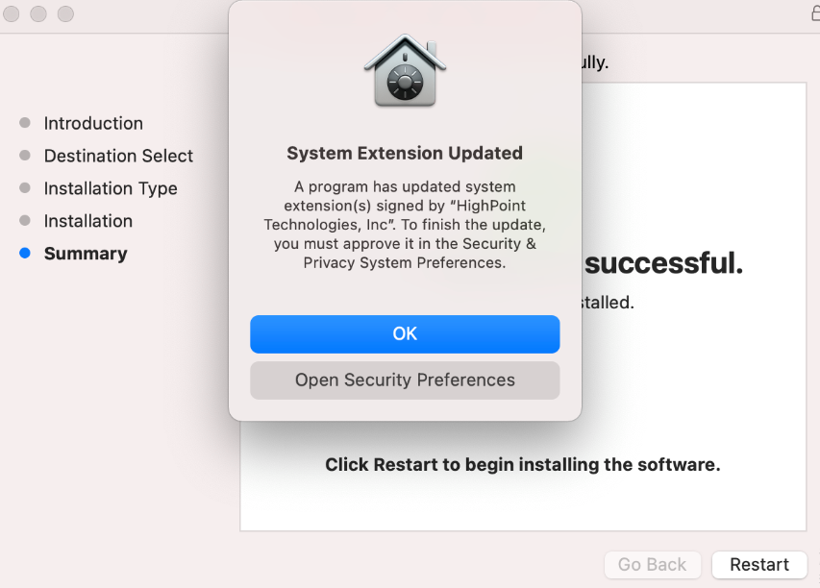
- Make sure App Store and identified developers is checked, and then click Allow.
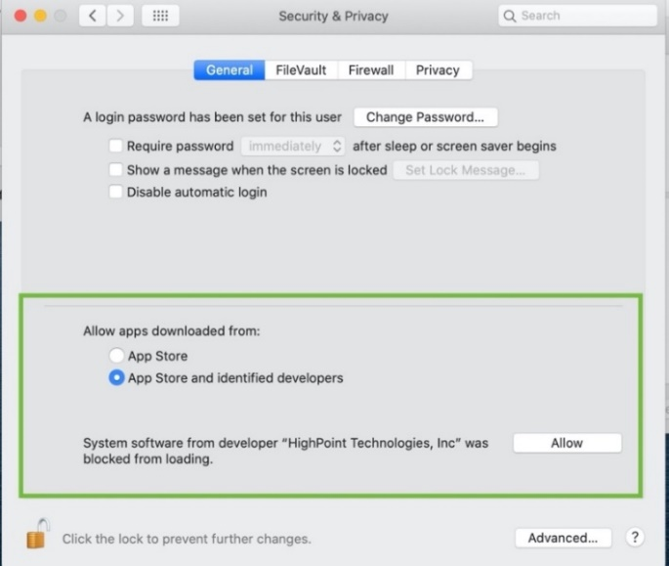
- You will receive a popup window, prompting you to restart. Click Not Now.
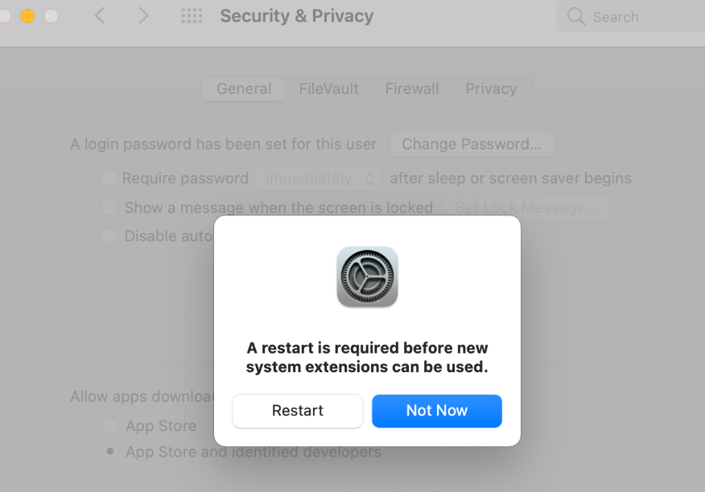
- If you receive the permission prompt for the second time, click "Open Security Preferences" again.
- Make sure App Store and identified developers is checked, and then click Allow.
- You will receive a popup window, prompting you to restart. Click Not Now.
- Return to the driver installation window. Click Restart to restart the system.
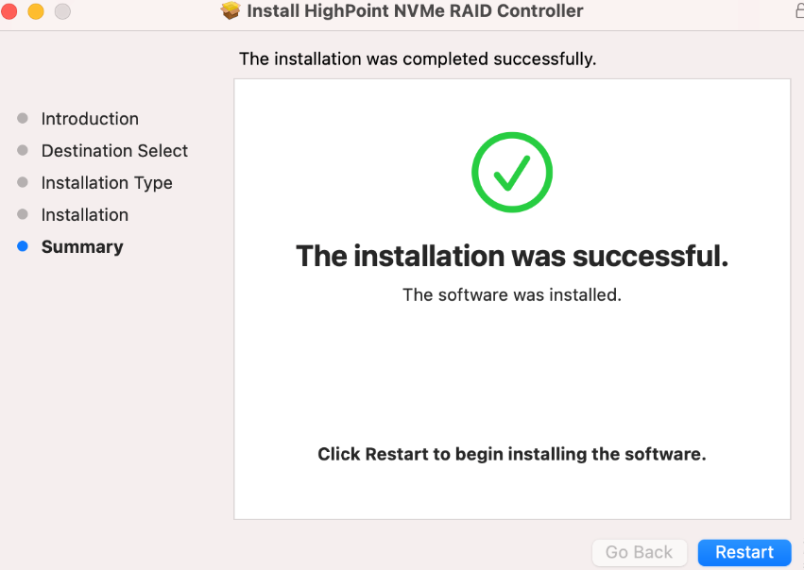
- After the system restarts, the driver’s status can be viewed under System Information→Extensions; The following screenshot shows the HighPointNVMe driver has been loaded:
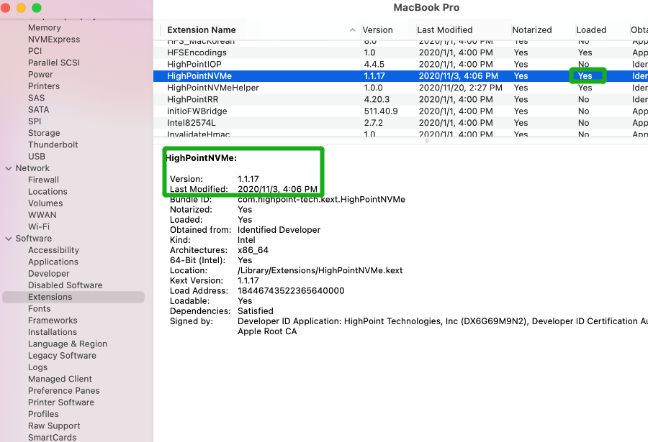

Updating the Device Driver
Note：Update the driver, please make sure the RAID controller is connected to the host.
Current drivers can be downloaded from each product’s Software Downloads webpage.
Product | Download Page
SSD7101A-1 | https://www.highpoint-tech.com/USA_new/series-ssd7101a-1-download.htm
SSD7120 | https://highpoint-tech.com/USA_new/series-ssd7120-download.htm
SSD7204 | https://highpoint-tech.com/USA_new/series-ssd7204-download.htm
SSD7104 | https://highpoint-tech.com/USA_new/series-ssd7104-download.htm
SSD6540M | https://highpoint-tech.com/USA_new/series-ssd6540m-download.htm
SSD6540 | https://highpoint-tech.com/USA_new/series-ssd6540-download.htm
SSD7103 | https://highpoint-tech.com/USA_new/series-ssd7103-download.htm
SSD7140 | https://highpoint-tech.com/USA_new/series-ssd7140-download.htm
RS6661A-NVMe | https://highpoint-tech.com/USA_new/series-rs6661a-nvme-download.htm
SSD7505 | https://highpoint-tech.com/USA_new/series-ssd7500-download.htm
SSD7540 | https://highpoint-tech.com/USA_new/series-ssd7500-download.htm

Updating the Device Driver (for macOS11.0)

- Locate the download and double click the HighPointNVMe.pkg package to start the installer. Click the Continue button:
- macOS will prompt you to install the driver. Click Install to proceed.
- You will be prompted that installer is trying to install new software, enter the Administrator Username and Password. Once these have been entered, Click Install Software.
- If no pop-ups appear, please proceed to the next step of installation. Click Restart.
- If you receive a popup window prompting you for permission, click Open Security Preferences.
- Make sure App Store and identified developers is checked, and then click Allow.
- You will receive a popup window, prompting you to restart. Click Not Now.
- If you receive the permission prompt for the second time, click "Open Security Preferences" again.
- Make sure App Store and identified developers is checked, and then click Allow.
- You will receive a popup window, prompting you to restart. Click Not Now.
- Return to the driver installation window. Click Restart to restart the system.
- After the system restarts, the driver’s status can be viewed under System Information→Extensions; The following screenshot shows the HighPointNVMe driver has been loaded:

Uninstalling the Device Driver

Uninstalling the Device Driver for macOS11.0
To uninstall the NVMe driver, you will need to open a Terminal window and enter the following command:
sudo rm -rf /Library/Extensions/HighPointNVMeHelper.kext
sudo rm -rf /Library/Extensions/HighPointNVMe.kext
sudo kextcache –i /
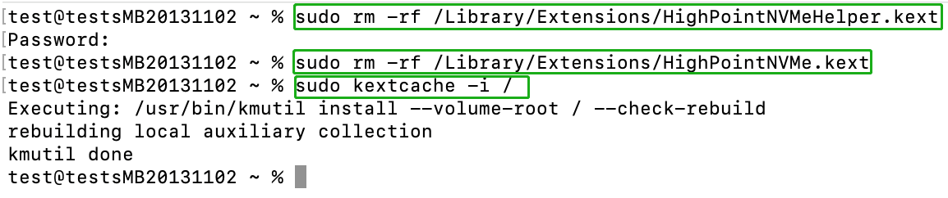

Installing the RAID Management Software (WebGUI)

Installing the WebGUI for macOS11.0
- Double click the package named HighPointWebGUI.pkg to start the installer. When the window appears, click the Continue button.
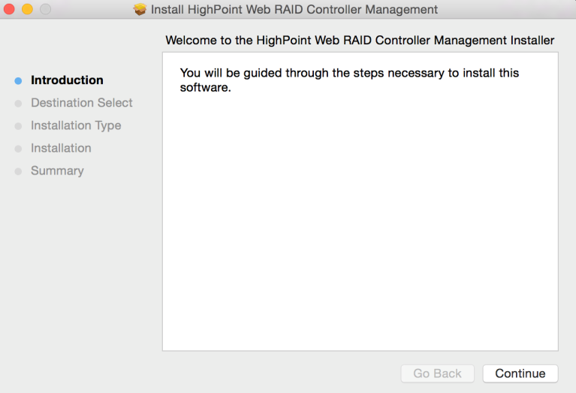
- You will be promoted to click the Install button. Click Install to continue.

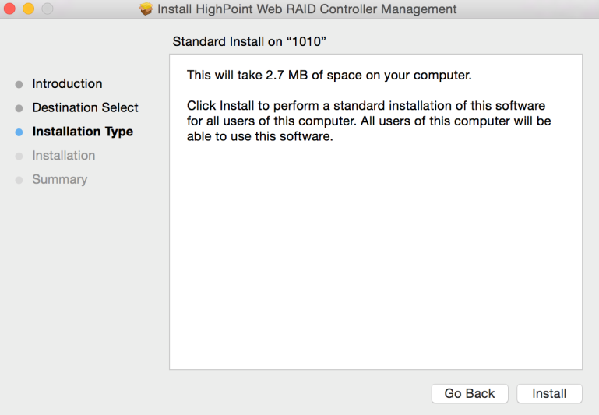
- You will then be promoted to enter the Administrator Username and Password. Once these have been entered, click Install Software to continue.
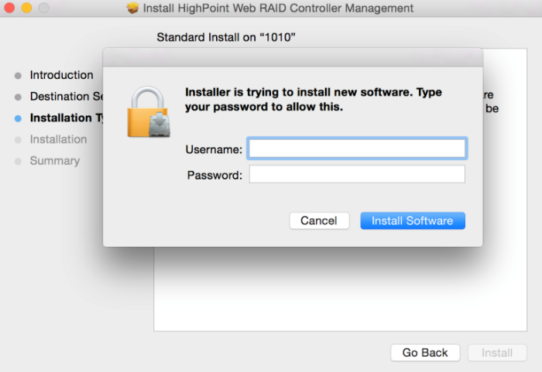

- The WebGUI Management software has been installed. Click Close to complete the procedure.
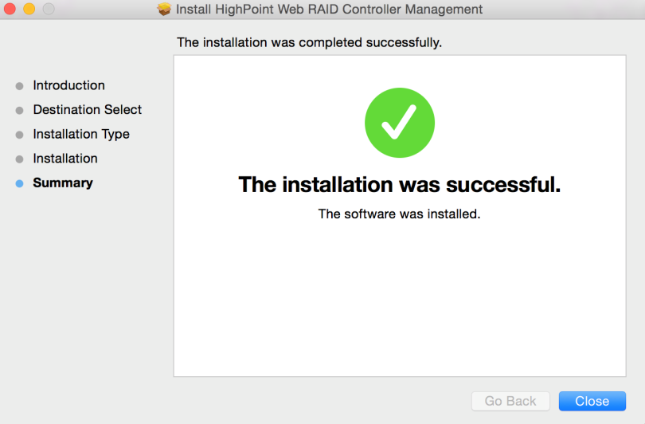

Updating the WebGUI for macOS11.0
- First, uninstall the current WebGUI. Please refer to item 7 below (Uninstalling the WebGUI).
- Once the system has rebooted, download the latest version of the WebGUI from the appropriate Software Downloads webpage.
- Locate the download and double click the package named HighPointWebGUI.pkg to start the installer. Please refer to Installing the WebGUI for macOS11.0 for more information.

Uninstalling the WebGUI for macOS11.0
To uninstall the WebGUI, access Applications, click on HPTWEBGUI, select uninstall, and double-click the uninstall-WebGUI.command. The uninstall command will automatically open a terminal and uninstall the software:
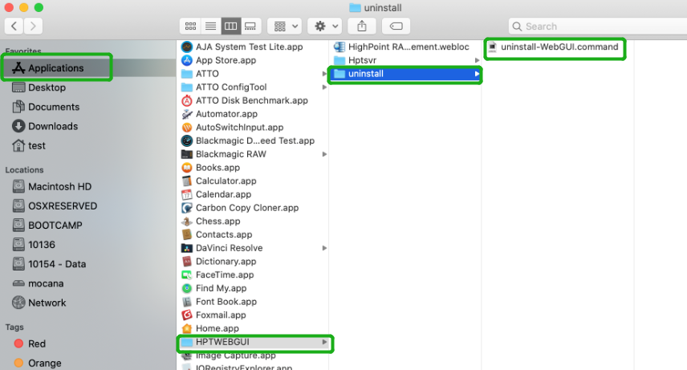
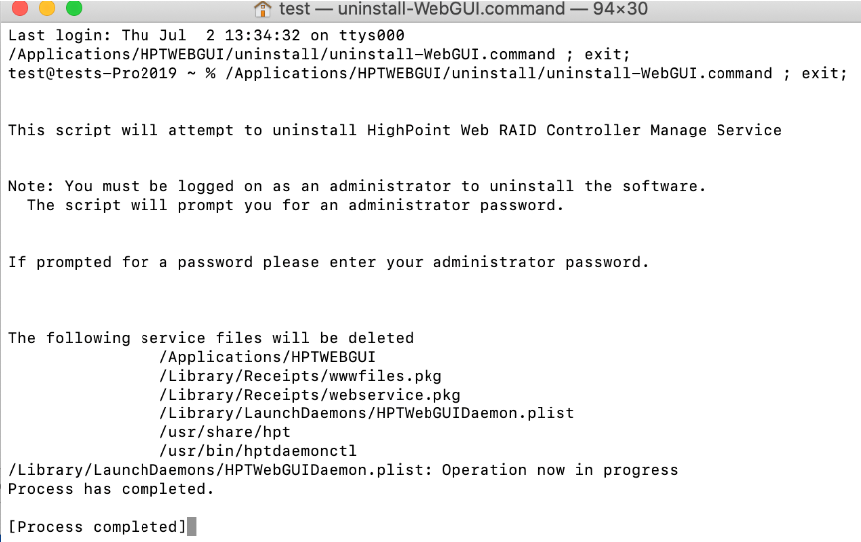

Trouble shooting

Unable to connect to the WebGUI
After the driver and management software are installed, the management software displays a "Connection Failure" warning when attempting to start the interface: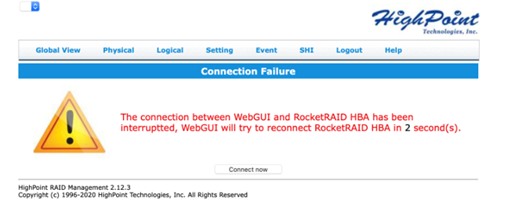
This error can be triggered by one of the following issues:
- The HighPoint NVMe hardware is not recognized by macOS
- The HighPoint NVMe device driver is not installed or is not loading properly.
- WEBGUI service is not running.
- The system’s SIP status is incorrect.
- If you are using a T2 system; Secure Boot may not be disabled

Verifying the HighPoint NVMe hardware
Please refer to the Appendix – Verifying Product Installation to make sure the HighPoint NVMe device is properly recognized by macOS.
Note: If you are using the RocketStor 6661A-NVMe:
- If you are using the RocketStor 6661A-NVMe (RS6661A-NVMe), or another SSD7000 series controller via our RocketStor 6661A adapter and a Thunderbolt™ 3 connection, refer to the third screenshot displayed under - Appendix – Verifying Product Installation. If the RS6661A entry is present, proceed to screenshot #2.
- If the RocketStor 6661A entry is not displayed, this may be related to a connection problem – move the RS6661A to another Thunderbolt™ 3 port or replace the cable and recheck the entry.

Make sure the HighPoint NVMe Driver is loaded
Please refer to the Appendix - Checking the Driver status and Version to make sure the HighPoint NVMe driver is installed properly.
- If the HighPoint NVMe driver is not loading, proceed to step 2 – Check the security & privacy status. If HighPoint software is blocked in the permission, you need to click Allow.
- If the driver is loading properly, but the WebGUI is still unable to start, please try to restart the WEBGUI service. Please refer to Appendix - WEBGUI service restart make settings.
If WEBGUI is still not connected, please contact our Support Department to open a support ticket. Please make sure to include any screenshots and system information you are able to collect (see the Appendix for more information).

Check the SIP status
- Please refer to the Appendix - Checking the SIP Status .
- If the settings are not correct for your system, please refer to the driver installation manual for each system to reset the SIP status.

For T2 Systems: Make sure Secure Boot is disabled
- Please refer to the Appendix – Systems with T2 chipsets – Secure Boot status . If the setting is incorrect, you will need to reboot the system to change the setting.
If you encounter any problems while checking items 1-5, please refer to the Appendix to collect information about your system and configuration, and submit a support ticket to our Customer Support department using our Online Support Portal: https://www.highpoint-tech.com/websupport/main.php

The WebGUI can’t connect to a remote system
If you can’t connect to a remote system, make sure raidman-httpsd is running on the target system, and confirm that you can access the remote system via a TCP/IP connection. If you have a firewall configured, make sure TCP port 7402 is not blocked.

Appendix
When submitting s support ticket via our Online Support Portal, the following information will help our Support Department diagnose and resolve your issue as quickly and efficiently as possible.

Collecting the macOS version
- Click on the Apple logo located near the upper left-hand portion of the Desktop, and click “Version
”. Then the version number of the system will all be displayed.
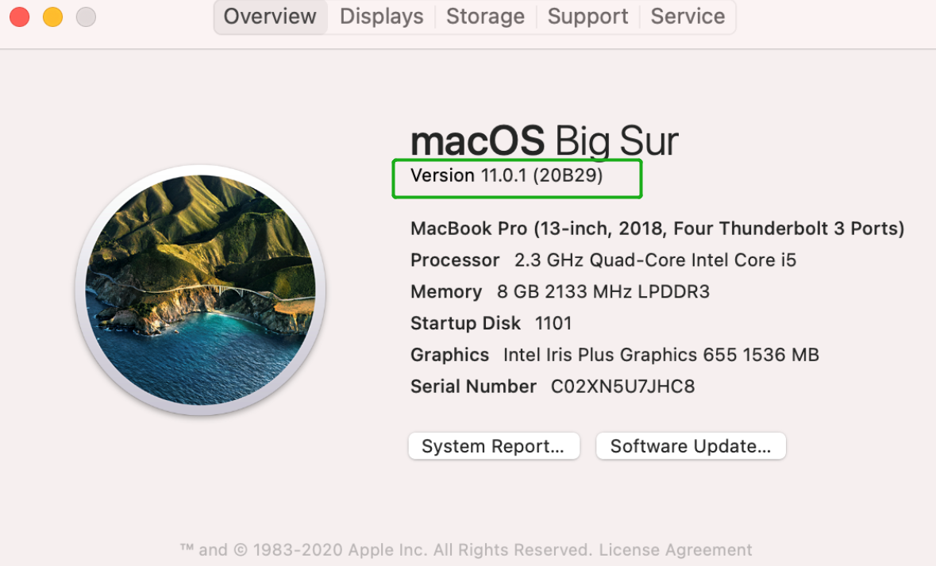

Check the security & privacy
- Check if there is HighPoint software blocked in the permission, if it is blocked, you need to click “Allow”.
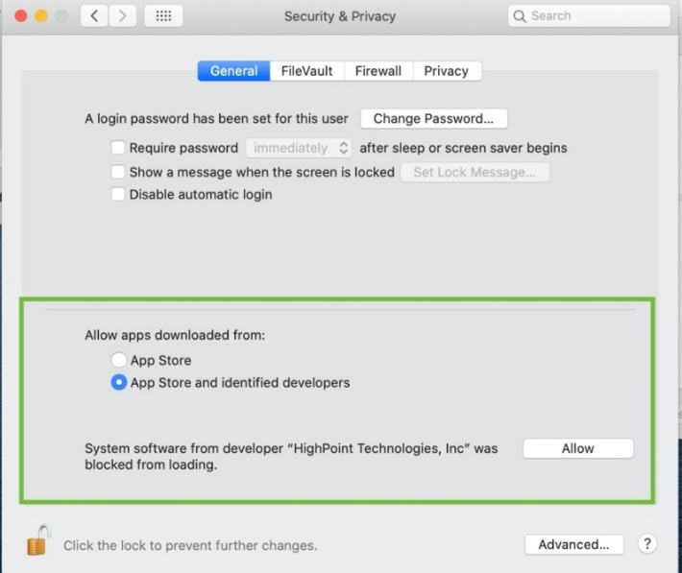

Verifying Product Installation
- Click on the Apple logo located near the upper left-hand portion of the Desktop, and select “About this Mac”.
RocketStor 6661A-NVMe (Thunderbolt entry):
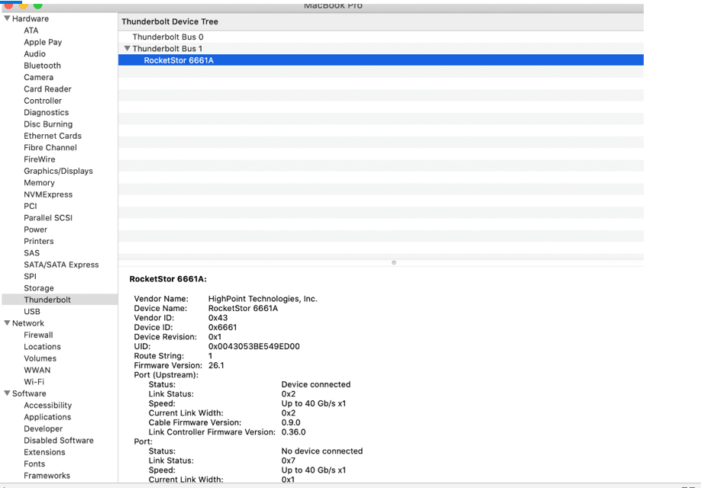
- If you are using a SSD7000 series NVMe RAID controller, check under Hardware, PCI. Reference screenshots for each product are show below.
SSD7101A / 7104 / 7204 / 7120 / 6540 / 6540M , or RS6661A-NVMe:
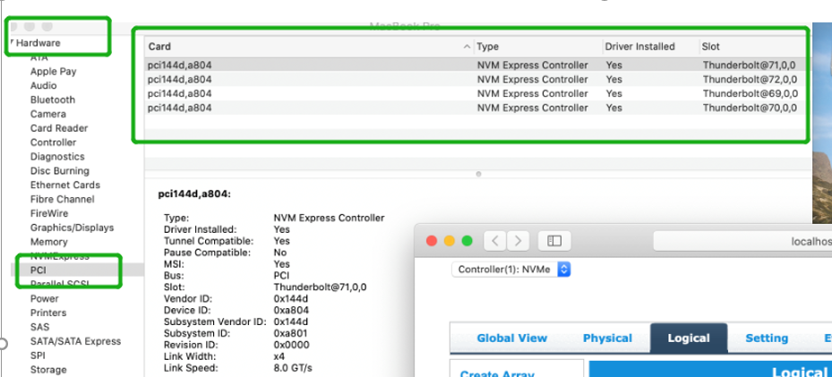

SSD7140:
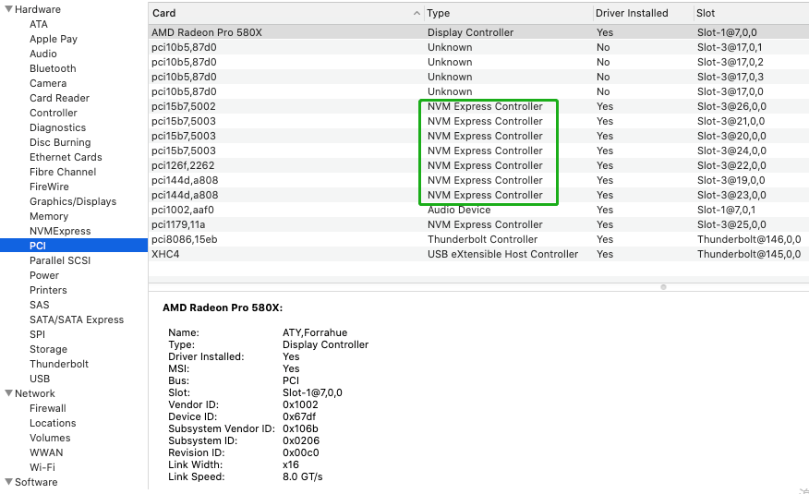
SSD7103:
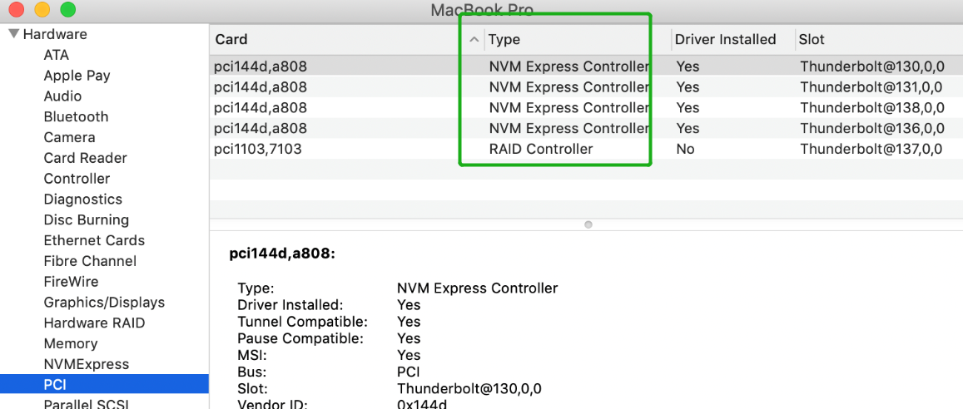

SSD7110:
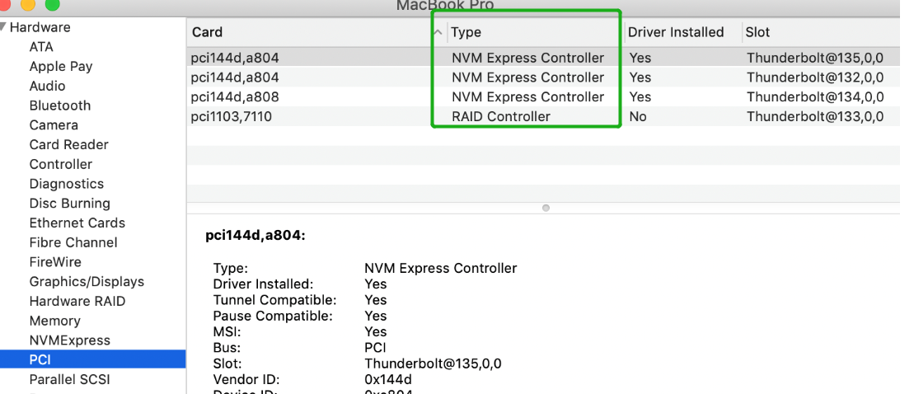

SSD7505：
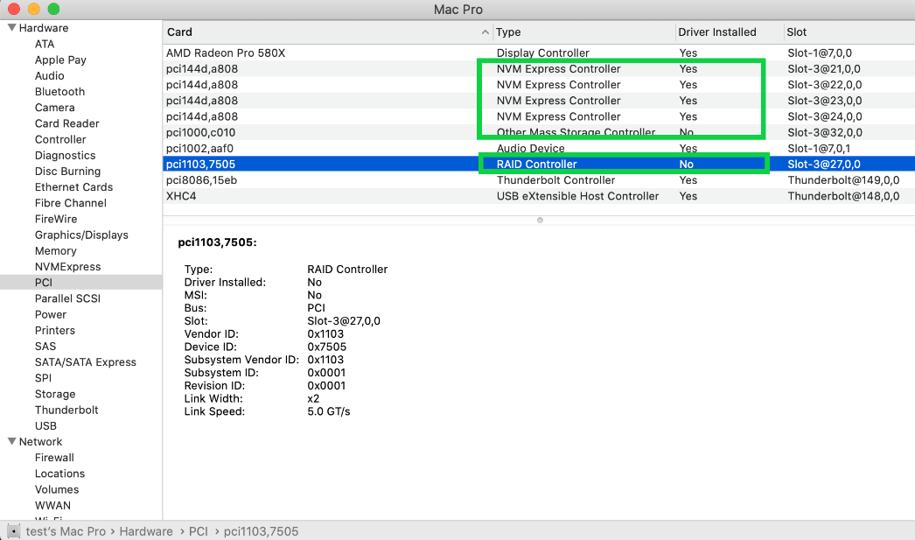
SSD7540
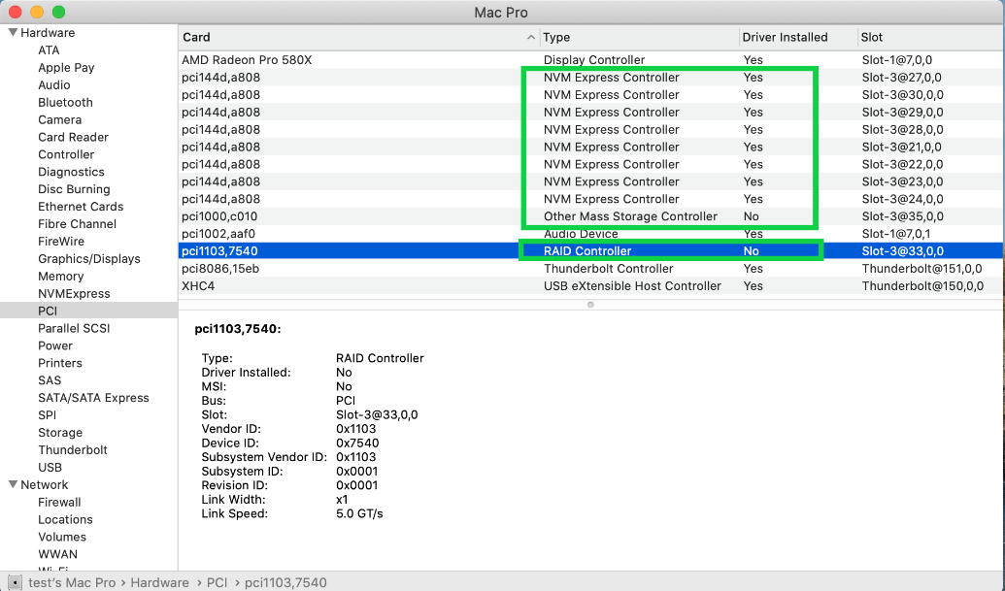

WEBGUI Screenshots
Please take screenshots of WEBGUI each Tab (such as Physical, Logical, Event, etc.) and upload these to your support case. In addition, check the Event log tab and save a copy of the current log – please upload this to the support case.

WEBGUI service restart
If you can’t connect to the WebGUI, please check if a process named raidman-httpsd is running on the system. If it is not running, you can start it manually by opening a terminal window and running the command: “sudo hptdaemonctl restart”.

Checking the SIP Status
Open a Terminal window and enter the following command:
csrutil status
Please take a screenshot of the output, and attach it to a support case (see example below):
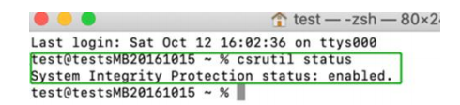
The status will vary depending on which version of macOS you are using:
MacOS Version | SIP Status | Driver Status
11.0.x | Enable | Loaded

Systems with T2 chipsets – Secure Boot status
You will need reboot the system and enter Recovery Mode to check the Secure Boot status. This setting should remain disabled.

Checking the Driver status and Version
- Click on the Apple logo located near the upper left-hand portion of the Desktop, and select “About this Mac”.
- Click on Extensions, and then click on HighPoint NVMe entry – please take a screenshot and attach it this support case (see the example below):
System InformationSoftwareExtensionsHighPointNVMe

How to Collect System Logs
- Please attach a copy of the /var/log folder to your support ticket.
To locate the /var/log Folder: 1. Go to Applications → Utilities → Console:
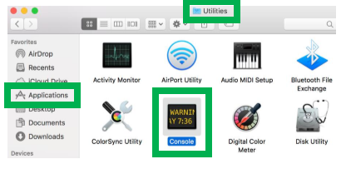

- On the left side of the Console application, right-click on the /var/log folder and select Reveal in Finder:
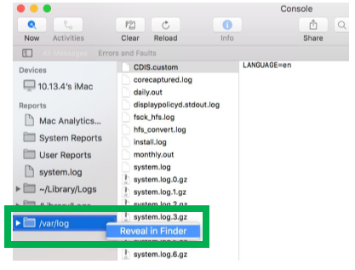

- You should then be automatically directed to the log folder in the var directory. Please remember when sending the folder to zip file, you should first direct it to a separate location (such as the desktop).
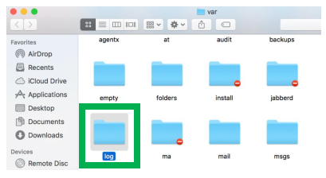
- In addition to /var/log Folder detailed above, please attach a copy of the errlog.txt file:
- Open terminal and type the following, then press Enter:
log show |grep kernel > hptsyslog.txt
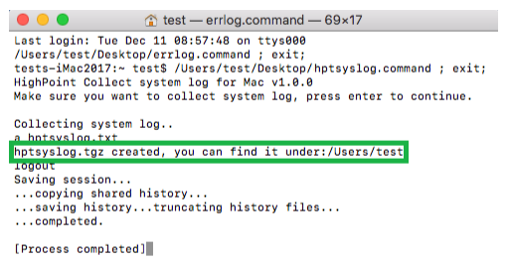
- Please attach the hptsyslog.txt to your support ticket.

