SSD7000 RAID Management Guide
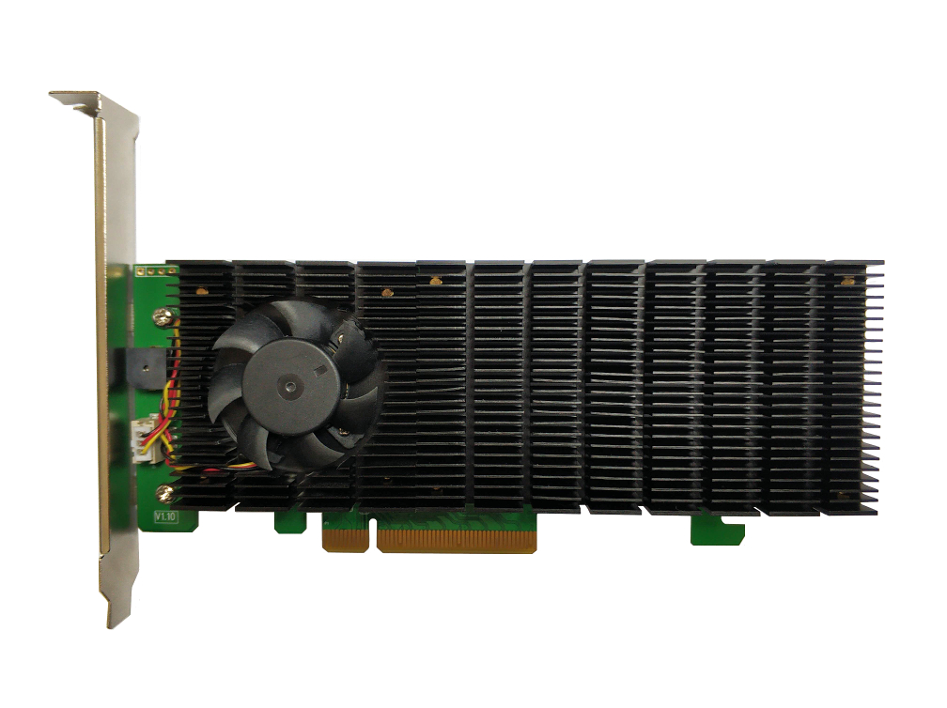

Version 1.04

Copyright © 2020 HighPoint Technologies, Inc.
All rights reserved

Table of Contents
SSD7000 RAID Management Guide 1
HighPoint RAID Management Software 4
Using the HighPoint RAID Management (WebGUI) Software 5
Starting the WebGUI 5
How to login WebGUI in Windows/Mac 5
How to login WebGUI in Linux 6
Verify the Controller Status 7
Creating an Array 9
Single controller to create an array 9
Using the Cross-Sync feature to create an array 11
Array Type 13
Adding Spare Disks 17
Obtaining Logical Device Information 18
Array Information &Maintenance Options: Normal Status 19
Array Information & Maintenance Options: Critical Status 20
Array Information & Maintenance Options: Disabled Status 21
Physical Device Information 22
System Setting 23
System Setting 24
Password Settings 25
Email Setting 25
Email Precautions 26
Event Tab 29
SHI (Storage Health Inspector) 29
How to Enable SMART Monitoring 30
How to Use the Health Inspector Scheduler 32
How to Create a New Verify Task 33
Using the HighPoint Command Line Interface (CLI) 34
How to use the CLI in Windows 34
How to use the CLI in a Linux system 34
CLI Command Reference 35
Query Commands 35
query controllers 35
query enclosures 36
query devices 38
query devices {device_id} 40
query arrays 41
query arrays {arrays_id} 42
Init Commands 42
init {device_id} 43
init {array_id} {start|stop} 43
Create Commands 44
Delete Command 46
Unplug Command 47
Rebuild Commands 48
rebuild {array_id} {device_id} 48
rebuild {array_id} {start|stop} 50
Verify Command 50
Rescan Command 50
Lscard Command 50
Events Commands 50
events 50
events clear 50
events save {file_name} 50
Mail Commands 50
mail recipient 50
mail recipient add {recipient_name} {mail_address} [Inf|War|Err] 50
mail recipient delete {recipient_name} 50
mail recipient test {recipient_name} 50
mail recipient set {recipient_name} {Inf|War|Err} 50
mail server 50
mail server set {server_address} {port} {ssl} {status} {from_address} [username] [password] 50
mail server set {a|p|s|m|u|t} {value} 50
Task Commands 50
task 50
task rebuild {array_id}{name=}{once|daily|weekly|monthly={day} interval={interval} start=mm/dd/yyyy end=mm/dd/yyyy time=hh:mm:ss 50
task verify 50
task delete {task_id} 50
task enable {task_id} 50
task disable {task_id} 50
Set Commands 50
set 50
Help Commands 50
help 50
help {command} 50
Exit Command 50
Clear Commands 50
Troubleshooting 50
Table 1. WebGUI Icon Guide 50
Table 2. RAID Level Reference Guide 50
HighPoint Recommended List of NVMe SSDs and Motherboards 50
Contacting Technical Support 50

HighPoint RAID Management Software

Your Choice – Graphical or Text-only interfaces
HighPoint understands that one size doesn’t fit all - when it comes to maintaining critical storage configurations, each customer has specific needs and preferences. We have developed both graphical and text-based management interfaces for the SSD7101A-1 / 7103 / 7120 / 7202 / 7204 / 7104 / 6540 / 6540M / 7184 / 7180 / 7505 / 7140 NVMe RAID Controllers. To simplify installation and upgrade procedures both interfaces are packaged into a single download, and are available for each operating system platform.

Both management interfaces share universal layouts across all major operating systems, and can be administered locally or remotely via an internet connection. – if you are comfortable with the Windows release, you will have no problem managing NVMe RAID configurations installed for a Linux distribution.

The Web RAID Management Interface (WebGUI), is a simple, and intuitive web-based management tool available for Windows and Linux operating systems. It is an ideal interface for customers unfamiliar with RAID technology. The Wizard-like Quick Configuration menu allows even the most novice user to get everything up and running with a few simple clicks. Experienced users can fine tune configurations for specific applications using the Advanced Options menu.

The CLI (command line interface) is a powerful, text-only management interface designed for advanced users and professional administrators. The universal command lines work with any platform, and are shared across our entire product line. Comprehensive user guides are available for the CLI, and are included with the most recent product updates available from the SSD7101A-1 / 7120 / 7103/ 7202 / 7204 / 6540 / 6540M / 7184 / 7104 / 7505 / 7140 Software Updates webpage.

Using the HighPoint RAID Management (WebGUI) Software
This guide provides an overview of the Web-RAID Management graphical user interface, also known as the WebGUI. The WebGUI is an intuitive, yet comprehensive management tool designed for users of any experience level.

Starting the WebGUI

How to login WebGUI in Windows/Mac
Double click the Desktop ICON to start the software using the system’s default web browser. It will automatically log-in to the WebGUI.
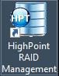

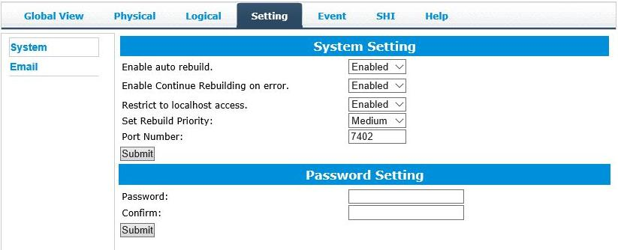
The password can be set after the first log-in. To change the password, select Setting>Security from the menu bar (see page 25 for more information).

How to login WebGUI in Linux
Enter http://127.0.0.1:7402 into the browser to log into the WebGUI, 7402 is the WebGUI’s Port Number, which can be modified.
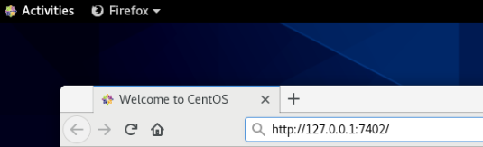

The password can be set after the first log-in. To change the password, select Setting>Security from the menu bar (see page 25 for more information).

Verify the Controller Status

- The Global View Tab will display the overall status of the controller.
- RAID configurations are listed under Logical Device Information.
- The individual M.2 SSDs are listed under Physical Device Information.

SSD7202:
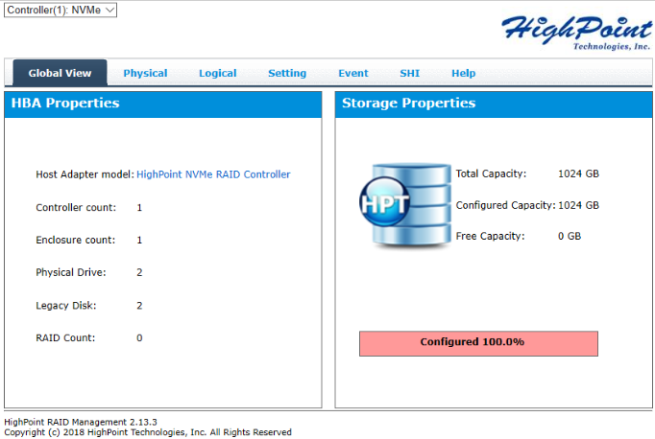

SSD7101A/7120/7103/7204/7104/6540/6540M/7505:
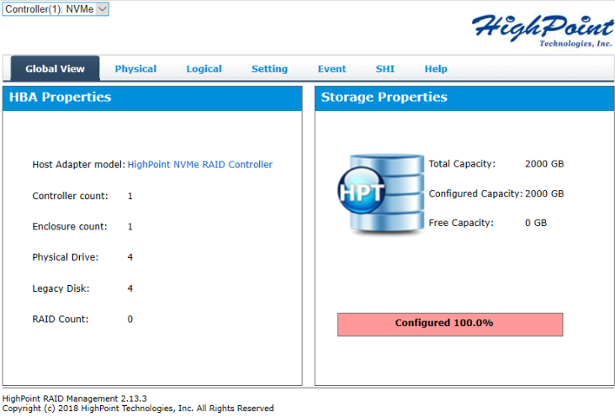

SSD7184/7180/7140:
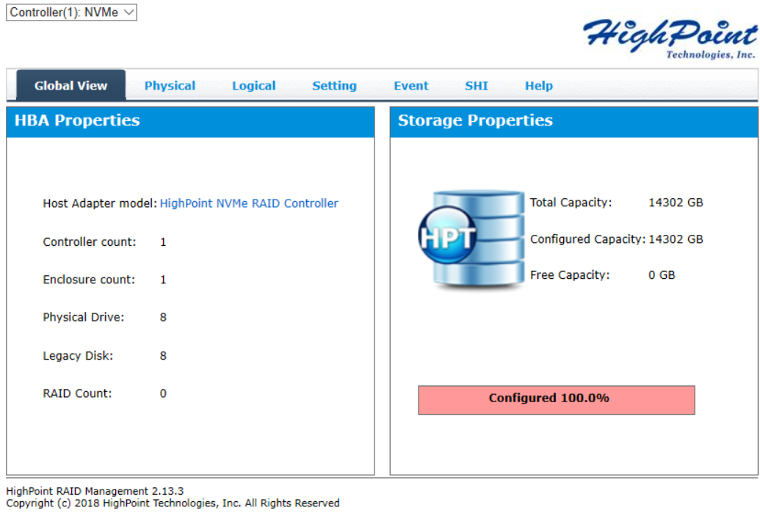

Creating an Array

Single controller to create an array

- Open the WebGUI

- Select the proper controller from the drop down on the top left

- Click the Logical tab
- Click Create Array
SSD7202：
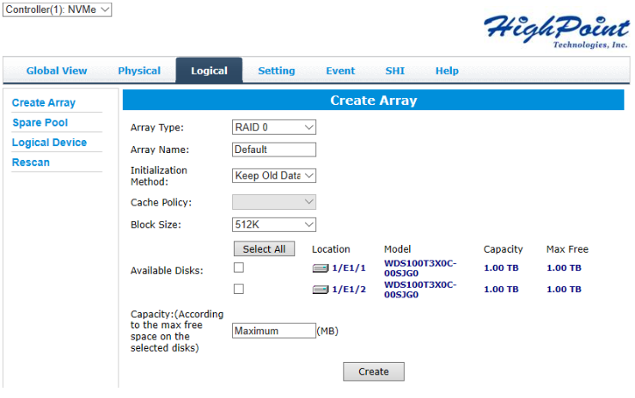

SSD7101A/7103/7204/7104/6540M/7505：

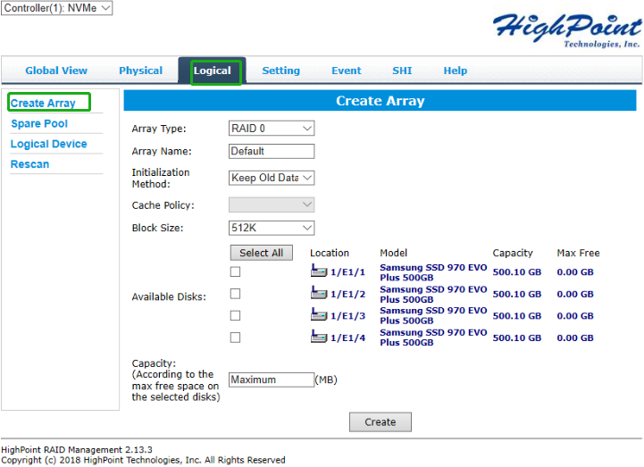

SSD7184/7180:

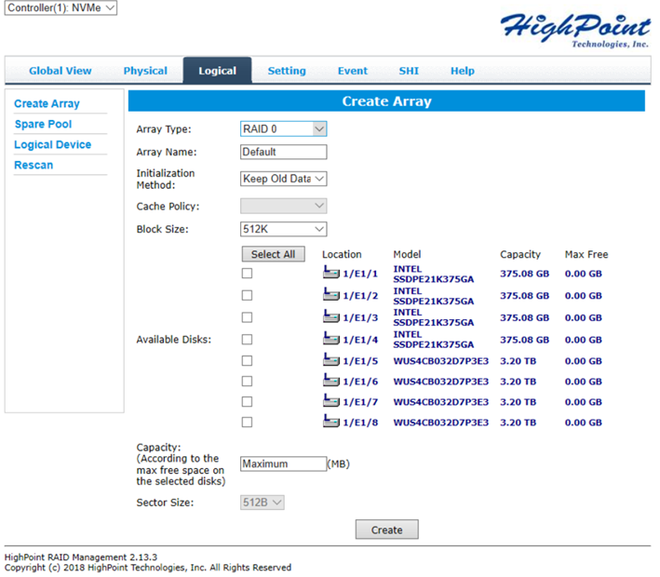

SSD7140:
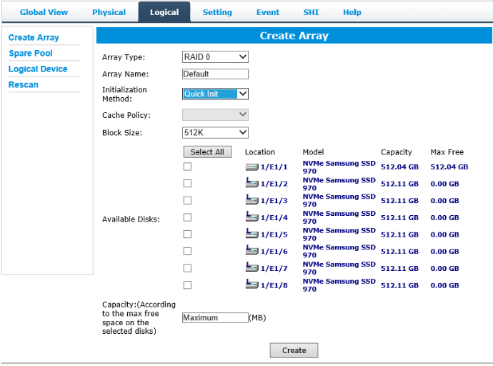

Using the Cross-Sync feature to create an array

Note: This function is only supported by SSD7101A-1, SSD7120, SSD7202 controllers

For more information about Cross-Sync, please submit a Support Ticket via our Online Support Portal, or contact sales@highpoint-tech.com

- Open the WebGUI
- Select the appropriate controller using the drop-down menu found in the upper left-hand corner of the interface
- Click the Logical tab
- Click Create Array – it should recognize the SSD’s attached to both cards.
SD7101A-1:
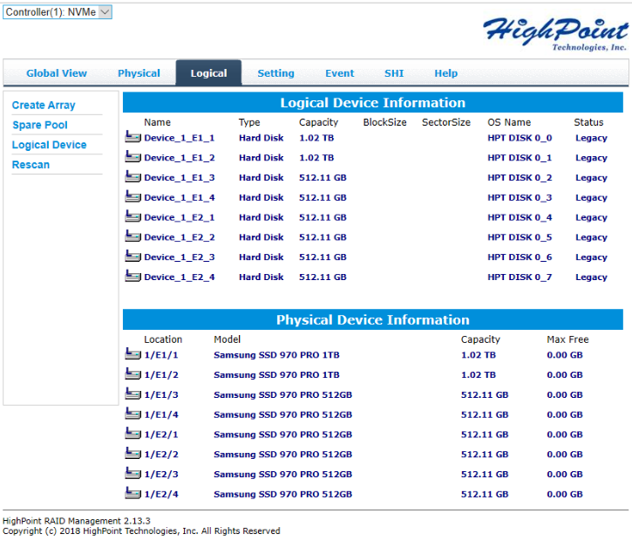

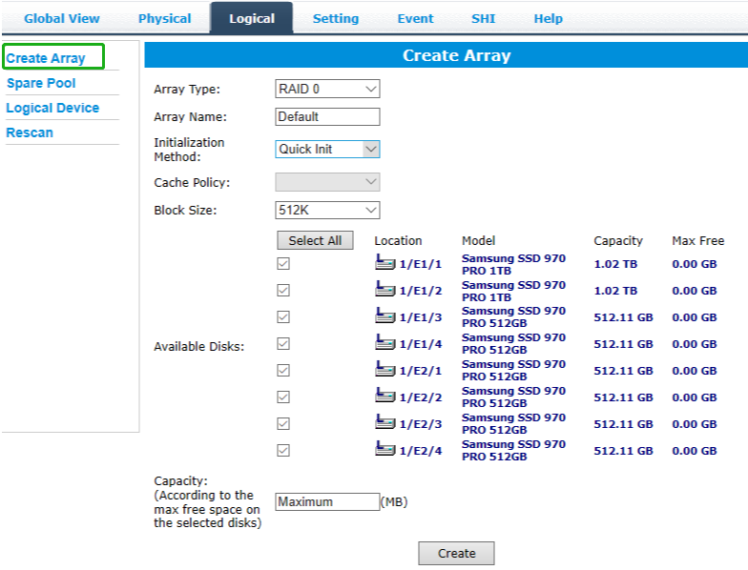

SSD7120:
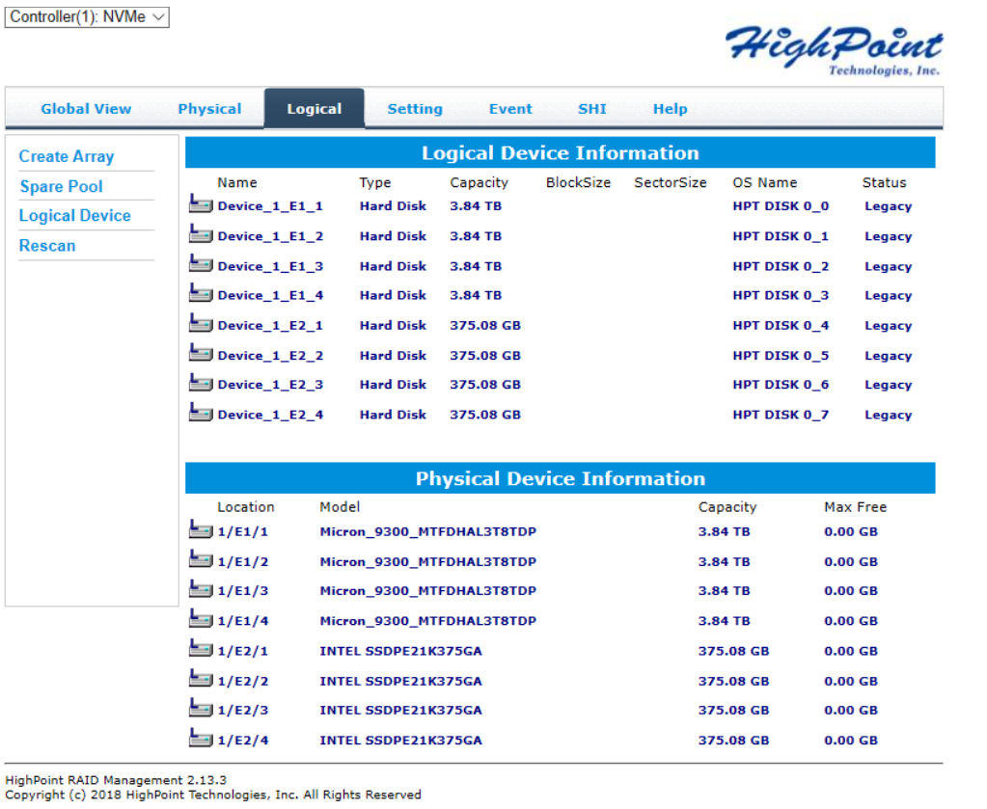
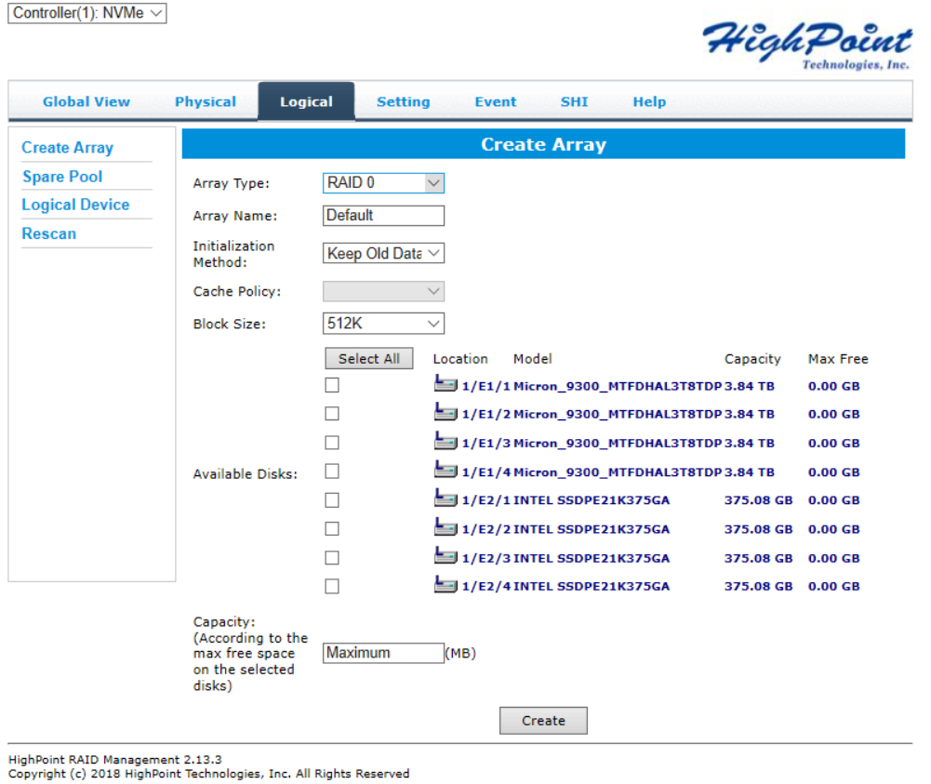

SSD7202:
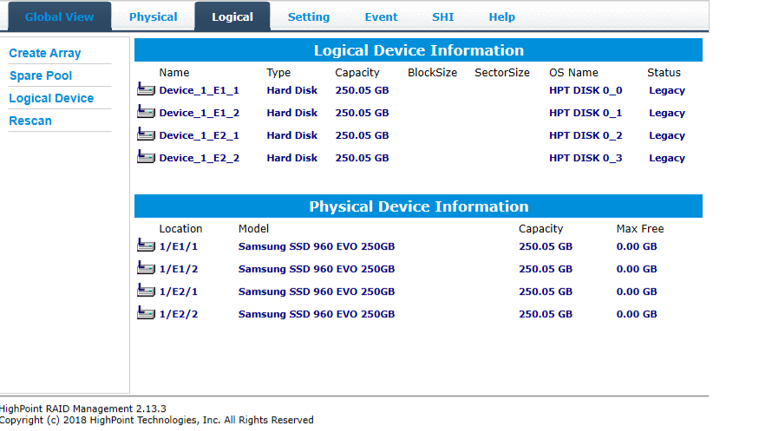

- You can view information about both controllers using the Physical tab. Note, the interface will refer to the controllers as “Enclosure 1” and “Enclosure 2”.

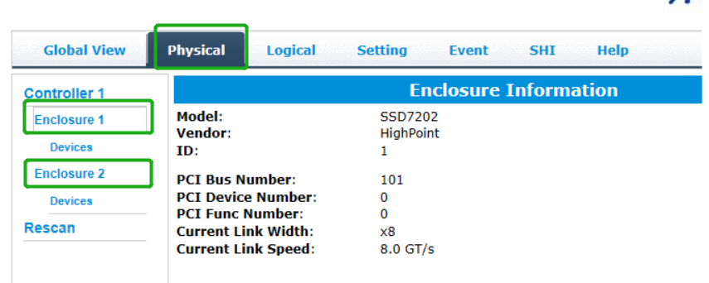

Array Type

This drop-down menu allows you to specify the RAID level. An array is a collection of physical disks that will be one virtual drive by your Operating System (OS).

The SSD7202 is capable of creating the following types of arrays:
- RAID 0 — Striping

- RAID 1 — Mirroring

The SSD7101A-1, SSD7103, SSD7120, SSD6540, SSD6540M, SSD7104, SSD7204，SSD7184, SSD7505 and SSD7140 controllers can create the following types of arrays:
- RAID 0 — Striping

- RAID 1 — Mirroring
- RAID10 — Striping Mirrored array

Each RAID level has its pros and cons based on the application you use it for (Note: Refer to RAID level Quick Reference)

Array Name: the name that will be displayed in Logical Device

Information (Default: RAID_<level>_<array number>)

Initialization Method:
Initialization of a disk sets all data bits to 0, essentially clearing all the data on the drive. It is important to initialize disks as previous data physically stored on the drive may interfere with new data.

- Keep Old Data: This option skips the initialization process and all data on each physical disk of the array will be untouched.

- Quick Init: This option grants immediate access to the RAID array by skipping the initialization process, but it will delete all data. Note: Skipping initialization is generally not recommended as residual data on disks may interfere with new data in the future.

- Foreground: The array initialization process will be set at high priority. During this time array is not accessible, but the initialization process will complete much faster.

- Background: The array initialization process will have a lower priority. During this time the array will be accessible, but the initialization process will take much longer to complete.

Note: Using a Samsung 970 EVO Plus 500GB as an example; RAID 1 Initialization (Foreground) time is approximately 10 minutes. Initialization using the Background option would take 12 minutes to complete.

Background and Foreground Initialization

Foreground initializing the array will completely zero out the data on the disks, meaning the disk will be completely wiped and every bit on the disk will be set to 0. Background initialization means the array will still be created, and you can still write new data onto the array. But when your array requires rebuilding, residual data left behind may interfere with the process.

Block Size (default: 512K)
SSD7103/7202/7505: [supported block sizes: 128K/256K/512K]

SSD7101A-1/SSD7120/7104/6540/6540M/7204/7184/7180/7140: [supported block sizes: 16K/32K/64K/128K/256K/512K/1024K]
Adjusting the block size towards your disk usage can result in some performance gain.

In a typical RAID configuration, data of the virtual drive is striped (or spread across) the physical drives. Having a smaller array block size will increase the likelihood of accessing all physical drives when processing large I/O requests. Multiple physical drives working in parallel increases the throughput, meaning better performance.

For smaller I/O requests (512 bytes to 4 kilobytes), it is better to have each individual disk handle their own I/O request, improving the IOPS (I/O per second), rather than having one tiny I/O request being handled by multiple disks.

Capacity (Default: Maximum)

This section allows you to set the total amount of space you want the RAID array to use. When creating RAID levels, disk capacities are limited by the smallest disk.

An example of how disk capacities are limited by smallest disk:

- You have 2 drives connected to the enclosure.

- The first drive is 6 TB, the second is 4 TB
- After creating a RAID level 1 using both drives and maximum capacity, the first drive will have 2 TB, the second 0 TB of free capacity

- The free capacity on the second drive can be used to create a separate array with other drives.

Adding Spare Disks

Note: This function is only supported by SSD7101A-1, SSD7103, SSD7505, SSD6540, SSD6540M, SSD7120, SSD7184, SSD7180, SSD7104, SSD7204 and SSD7140 RAID controllers.

Spare disks are physical disks that will immediately replace critical disks in an array.
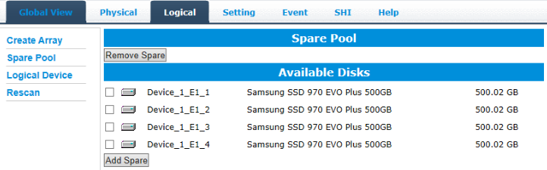

To add spare disks:

1. Open the WebGUI
2. Click Logical
3. Click Spare Pool:
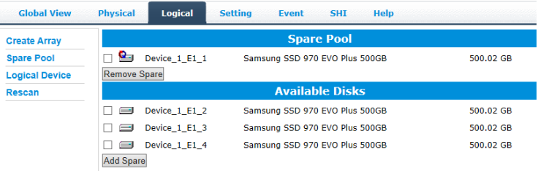

4. Check the box for the disk you want as a spare under Available Disks
5. Click Add Spare, and confirm by selecting OK from the pop-up window:
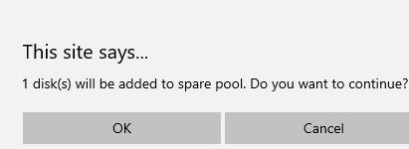

6. The disk has now been assigned as a spare. Click OK to confirm:
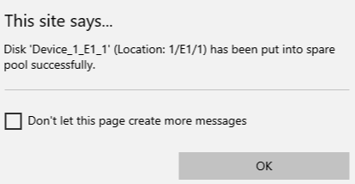

Disks added to the spare pool will be displayed under Spare Pool and can be removed by checking the box before the target drive, then
clicking the Remove Spare button.
Physical drives marked as a spare will automatically be added to an array whenever there is a disk failure. This feature minimizes the chances of a data loss by reducing the time an array is in the critical status.

Obtaining Logical Device Information

The Logical device tab is the default page after clicking the Logical tab of the HRM. This page contains information about your RAID arrays and the individual disks your system detects.

Logical Device Information

Arrays you create and the properties associated with them will appear here.

Maintenance

Once an array has been created, the Maintenance menu provides options to maintain or edit it. To access the Maintenance menu, click the Maintenance button towards the right-hand side of the array name.
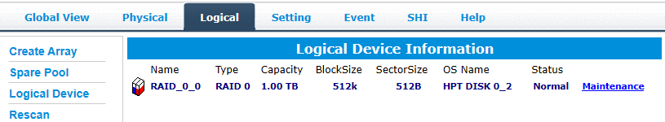

Array Information

Clicking on the Maintenance button will show you the Array information box. Different array statuses (Normal, critical, disabled) will have different maintenance options.

Array Information &Maintenance Options: Normal Status
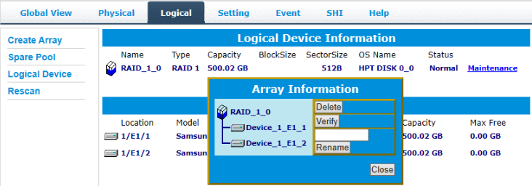

Arrays with the Normal status are healthy and functioning properly,

and have the following options:

Delete – deletes the selected RAID array

Verify – verifies the integrity of the RAID array

Rename – renames the RAID array.

Array Information & Maintenance Options: Critical Status
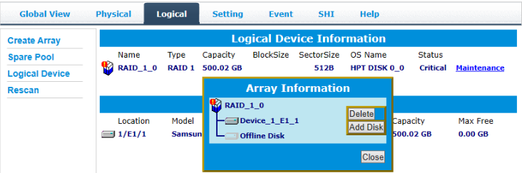

Arrays in the Critical status can be accessed and utilized, but are no longer fault tolerant. A Critical array should be rebuilt as soon as possible to restore redundancy.
A critical status array has all the normal status options except the following:

- The Array can no longer be renamed

- Add Disk replaces the Verify Disk option

Once the array status changes to critical, the faulty disk will be taken offline and you can either:

- Reinsert the same disk
- Insert a new disk

Reinserting the same disk should trigger the rebuilding status, since data on the disk would be recognized.

If you insert a new disk, clicking Add Disk will give you the option to
select that disk and add it to the array.

Array Information & Maintenance Options: Disabled Status
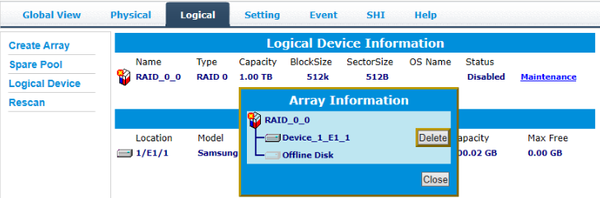

An array with the Disabled status means that the RAID level does not have enough disks to function.

- Your data will be inaccessible

- Rebuilding will not trigger, since the RAID array does not have enough parity data to rebuild.

Your options in Maintenance are:

- Delete

Delete – will delete the array

Physical Device Information

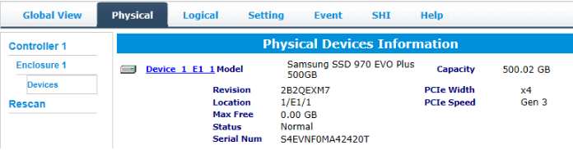

- Model — model number of the drive connected
- Revision — revised version of drive
- Location — which controller and port the drive is in

- Max Free — total capacity that is not configured
- Status — Current state of drive
- Serial Num — Serial number of the drive
- Capacity — total capacity of the drive
- PCIe Width — PCIe width occupied by the driver
- PCIe Speed — Rate of current bandwidth

Rescan

Clicking Rescan will ask the driver to recheck and report the array status.
When Rescan is initiated by the WebGUI; the driver will immediately check and see whether the status of any disk has changed. If there are any changes, the status of the disks and RAID array will be updated to reflect this.
- Disk Status – if any disks were added or removed, or if a disk is no longer responding, the status will change.
- RAID status – the RAID array’s status may change depending on the status of the disks.

System Setting

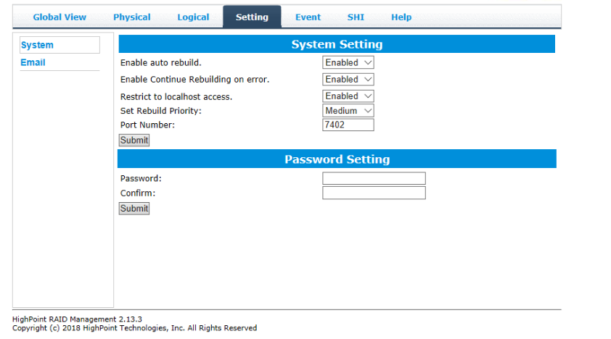

Using this tab, you can change the following:

- Enable auto-rebuilding
- Enable rebuilding on error
- Restrict to localhost
- Set rebuild priority
- Change port number

- Change HRM password

System Setting

Enable auto rebuild (default: Enabled)

When a physical drive fails, the controller will take the drive offline. Once you re-insert or replace the disk, the controller will not automatically rebuild the array unless this option is enabled.

Enable continue rebuilding on error (default: Enabled)

When enabled, the rebuilding process will ignore bad disk sectors and continue rebuilding until completion. When the rebuild is finished, the data may be accessible but may also be inconsistent, due to any bad sectors that were ignored during the procedure. If this option is enabled, HighPoint recommends checking the event log periodically for bad sectors warnings.

Restrict to localhost access (default: Enabled)

Remote access to the controller will be restricted when enabled; other users in your network will be unable to remotely log in to the HRM.

Rebuild Priority (default: Medium)

You can specify the amount of system resources you want to dedicate to rebuilding the array. There are 5 levels of priority [Lowest, Low, Medium, High, Highest]

Port Number (default: 7402)

The default port that the HighPoint HRM listens on is 7402. You may change it to any open port.

Password Settings

Changing your HRM password

Under Password Setting, type your new password, confirm it, then click Submit.

Recovering your HRM password

If you forget your password, you can delete the file hptuser.dat. Then, restart the computer and open the WEBGUI to set a new password.

For Windows Users:

- Open File Explorer
- Navigate to C:/Windows/
- Delete hptuser.dat
- Reboot

Email Setting

The following topics are covered under email:

SMTP Setting

Adding Recipients

You can instruct the controller to send an email out to the recipients of your choosing when certain events trigger (for more information, see Event Tab).

SMTP settings
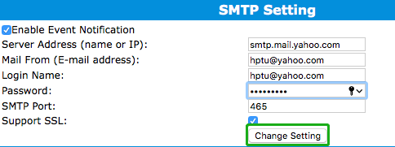
Note: After you click Change Setting, the password field will be reset.

To set up email alerts:

Using a Yahoo Mail account as an example:

- Check the Enable Event Notification box.

- Enter the ISP server address name or SMTP name
For example: smtp.mail.yahoo.com

- Type in the email address of the sender (email account that is going to send the alert)
For example: hptu@yahoo.com

- Type in the account name and password of the sender

- Type in the SMTP port (default: 25)

- Check the support SSL box if SSL is supported by your ISP (note the port value will change to 465).

Email Precautions
If you want to receive notification mail using a Webmail account, you may need to modify the mailbox’s permissions. The following example is for a Yahoo webmail account.

To change permission settings, please refer to the following link:
https://help.yahoo.com/kb/account/SLN27791.html?impressions=true

Procedure:

- Log in to yahoo email; click "Sign in" to log in:
https://www,yahoo.com
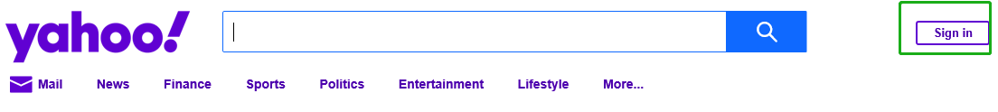

- After a successful login, click "Account Info" under the
user name：

- Go to the "Account Info" page, click "Account Security".
On the "Account Security" page, click the "Allow apps that use less secure sign in" button:
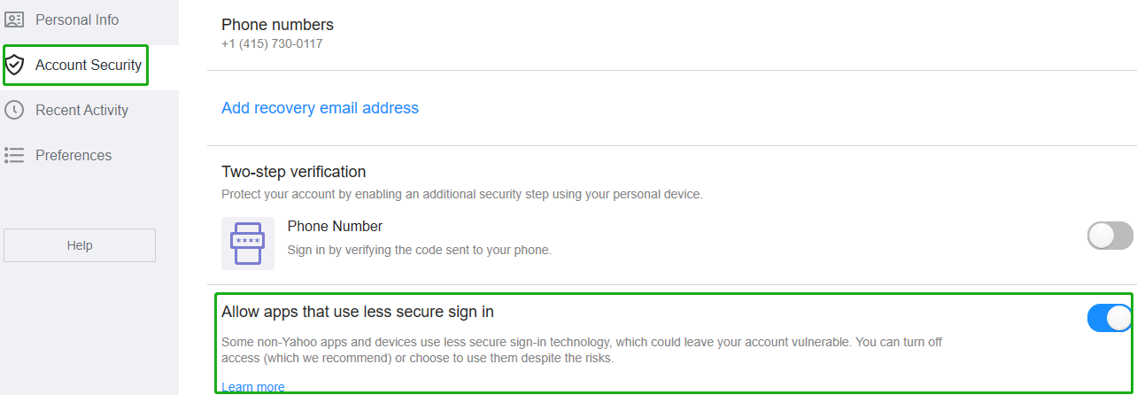

Note: If you are having trouble configuring notification for your Email account, please contact our Technical Support Department.

How to Add Recipients

You can add multiple email addresses as receivers of a notice.

- Type the email of the recipient in the E-mail text box
- Type the name of the recipient in the Name text box

- Set which type(s) of events will trigger an email using the respective Event Level check boxes.
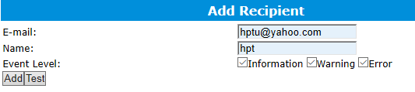

- (Optional) Click test to confirm the settings are correct by sending out a test email
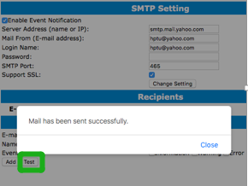

- Click add to add the recipient to recipient list
- The added recipient will display in under Recipients
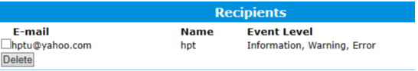

The email will include the output recorded in the event log.

Example email message:
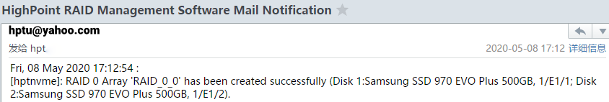

Figure 1. Example event log email

Event Tab

In the event tab, you can see log entries associated with the HighPoint device. The event log provides useful information when troubleshooting your set up.

In the event tab, there are four options available:
Download – Save the log file on your computer
Clear – Clears all log entries
Prev – View previous log page
Next – View next log page

SHI (Storage Health Inspector)

- S.M.A.R.T Attributes
- Schedule a task (Task list and Health Inspector Scheduler)

SHI outputs information collected using SMART (Self-Monitoring Analysis and Reporting Technology) Hard Drive Technology. The data provided on this tab helps you to anticipate any disk failures based on a variety of monitored hard disk properties.

How to Enable SMART Monitoring

To access the SMART attributes of an individual disk:
- Log in to the WebGUI

- Select the proper controller using the drop-down menu on the top left

- Click the SHI tab

- Click Detail on the desired disk:
Note: The current NVMe Temperature threshold is set to 60℃. If it does not exceed 60℃, it will display “Normal”;
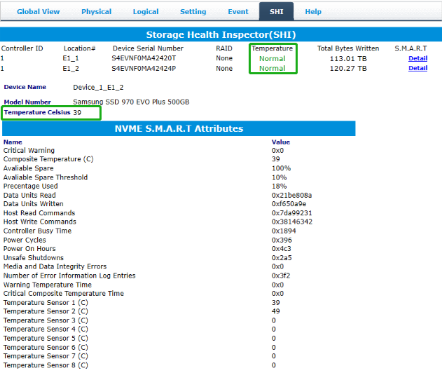

If the temperature exceeds 60℃, it will display “High”.
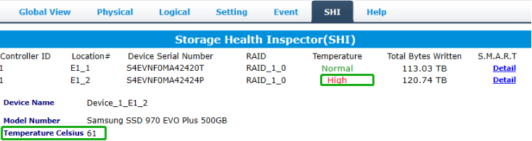

The TBW (Total Bytes Written) information can be used to monitor the lifespan of the NVMe drives.

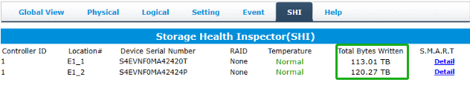

How to Use the Health Inspector Scheduler
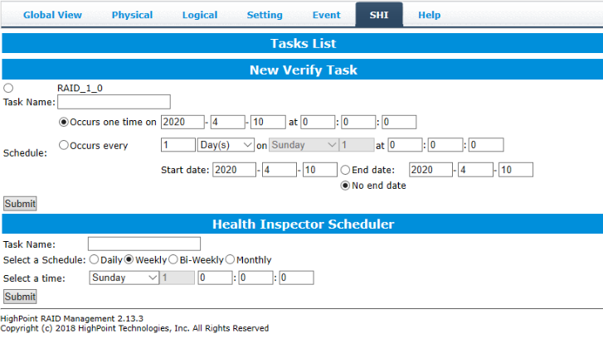

The Health Inspector Scheduler (HIS) enables you to schedule disk/array checkups to ensure disks/array are functioning optimally.
If you want to check the disk status on a daily, weekly, or monthly basis, you can enable this using the HIS function.

For example:
- Set the 'Task Name' to 't1', select the schedule as 'Daily', and set the time to 10:10
- After clicking "Submit", the task you created will be shown under the "Task List".
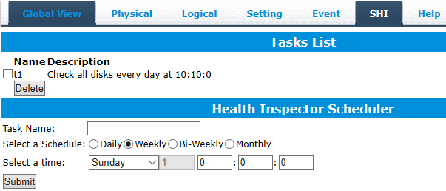

When the operating temperature of the disk exceeds 60°, a “Warning” event will appear in “Events”:
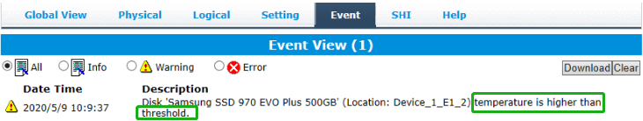

How to Create a New Verify Task

All Redundant RAID arrays (RAID 1) will appear under New Verify Task

- Log into the WebGUI
- Select the proper controller from the top left drop down
- Click SHI
- Click Schedule
- Select the array you want to schedule the verify task
- Type the name in Task Name entry box
- Choose whether you want to schedule
- One time verify task on specific date (YYYY-MM-DD) at (HH:MM: SS, 24-hr clock)
- Or a specific schedule you can adjust based on Daily, Weekly, or Monthly options
- Click Submit
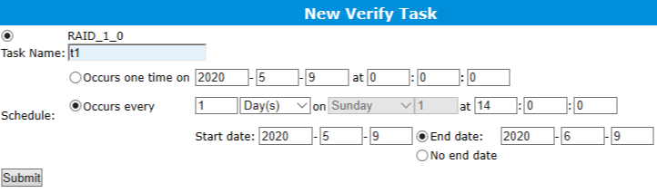
- Your entry will appear under Tasks List
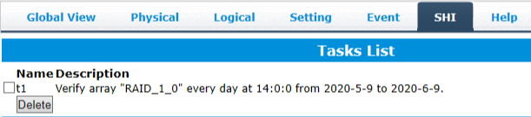

Note: New Verify Task box only appears if you have normal status arrays. If you have a critical array, New Rebuild Task will replace New Verify Task.

Using the HighPoint Command Line Interface (CLI)

How to use the CLI in Windows

Method1: Run ‘Command Prompt’ as Administrator and enter hptraidconf and press Enter

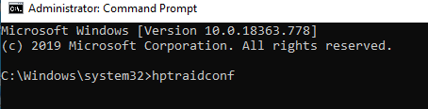

Method2：Click ‘Start’ to find the HighPoint RAID Management folder, and click on hptraidconf

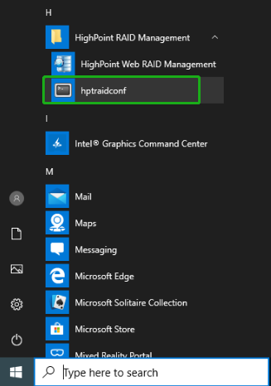

How to use the CLI in a Linux system

Open ‘Terminal’ and enter root permissions, then execute the command ‘hptraidconf’ to enter the CLI
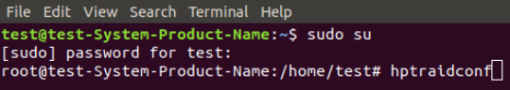

CLI Command Reference

This chapter discusses the various HighPoint CLI commands: Query, Create, Delete, OCE/ORLM, Rebuild, Verify, Unplug, Switch, Lscard, Rescan, Init, Events, Mail, Task, Set, Clear, Help and Exit.

Warning: using Create/Delete commands may destroy data stored in the disks, and this lost data can never be recovered. Please be cautious when executing these commands. The CLI utility will not prompt you before each command is executed.
The following example is for a Windows system:

Query Commands
Syntax：
query controllers | query devices | query devices {devices_id} |
query arrays | query arrays {array_id}

query controllers
This command reports controller information
Single card：
SSD7202：

SSD7101A-1/6540/6540M/7120/7103/7204/7104/7505：
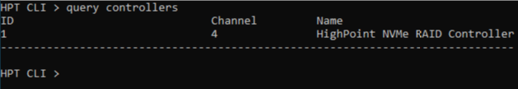

SSD7184/7180/7140:
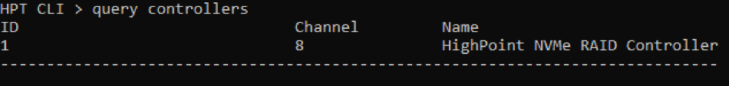

query enclosures
This command reports Product ID information.

Single card：
SSD7101A-1:
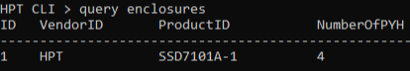

SSD7104:
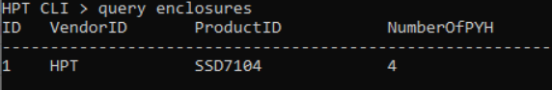

SSD7120:
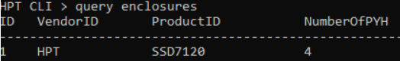

SSD7103:
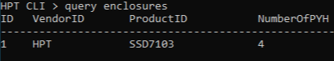

SSD7202:
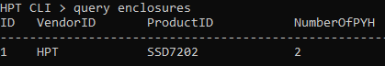

SSD7204：
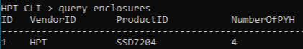

SSD6540/SSD6540M:
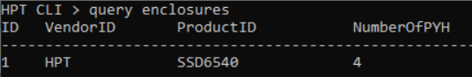

SSD7184:
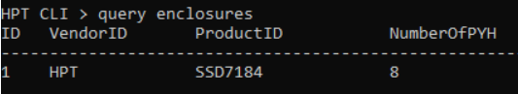

SSD7180:
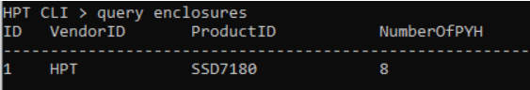

SSD7505:
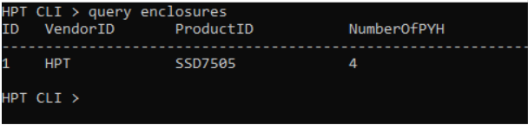

SSD7140:
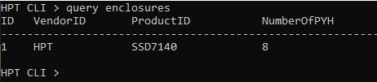

Cross-Sync：
Note: This function is only supported by SSD7101A-1, SSD7120 and SSD7202

SSD7101A-1:
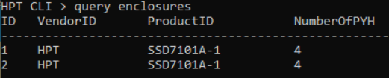

SSD7120:
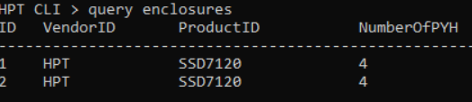

SSD7202:
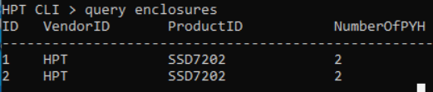

query devices
This command will provide the status of each physical device hosted by the controller. It provides a list of device ID’s, capacity, model numbers, status, and array attributes. Each device’s status will be listed as one of the following: NORMAL, DISABLED, SPARE, RAID and BOOT.

Attributes:
ID:
A device ID is a string used to represent a disk. It is in the format “controller/channel/device” for NVMe controllers. E.g. 1/E1/1 represents the disk on controller 1 port 1;

Capacity:
The capacity of the disk in GB.

MaxFree:
The Maximum sequence free space on a disk which can be used by creating array.
Flag:
Shows whether the disk is single or has been created RAID.
Status:
This will display the disk status (1 of 4 possible states):
- NORMAL: The disk's status is normal.
- DISABLED: The disk cannot be used. (may be related to disk failure or removal)
- RAID: The disk is a member of a RAID array.
- SPARE: The disk has been set as a spare disk

ModelNumber:
The disk's model number.

Example:

Single card：
SSD7202：
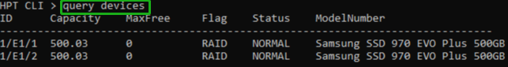

SSD7101A-1/7103/7120/7204/7104/7505:
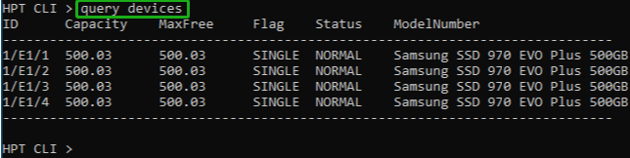

SSD7184/7180:
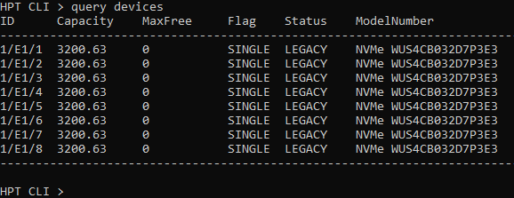
SSD7140:
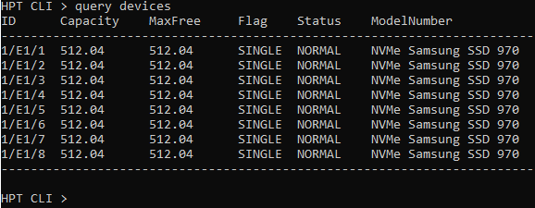
SSD7101A-1/7120 Cross-Sync：
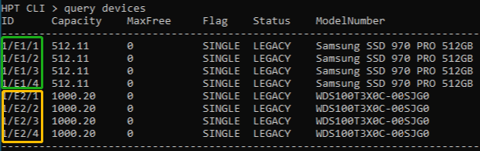

query devices {device_id}
This command presents information for the specified device.

Attributes:

Mode Number:
The disk's model number.

Serial Number:
The disk's Serial number.

Firmware Version:
The disk's Firmware version.

Read Ahead/Write Cache/TCQ/NCQ Status:
Disk’s Read Ahead/Write Cache/TCQ/NCQ status could be enabled/disabled/--(not support)

S.M.A.R.T Attributes:

S.M.A.R.T Attributes detailed information reported by hard disk.

Example:

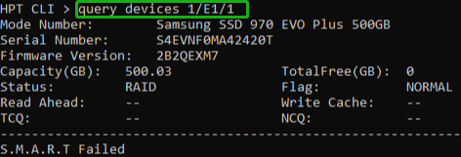

query arrays

This command lists information for all configured arrays. It will list each array’s ID, capacity, RAID level, and status information.
Note: An array ID is generally represented by number or set of numbers.
Attributes:
Type:
SSD7202: The array's type. (RAID0, RAID1)
SSD7101A-1/7103/7120/7204/7104/6540/6540M/7505/
7184/7180/7140:
The array's type. (RAID0, RAID1, RAID10)

Status:

- NORMAL: Array status is normal
- DISABLED: Array is disabled.
- REBUILDING: Array is being rebuilt
- VERIFYING: Array is verifying
- INIT(F): Initializing an array using Foreground mode
- INIT(B): Initializing an array using Background mode
- UNINITIALIZED: Array is not initialized
- CRITICAL: Array is in a degraded status (no data redundancy)

Block:
Array Block size.

Sector:
Bytes per sector.

Cache:
Array Cache Policy
WT: Write Through
WB: Write Back
NONE: No Cache policy enabled

Example:
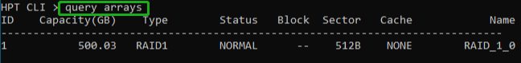

query arrays {arrays_id}

This command will present information of each disk of a specified array.

Example:

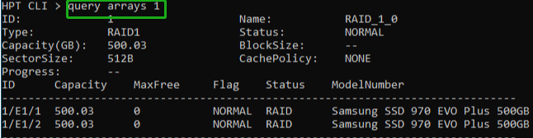

Init Commands
You can use init commands to initialize disks or arrays. A drive must be initialized first before being used to create arrays.

Syntax:
init {device_id} | init {array_id} {start|stop}

init {device_id}
This command initialize a disk for first use or a legacy disk on the controller.

Example:

After entering the CLI, enter the command: ‘query devices’ to view the current NVMe status is ‘LEGACY’, enter ‘init 1/E1/1’ ,NVMe status is ‘NORMAL’.
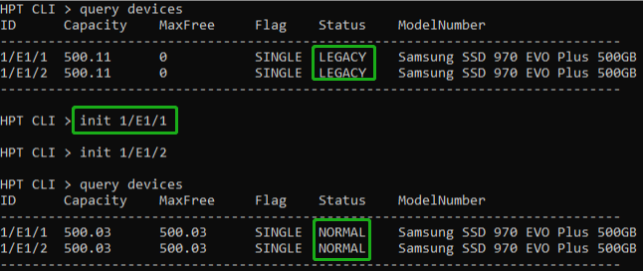
Note: This command instructs the controller to initialize the disk on controller 1 channel 1. All data on the disk will be destroyed.

init {array_id} {start|stop}
This command starts/stops the initialization process of a redundant RAID array (RAID 1)

Example:

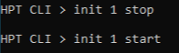
This command instructs the controller to stop/start initialization process on array 1. Take Samsung 970 EVO PLUS as an example, create RAID1 init time is about 10 minutes.

Create Commands

This command allows you to create a new RAID array, add a spare disk, or expand/migrate an existing array.
Note: A drive must be initialized first before being used to create arrays.

Syntax:
create {RAID0|RAID1|RAID10 spare} [create-options]

Parameters

You can specify one or more create options for this command, separated by a space. The options can be typed in any order.

disks= specifies member disks which will compose a new array, e.g. disks=1/E1/1,1/E1/2, disks=*. The character * means all available drives.
NOTE: When you enter a complete command with parameters disks=* at the shell prompt, the correct writing is disks="*".
For example:
hptraidconf –u RAID –p hpt create RAID0 disks="*".

init= specifies the initialization option (foreground, background, quickinit, keep old data). The default option is create-only. The create-only option is applicable for all the RAID types, which is to create an array without any initialization process. Initialization is needed for redundant arrays to provide data redundancy.

foreground : Initialize an array using foreground mode. This is the recommended method when creating redundant RAID arrays.

background : Initialize an array using background mode. The array is accessible during array initialization.

quickinit : Do a quick init.

keep old data: This option will create the RAID array but keep existing data on RAID array. This option should be selected when trying to recover a RAID array.

name= specifies the name for the array being created.
If the option is omitted, the utility will assign a default name for the array.

src= specifies an existing array to be expanded/migrated. All data on
the source array will be redistributed online to the target array. If this parameter is omitted, a new array is created.

capacity= specifies the capacity, in size of MB, for the target array. Maximum capacity is default.

bs= specifies the block size, in KB, for the target array. This option is only valid for stripped RAID levels. Default is 64KB.

sector= specifies the logical sector size, in B/KB, for the target array. This option is only valid for stripped RAID levels. The default is 512 Bytes.

Examples:

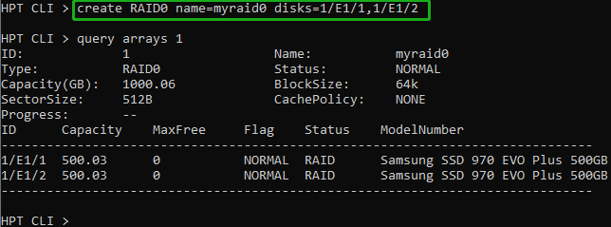
This command instructs the system to create a RAID0 array using
the disks attached to controller 1 channels 1 and 2, and name it myraid0.

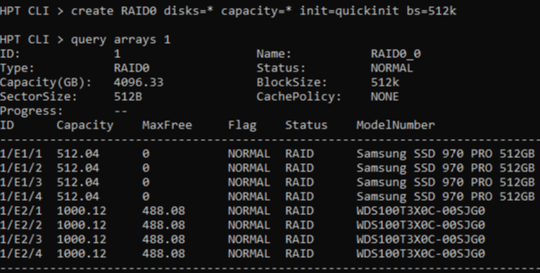
This command instructs the system to create a RAID0 array using
the disks attached to controller 1 channels 1/2/3/4, and controller 2 channels 1/2/3/4; capacity is maximum, Block Size is 512KB.

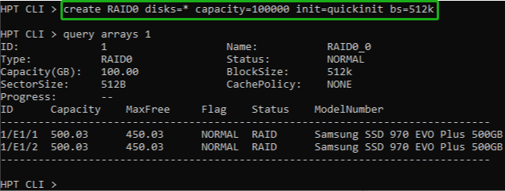
This command instructs the system to create a RAID0 array using
the disks attached to controller 1 channels 1 and 2; capacity is 100GB, Block Size is 512KB.

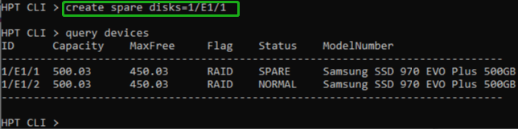
This command instructs the system to set the disk on controller 1 channel 1 to function as a spare disk.

Delete Command

This command allows you to delete an existing RAID array or remove a spare disk. After deletion, the original array and all data on it will be lost. All the member disks will be listed as available single disks.

Note：If you want to use a single disk after deleting the RAID, please restart the system after deleting the RAID. When the single disk status shows the Legacy status in WEBGUI or CLI, it can be used normally.

Syntax
delete {array_or_spare_ID}

Examples

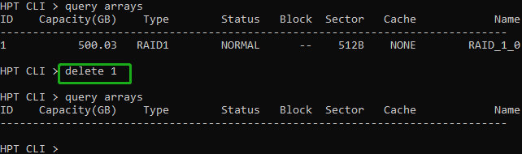
This command instructs the system to delete the array whose id is “1”. You can query the array ID before the deletion.

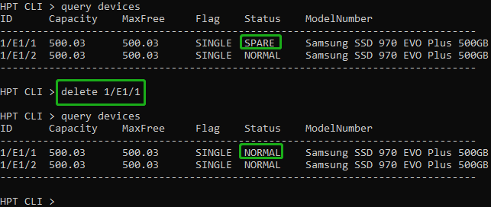
This command is used to remove the spare disk on
controller 1 channel 1.

Unplug Command

This command allows you to remove an array or disk from a running system without shutting down. It is only supported on SSD7120.

Syntax
unplug {array _id or device _id}

Examples

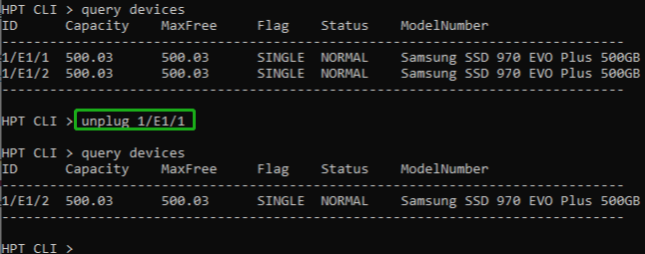
This command allows you to remove a disk from a running system without shutting down.

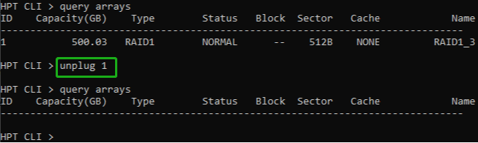
This command instructs the controller to disconnect the array “1”; you can then disconnect the drives safely.

Rebuild Commands

You can use rebuild commands to rebuild a RAID1 array when it is critical or broken.

Syntax
rebuild {array_id} {device_id}
rebuild {array_id} {start|stop}

rebuild {array_id} {device_id}

This command allows you to add the specified disk to a broken array and rebuild it.

Example

HPT CLI> rebuild 1 1/E1/1
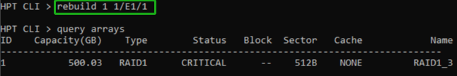
This command instructs the controller to add the disk “1/E1/1” to rebuild the array “1”. You can use the query commands first to verify the device ID and the array ID information before the rebuild command.

rebuild {array_id} {start|stop}

This command allows you to start or stop the rebuilding process on the specified array. After you stopped a rebuilding process, you can resume it at a later time by the rebuild start command.

Examples

HPT CLI> rebuild 1 start
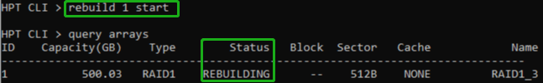
This command starts the rebuilding process on the array “1”.

HPT CLI> rebuild 1 stop
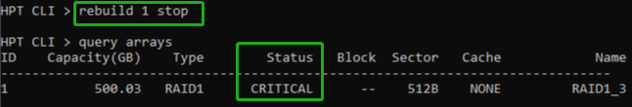
This command stops the rebuilding process on the array “1”.

Verify Command

Syntax

verify {array_id} {start|stop}
This command starts or stops the verify process on the specified
array.

Examples

HPT CLI> verify 1 start
This command starts to verify the array “1”.

HPT CLI> verify 1 stop
This command stops the verify process on the array “1”.

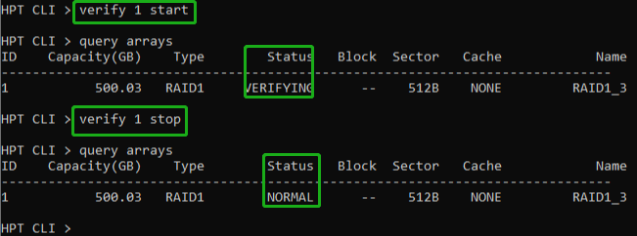

Rescan Command

This command will rescan all of the physical devices attached to the RAID controller.

Syntax
rescan

Example
HPT CLI> rescan
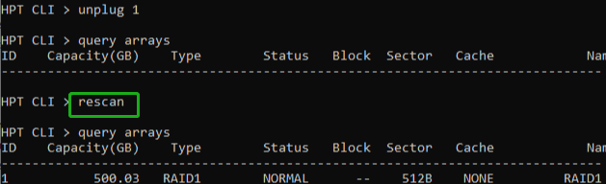

Lscard Command

The lscard command is used to list multiple RAID controllers.

Syntax
lscard

Example

HPT CLI> lscard
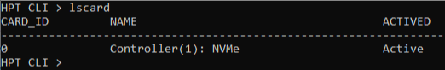

Events Commands

The CLI system will automatically record three types of events: Information (shortened to “Inf”), Warning (shortened to “War”), and Error (shortened to “Err”) on the screen output. These commands allow you to query, save, or clear the logged events.

Syntax
events | events clear | events save {file_name}

events

This command will display a list of all the logged events.

Example
HPT CLI> events
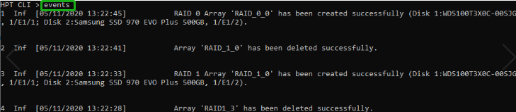

events clear

This command will clear all the logged events.

Example

HPT CLI> events clear
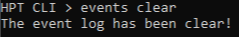

events save {file_name}

This command will save all the logged events as a plain text file.

Example

HPT CLI> events save C:/raidlog.txt
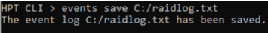
This command will save all the events to C:/raidlog.txt.

Mail Commands

Syntax

mail recipient
mail recipient add {recipient_name}{mail_address} [Inf|War|Err]
mail recipient delete {recipient_name}
mail recipient test {recipient_name}
mail recipient set {recipient_name}{Inf|War|Err}
mail server
mail server set {server_address}{port} { status } {from_address} [username] [password]
mail server set {a|p|s|m|u|t} {value}

mail recipient

--- List all of the mail recipients

Example

HPT CLI> mail recipient
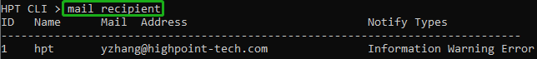

mail recipient add {recipient_name} {mail_address} [Inf|War|Err]

--- Add a new recipient

Example

HPT CLI> mail recipient add admin admin@somecompany.com Inf War Err
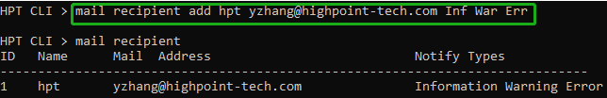
This command will setup the RAID system to send mail to admin@somecompany.com for any logged events.

mail recipient delete {recipient_name}

--- Delete an existing recipient.

Example

HPT CLI> mail recipient delete hpt
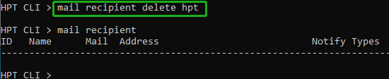

mail recipient test {recipient_name}

--- Send a test email to a specified recipient.

Example

HPT CLI> mail recipient test hpt
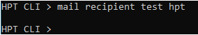
You will receive a test email.
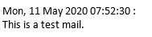

mail recipient set {recipient_name} {Inf|War|Err}

--- Set the notification type for a recipient.

Example

HPT CLI> mail recipient set admin War Err

mail server

--- display the SMTP server information

Example

HPT CLI> mail server
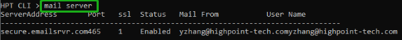

mail server set {server_address} {port} {ssl} {status} {from_address} [username] [password]

--- Use this command to configure mail server settings.
{server_address} – SMTP server address
{port} – port, generally 25
{ssl} – used ssl, '1' for enable and port need 465, '0' for disable
{status} – status, ‘e’ for enable or ‘d’ for disable
{from_address} – mail from address
{username} –mail username
{password} – the user’s password

Examples:

HPT CLI> mail server set secure.emailsrvr.com 465 1 e name@somecompany.com name@somecompany.com password

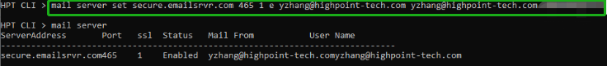

HPT CLI> mail server set mail.somecompany.com 25 0 e admin@somecompany.com password
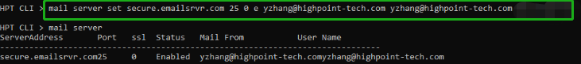

mail server set {a|p|s|m|u|t} {value}

--- Use this to separate set your mail server value

Parameters

a – SMTP server address
p – port, generally 25
s – status, ‘e’ for enable or ‘d’ for disable
m – mail from address
u – username
t – user’s password

Examples:

HPT CLI> mail server set a smtp.somecompany.com
--- Change the server address

HPT CLI> mail server set p 465
--- Change the port
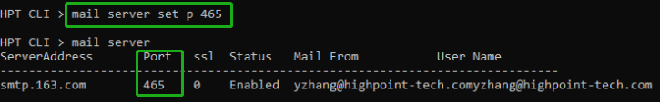

HPT CLI> mail server set s d
--- Disable mail notification
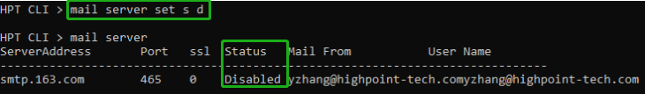

HPT CLI> mail server set s e
--- Enable mail notification
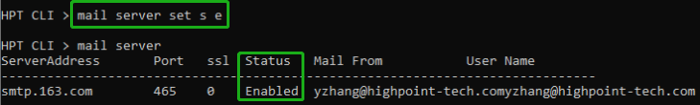

Task Commands

When an array requires regular verification or rebuilding, you can use the task commands to automate this process in the background. If you have the appropriate privileges, you can add new tasks, and modify or delete existing tasks.

Syntax

task
task rebuild {array_id} {name=} {once|daily|monthly|weekly}={day} interval={interval} start=mm/dd/yyyy end=mm/dd/yyyy time=hh:mm:ss

task verify {array_id} {name=} {once|daily|monthly|weekly}={day
interval={interval} start=mm/dd/yyyy end=mm/dd/yyyy time=hh:mm:ss

task delete {task_id}
task enable {task_id}
task disable {task_id}

task
This command displays detailed information about all scheduled tasks.

Example

HPT CLI> task
This command displays the current background tasks.

task rebuild {array_id}{name=}{once|daily|weekly|monthly={day} interval={interval} start=mm/dd/yyyy end=mm/dd/yyyy time=hh:mm:ss

This command allows you to schedule the frequency as once, daily, weekly or monthly, and the detailed time range to rebuild a specified array. The first mm/dd/yyyy specifies the task start date, while the second mm/dd/yyyy specifies the task end date.

Note:
When you add a task to rebuild a selected array once, the parameter {day} should be omitted.

Examples

HPT CLI> task rebuild 1 name=test once start=5/11/2020 time=17:03:35
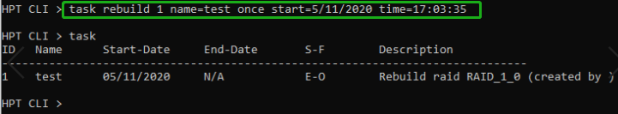
This command adds a task schedule named test to rebuild the array “1”at 17:03:35 on 5/11/2020. The rebuild frequency is set to once.

HPT CLI> task rebuild 4 name=myraid4 daily=2 start=2/8/2020 end=2/22/2020 time=13:49:58
This command adds a task schedule named myraid4 to rebuild the array ”4” at 13:49:58 every 2 days from 2/8/2005 to 2/22/2020.

HPT CLI> task rebuild 3 name=myraid3 weekly=2 interval=3 start=2/8/2020 end=2/22/2020 time=13:49:58
This command adds a task schedule named myraid3 to rebuild the array ”3” at 13:49:58 on Monday (the 2nd day in a week) every 3 weeks from 2/8/2020 to 2/22/2020.

HPT CLI> task rebuild 2 name=myraid2 monthly=3 interval=4 start=2/8/2020 end=2/8/2020 time=12:30:33
This command adds a task schedule named myraid3 to rebuild the array ”2” at 12:30:33 on the 3rd day of a month every 4 months from 2/8/2020 to 2/8/2020.

task verify
{array_id} {name=} {once|daily|weekly|monthly}={day} interval={interval} start=mm/dd/yyyy end=mm/dd/yyyy time=hh:mm:ss

This command allows you to schedule a verify task. The usage of this command is the same as adding a rebuild task schedule.

example

HPT CLI> task verify 1 name=test once start=5/11/2020 time=17:12:33
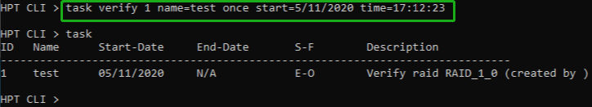

task delete {task_id}

This command allows you to delete a scheduled task. You can query the task ID by task command.

Example

HPT CLI> task delete 1
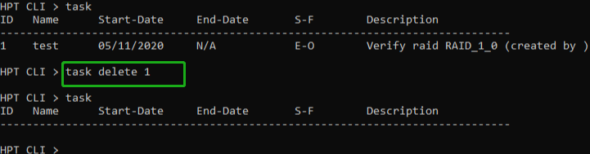
This command will delete the task ”1”.

task enable {task_id}

This command will enable a disabled task.

Example

HPT CLI> task enable 1
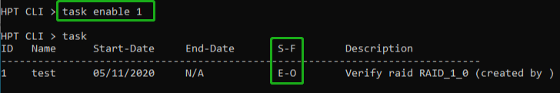
This command will enable the disabled task ”1”.

task disable {task_id}

This command will disable a scheduled task manually.

Example

HPT CLI> task disable 1
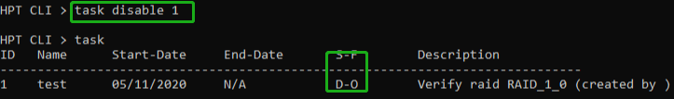
This command will disable the scheduled task”1”.

Set Commands

Syntax

set | set [name]={value}

set
Show the system settable parameters.
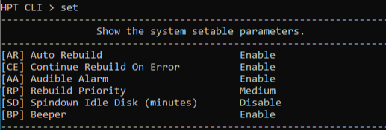

- set AR={y|n}

Set enable or disable to the [Auto Rebuild] parameter.

Example

HPT CLI> set AR=y

- set CE={y|n}

Set enable or disable to the [Continue Rebuilding On Error] parameter.

Example

HPT CLI> set CE=y

- set AA={y|n}

Enable or Disable the [Audible Alarm] parameter.

Example

HPT CLI> set AA=y

- set RP={0-100}

Change rebuilding priority. If a controller is not specified, this command will set the global rebuilding priority.

Note:

[0-12] Lowest
[13-37] Low
[38-67] Medium
[68-87] High
[>88] Highest

Example

HPT CLI> set RP=50

- set SD={minutes}

Set value of [Spindown Idle Disk]
[1-10] 10
[11-20] 20
[21-30] 30
[31-60] 60
[61-120] 120
[121-180] 180
[181-240] 240

Example

HPT CLI> set SD=10

- set BP={y|n}

Set enable or disable beeper.

Example

HPT CLI> set BP=y

Help Commands
Syntax

help | help {command}

help

Show generic help about this utility.

Example

HPT CLI> help
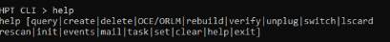

help {command}

Show help about a specific command.

Example

HPT CLI> help create
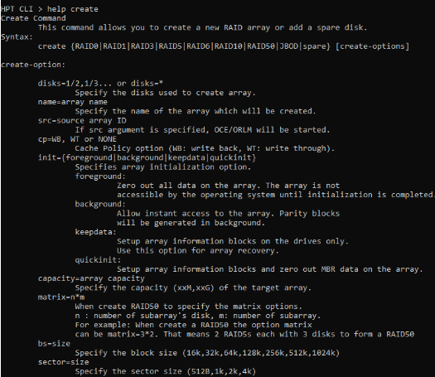

Exit Command
Syntax
exit
Exit from the interactive mode and close the window.

Clear Commands
Syntax

clear/cls/clr
This command is used to clear screen.

Troubleshooting

Debugging an Abnormal RAID status

Please submit a support ticket using our online service at https://www.highpoint-tech.com/websupport/

Table 1. WebGUI Icon Guide

Critical – missing disk

A disk is missing from the array bringing it to ‘critical’ status. The array is still accessible but another disk failure could result in data loss.
Verifying
The array is currently running a disk integrity check.

Rebuilding

The array is currently rebuilding meaning you replaced a failed disk or added a new disk to a ‘critical’ state array.

Critical – rebuild required
The array has all disks, but one disk requires rebuilding.

Disabled

The icon represents a disabled array, meaning more than one disk failed and the array is no longer accessible

Initializing

The array is initializing. The two types of initialization are Foreground and Background. (See Initialization)

Uninitialized

The array initialization process has been interrupted, and the process is incomplete.

Not Initialized
Disk is not initialized yet, and needs to be initialized before use

Legacy

An existing file system has been detected on the disk. These disks are classified as legacy drives.

Normal
The array status is normal

Initializing
The array is initializing, either foreground or background initialization

Initialization Stopped
The initialization has been stopped. Current status is uninitialized.

Critical – Inconsistency
Data in the array is inconsistent and needs to be rebuilt.

Critical – missing disk
A disk has been removed or experienced failure, and user needs to reinsert disk or add a new disk.

Rebuilding
The array is currently rebuilding.

Verifying
The array is performing a data consistency check. Array status will show ‘verifying’.

Disabled
The array does not have enough disks to maintain the RAID level. A disabled array is not accessible.

Table 2. RAID Level Reference Guide

 | Type | Description | Min. | Usable | Advantage |  | Disadvantage | Application
 |  |  | disks | space
 |  | Disk Striping |  |  | Offers the highest performance |  | No fault tolerance - failure of one | Temporary file,
 | RAID 0 |  | 4 | 100% |  |  | drive results in complete data loss | performance driven
 |  |  |  |  |  |  |  | application.
 |  | Disk |  |  | Provides convenient low-cost |  | Useable storage space is 50% of | Operating system,
 | RAID 1 | Mirroring | 2 | 50% | data redundancy for smaller |  | total available capacity. Can | backup, and transaction
 |  |  |  |  | systems and servers |  | handle 1 disk failure. | database.
 | RAID10 | Striping with Mirroring | 4 | 50% | High read performance and medium write performance with data protection for up to 2-drive failures |  | Useable storage capacity equals total capacity of all drives in the array minus two | Fast database and application servers which need performance and data protection

HighPoint Recommended List of NVMe SSDs and Motherboards

HighPoint maintains a list of NVMe SSD’s and motherboards suitable for use with the SSD7101A/SSD7103/SSD7202/SSD7204/SSD7104/SSD7184/
SSD7180/SSD7140/SSD7120/SSD6540/SSD6540M. This document is routinely updated, and is available from the SSD7101A/SSD7103/SSD7202/ SSD7204/SSD7104/SSD7184/
SSD7180/SSD7140/SSD7120/SSD6540/SSD6540M Resources webpage:
SSD7101A:
https://highpoint-tech.com/PDF/Compatibility_List/SSD7101A _Compatibility_List.pdf

SSD7103：
https://highpoint-tech.com/PDF/Compatibility_List/SSD7103_Compatibility_List.pdf

SSD7202：
http://www.highpoint-tech.com/PDF/Compatibility_List/SSD7202_Compatibility_List.pdf

SSD7204：
http://www.highpoint-tech.com/PDF/Compatibility_List/SSD7204_Compatibility_List.pdf

SSD7104:
http://www.highpoint-tech.com/PDF/Compatibility_List/SSD7104_Compatibility_List.pdf

SSD6540:
https://www.highpoint-tech.com/PDF/Compatibility_List/SSD6540_Compatibility_List.pdf

SSD6540M:
https://highpoint-tech.com/PDF/Compatibility_List/SSD6540M_Compatibility_List.pdf

SSD7120:
https://www.highpoint-tech.com/PDF/Compatibility_List/SSD7120_Compatibility_List.pdf

SSD7184:
https://www.highpoint-tech.com/PDF/Compatibility_List/SSD7184_Compatibility_List.pdf

SSD7180:
https://www.highpoint-tech.com/PDF/Compatibility_List/SSD7180_Compatibility_List.pdf

SSD7140:
https://www.highpoint-tech.com/PDF/Compatibility_List/SSD7140_Compatibility_List.pdf

Contacting Technical Support

FAQ’s, technical articles, and trouble-shooting tips are available from our Support web page
https://highpoint-tech.com/USA_new/support.htm

If you require technical Support, please submit a support ticket using our online service at https://www.highpoint-tech.com/websupport/ .

